Lesson 1: Legal and Illegal Substances

Introduction
While some of the discussion on legal and illegal substances in this lesson is a review from previous grades, there is a stronger focus on prescription and over-the-counter (OTC) drugs. This lesson reinforces the drug classifications and challenges students to consider both the positive and negative effects of all types of drugs.

________________________________________________________________________________

Specific Learning Outcomes
11.SU.1 Explain ways in which drugs and other substances are classified.
11.SU.4 Use reliable information in making healthy decisions for helping self and/or others regarding substance use and abuse.
________________________________________________________________________________


Key Understandings
  - Drugs and other substances are often classified by the way they affect the mind and/or body.
  - Misuse of any drug (OTC, prescription, illegal) can be a serious health risk.
  - Know the benefits and risks of a drug before taking it.
________________________________________________________________________________

Essential Questions


- How are drugs classified?
- What information is provided on a prescription drug label? Why?
- How do you make healthy choices when using different drugs?
________________________________________________________________________________
Background Information
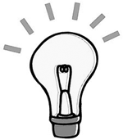
Alcohol and Other Drugs
Scientifically, a drug is any substance, other than food, that is taken to change the way the body or the mind functions. In other words, a drug is any chemical that, when it enters the body, affects the way the body works. Alcohol, caffeine, nicotine, and medications are all drugs. A drug must be able to pass from the body into the brain. Drugs change the messages that brain cells send to each other and to the rest of the body. They do this by interfering with the brain’s own
chemical signals: neurotransmitters.
Note to Teacher
For the purposes of this document, the terms substances and drugs are considered interchangeable.
There are two types of drugs:
  - Legal drugs are known as over-the-counter (OTC) and prescription (Rx) drugs. Alcohol, nicotine, and caffeine are all legal drugs as well.
  - Illegal drugs refer to drugs that are not prescribed by a licensed medical professional, and their use is unlawful under the Controlled Drugs and Substances Act (Department of Justice Canada).
Reference

For additional information, refer to the following website:
Canada. Department of Justice Canada. Controlled Drugs and Substances Act. Ottawa, ON: Department of Justice, 1996. Available online at <http://laws.justice.gc.ca/en/C-38.8/>.
For website updates, please visit Websites to Support the Grades 11 and 12 Curriculum at <www.edu.gov.mb.ca/k12/cur/physhlth/>.
________________________________________________________________________________


Suggestion for Instruction / Assessment
KWL
To check students’ prior knowledge of different legal and illegal drugs, use the KWL (Know – Want to know – Learned) strategy. Use K and W below to guide students’ thinking at the beginning of the lesson or unit, and L at the end of the lesson or unit.
K Know: Identify the names of legal and illegal drugs that you know.
W Want to know: Identify drugs that you would like to know more about.
L Learned: Identify what you learned in this lesson or unit about legal and illegal
drugs.
References
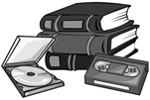
For additional information on the KWL strategy (developed by Donna Ogle), refer to the following departmental publications:
Manitoba Education and Training. Senior Years Science Teachers’ Handbook: A Teaching Resource. Winnipeg, MB: Manitoba Education and Training, 1997. See pages 9.8, 9.9, 9.24, and 9.25.
---. Success for All Learners: A Handbook on Differentiating Instruction: A Resource for Kindergarten to Senior 4 Schools. Winnipeg, MB: Manitoba Education and Training, 1996. See pages 6.20–6.23, 6.94, and 6.95.
________________________________________________________________________________

Background Information
Legal Drugs
Legal drugs are considered permissible for use, and are either prescribed by a physician (prescription medications) or are available over the counter at a pharmacy or other outlet (non-prescription medication). They are intended for medical purposes, such as to ease pain symptoms and to treat health conditions.
OTC drugs or non-prescription medications are available to consumers without a prescription. There are many categories of OTC drugs, such as pain relievers, cold and flu medicines, allergy medications, acne products, and weight-control products. These drugs are usually safe when consumers follow the directions on the label and the directions from their health care professional. Each drug label must have information related to the medicinal and non-medicinal ingredients, use of the drug, applicable warnings or cautions, directions, and dosage.
As indicated by the Center for Drug Evaluation and Research (CDER),
“OTC drugs” generally have these characteristics:
  - their benefits outweigh their risks
  - the potential for misuse and abuse is low
  - the consumer can use them for self-diagnosed conditions
  - they can be adequately labelled
  - health practitioners are not needed for the safe and effective use of the product
(CDER, “Introduction”)
Reference
For additional information, refer to the following website:
U.S. Food and Drug Administration (FDA). Center for Drug Evaluation and Research (CDER). Office of Nonprescription Products. 7 June 2006. <www.fda.gov/CDER/Offices/OTC/>.
For website updates, please visit Websites to Support the Grades 11 and 12 Curriculum at <www.edu.gov.mb.ca/k12/cur/physhlth/>.
________________________________________________________________________________

Suggestion for Instruction / Assessment
How to Read an OTC Drug Label
Provide students with a label of an OTC drug. Have students read the label and identify the information related to each of the following areas, as applicable:
Note to Teacher
Before asking students to examine a prescription label of an OTC drug, remove the label from the container or make sure the container is empty.
  - medicinal ingredients
  - non-medicinal ingredients
  - use
  - warnings
  - cautions
  - directions
  - dosage
  - other
Reinforce the importance of following the information on the label and discuss the risks associated with not doing so.
Reference
For a Canadian reference on interpreting OTC drug labels, refer to the following website:
Be MedWise. How to Read a Drug Label. 10 Jan. 2005. <www.bemedwise.ca/English/howtoread.html>.
This website was created with the participation of the Canadian Pharmacists Association (CPhA) and the Drug Information and Research Centre (DIRC).
For website updates, please visit Websites to Support the Grades 11 and 12 Curriculum at <www.edu.gov.mb.ca/k12/cur/physhlth/>.
________________________________________________________________________________

Background Information
Prescription Drugs
There are many prescribed drugs that are frequently misused or abused by people.
  - Substance misuse is classified as either intentional or unintentional use of a substance (including prescription medications, non-prescription medications, and alcohol) that causes a problem.
  - Substance abuse is an intentional pattern of harmful use of any substance for mood-altering purposes.
Either substance misuse or abuse can result in repeated adverse social consequences related to drug use, such as failure to meet work, family, or school obligations, interpersonal conflicts, or legal problems.
A prescription drug must be prescribed by a physician or other qualified health professional. Prescriptions authorize a pharmacist to provide a specified amount of a particular medication for a specific patient, with instructions for its use. These drugs are regulated by Health Canada’s Therapeutic Products Directorate (TPD).
Often people are unaware of the serious health risks involved in abusing prescription drugs. Because prescription drugs are “legal” and are known to be manufactured to meet quality and safety standards, many young people mistakenly believe that they are always safe to use. Safety can only be assumed if the drug is taken by the intended person as directed by the prescribing doctor. Increasingly, young adolescents are obtaining prescription drugs from classmates, friends, and family members or are stealing them from people for whom the drugs had been legitimately prescribed. As prescription drugs are readily available and can be obtained easily by teenagers, there is cause for concern.
Categories of Prescription Drugs
Three main categories of prescription drugs are of particular concern with regard to their potential for abuse. All the substances in these categories will alter a person’s mood and/or behaviour, and are thus “psychoactive” (have an effect on the functioning of the brain). All three categories also represent substances that have serious potential to produce dependence or addiction.
These three categories of “psychoactive” prescription drugs are as follows:
  - Narcotic pain medications (e.g., opioids) are prescribed to manage chronic or severe pain. Generic and brand names include morphine- and codeine-related drugs such as Demerol, OxyContin, Vicodin, and Dilaudid.
  - Central nervous system (CNS) depressants (sedatives and tranquilizers) are prescribed to treat conditions such as anxiety and acute stress reaction, panic attacks, and sleep disorders. Generic and brand names include barbiturates such as Nembutal and benzodiazepines such as Valium (diazepam) and Xanax (alprazolam).
  - CNS stimulants are prescribed to treat conditions such as attention deficit disorder (ADD) and attention deficit hyperactivity disorder (ADHD). Generic and brand names include amphetamines such as Ritalin.
Other prescription drugs that may be misused include anabolic steroids, which are often used in an attempt to build muscle mass, and cannabis-related prescription products (e.g., medical marijuana or the tablet form dronabinol/Marinol). There are several other classes of prescription drugs that have psychoactive properties (e.g., antipsychotics, anti-mania drugs, antidepressants), but do not tend to be abused for “recreational” purposes.
Naming of Drugs
Drug names originate from
  - the structural formula (chemical composition) of the drug (generic name). This is the “common” name of a drug and does not require capitalization (e.g., acetaminophen is a common name of a popular pain medication).
  - the name used by pharmaceutical companies to market the product (brand or trade name). The name usually has advertising value. Companies will register or copyright the brand or trade name (e.g., Tylenol is one brand name of acetaminophen). Because they are “proper” names, these brand and trade names are capitalized.
Reference
For additional information, refer to the following resource:
U.S. Department of Health and Human Services. National Institute on Drug Abuse (NIDA). NIDA InfoFacts: Prescription Pain and Other Medications. Bethesda, MD: NIDA, June 2006. Available online at <www.drugabuse.gov/Infofacts/Painmed.html>.
For website updates, please visit Websites to Support the Grades 11 and 12 Curriculum at <www.edu.gov.mb.ca/k12/cur/physhlth/>.
________________________________________________________________________________

Suggestion for Instruction / Assessment
How to Read a Prescription Drug Label

To help students learn about what information is included on a prescription drug label, have them complete RM 1–SU. Reinforce the importance of reading the information and following the directions on the label. Also emphasize that only the person for whom a drug is prescribed should take the drug.
Refer to RM 1–SU: How to Read a Prescription Drug Label.
References
For information on reading a prescription drug label, refer to the following report:
Health Quality Council of Alberta (HQCA). Health Report to Albertans. Calgary, AB: HQCA, January 2007. Available online at <www.hqca.ca/phpBB2/files/hqca_health_report_2007_202.pdf>.
For information on prescription drugs that students may be taking, refer to the following website, which is operated by the Ontario government and the Ontario Ministry of Health Promotion:
HealthyOntario.com. Drugs. <www.healthyontario.com/Drugs.aspx>.
For website updates, please visit Websites to Support the Grades 11 and 12 Curriculum at <www.edu.gov.mb.ca/k12/cur/physhlth/>.
________________________________________________________________________________
Background Information
Illegal Drugs
Illegal drugs are regulated or unlawful substances (e.g., cocaine, crystal methamphetamine [meth], anabolic steroids, heroin, cannabis), which are usually obtained by dishonest or prohibited means (e.g., through drug dealers).
Whether or not a drug is legalized is often influenced by political, cultural, and social concerns. For example, tobacco was considered illegal when it was first brought to England. It was legalized, however, when it was determined to be a revenue source for the government. Despite the fact that it is now known to be a health risk, tobacco remains a legal substance.
The dynamic of changing the legal status of drugs continues today, as is the case with marijuana. Debate continues about the therapeutic properties of marijuana and its legal status, as well as its potential as a source of revenue. There is still the concern that even if a drug is legal (e.g., alcohol is a legal drug), it isn’t necessarily safe.
Numerous health problems (both physical and psychological) and social problems are associated with illegal drug use. For example, overdose and death can occur because users do not know the purity, quality, or strength of the drugs they are taking. People can become addicted to illegal drugs, as there is generally no counselling regarding their use. As with legal drugs, illegal drugs may have side effects that could be dangerous or life-threatening. In addition, some diseases can be contracted by activities associated with illegal drug use, including sharing needles, which can cause people to contract the human immunodeficiency virus (HIV), hepatitis, and other infections. Obtaining illegal drugs requires associating with “drug dealers” and the illicit drug environment, which can create its own problems. For example, users may become involved in the legal system if they find themselves charged with drug possession or trafficking.
Illegal drugs are often classified based on the common effects they may have on the mind or on the body. The Addictions Foundation of Manitoba uses the following drug classifications and definitions:
  - Depressants (e.g., alcohol, opiates, heroin, morphine) slow down the heart rate and cause body temperature and blood pressure to drop.
  - Stimulants (e.g., cocaine, crystal meth) speed up the heart rate and cause body temperature and blood pressure to rise.
  - Hallucinogens (e.g., acid, magic mushrooms, peyote) have some depressant qualities and some stimulant qualities. These drugs may cause people to hear or see things that are not really there.
  - Cannabis (e.g., marijuana, hashish [hash], hash oil). See Basic Fact Sheet on Marijuana in the following reference.
Reference
Fact sheets on alcohol and other drugs are available on the following website:
Addictions Foundation of Manitoba (AFM). “The Basics Series on Alcohol and Other Drug Information.” Learn More: Alcohol and Other Drugs. 2005. <www.afm.mb.ca/Learn%20More/alcohol_drugs.htm#factsheets>.
For website updates, please visit Websites to Support the Grades 11 and 12 Curriculum at <www.edu.gov.mb.ca/k12/cur/physhlth/>.
________________________________________________________________________________

Suggestion for Instruction / Assessment
Did You Know?
Have students form small groups for a Jigsaw discussion (see Appendix E) of fact sheets on alcohol and other drugs, provided by AFM as part of the “Basics Series on Alcohol and Other Drug Information.” Provide each small group with a different fact sheet to discuss the key points. Each group then becomes the expert group on a given topic. After a set time, students form new groups, with a person from each of the expert groups moving to a new group and sharing the information just learned.
Note to Teacher
When discussing the different drug classifications and information about the different drugs, it is very important to use words such as “may,” “might,” and “can,” as there are no absolutes when it comes to using substances.
Students could also create a Did You Know? poster or advertisement to convince others not to use or abuse drugs.
________________________________________________________________________________

Suggestion for Instruction / Assessment
You Be the Judge
To help students learn how to describe the benefits and risks of OTC or prescription drug medications, have them complete RM 2–SU, following the instructions provided. This learning activity promotes critical and creative thinking, as well as awareness of concepts related to consumerism and drug marketing and education.
Refer to RM 2–SU: You Be the Judge.
________________________________________________________________________________
RM 1–SU: How to Read a Prescription Drug Label

Sample of Prescription Drug Label
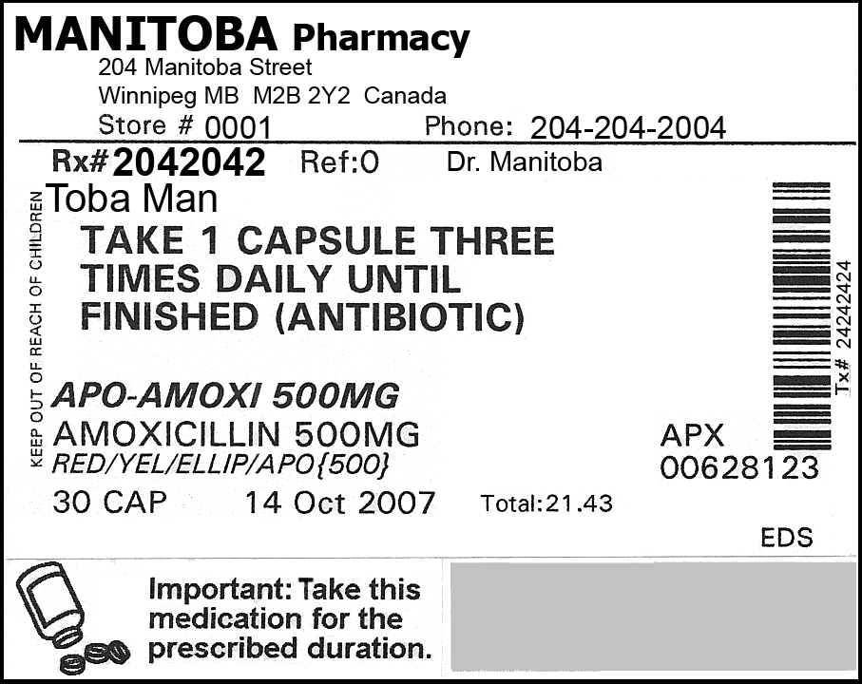

Continued
RM 1–SU: How to Read a Prescription Drug Label (Continued)
Using the sample label provided, answer the following questions to determine what important information must be included on a prescription drug label.
- What is the name of the pharmacy?
- What is the address of the pharmacy?
- What is the store number of the pharmacy?
- What is the phone number of the pharmacy?
- What is the prescription number?
- What is the physician’s name?
- What is the date that the prescription was filled?
- What is the name of the person for whom the drug is prescribed?
(Prescription drugs should be used only by the person for whom the drugs were prescribed.)
- What is the brand name of this drug?
(Various manufacturers or companies may make the same generic drug but will call it by their own brand or trade name.)
- What is the name of the medication or the main ingredient?
- What is the strength of the medication?
- What do the letters APX mean?
- What does the number listed below the company code represent?
- How much is in the package?
- What are the directions or instructions for taking the medication?
- Are there any cautions or warnings on the label?
- Do prescription drug labels often include any additional information that is not on this one?

Continued
RM 1–SU: How to Read a Prescription Drug Label (Continued)
(Answer Key)
- What is the name of the pharmacy? | Manitoba Pharmacy
- What is the address of the pharmacy? | 204 Manitoba Street, Winnipeg MB M2B 2Y2 Canada
- What is the store number of the pharmacy? | Store: #0001
- What is the phone number of the pharmacy? | Phone: 204-204-2004
- What is the prescription number? | Rx: #2042042
- What is the physician’s name? | Dr. Manitoba
- What is the date that the prescription was filled? | October 14, 2007
- What is the name of the person for whom the drug is prescribed?  (Prescription drugs should be used only by the person for whom the drugs were prescribed.) | Toba Man
- What is the brand name of this drug?  (Various manufacturers or companies may make the same generic drug but will call it by their own brand or trade name.) | APO–Amoxi
- What is the name of the medication or the main ingredient? | Amoxicillin is the generic name for the drug.
- What is the strength of the medication? | 500 mg
- What do the letters APX mean? | The letters indicate the manufacturer’s/company’s code.
- What does the number listed below the company code represent? | This number indicates the drug identification number (DIN).
- How much is in the package? | 30 cap (capsules)
- What are the directions or instructions for taking the medication? | Take 1 capsule three times daily until finished (antibiotic).
- Are there any cautions or warnings on the label? | Important: Take this medication for the prescribed duration.  Keep out of reach of children.
- Do prescription drug labels often include any additional information that is not on this one? | Expiry date, refill information, and additional information, on stickers, such as Take with food.

RM 2–SU: You Be the Judge*
Objectives
Students will
  - describe the benefits and risks of OTC or prescription medications
  - demonstrate critical thinking skills
  - demonstrate advocacy skills for health education
Procedure
This is a critical-thinking and problem-solving learning activity that includes concepts related to consumerism and drug education. It also enables students to advocate for a particular position related to OTC or prescription medications.
- Have students work in small groups (e.g., four).
- Assign each group member a task: facilitator, reader, recorder, and reporter.
- Use one of the identified websites to gather information regarding the benefits and risks associated with specific OTC or prescription medications. Other drugs can also be used (e.g., crack, crystal meth)
- Addictions Foundation of Manitoba. <www.afm.mb.ca/>.
- Drug Infonet. <www.druginfonet.com/>.
- Medline Plus. Drugs, Supplements, and Herbal Information. <www.nlm.nih.gov/medlineplus/druginformation.html>.
- RxList Inc.: The Internet Drug Index. <www.rxlist.com/script/main/hp.asp>.
- Create a new name for a drug or scramble the name of the drug in question.
Example: Claritin = trial inc.
Consider using an anagram generator, such as the following, to help create new names:
- Wordsmith.org. Internet Anagram Server. <www.wordsmith.org/anagram/>.
It is important to create a new name so that students do not come to the task with preconceived ideas about the benefits and/or risks of the substance selected.
Continued
__________
* Source: Ludwig, Michael. “Thinking Critically about Over-the-counter and Prescription Drugs.” American Journal of Health Education 36.2 (Mar./Apr.): 124–26. Adapted with permission. Permission is granted by the American Association for Health Education/American Alliance for Health, Physical Education, Recreation and Dance which owns and publishes the American Journal of Health Education.
RM 2–SU: You Be the Judge (Continued)
- Provide groups with questions such as those suggested below (or similar ones) and instruct students to answer them collaboratively.
- Do the benefits of this drug outweigh the risks?
- What else would you like to know about this drug to make an informed decision about it?
- If approved, what should the warning label for this drug emphasize?
- Are there other ways to achieve the benefits without using the substance?
- Have the groups share their insights with the class.
- Have students create a public service announcement regarding the substance under review. Give them the information provided on the following page.

You Be the Judge Scenario
You have been selected to serve on Health Canada’s Health Products and Food Branch (HPFB), the drug approval committee for Canada. The manufacturer seeks to market _________________ as a new OTC/prescription medication in three different ways:
  - in combination with pain relief medications (analgesics)
  - as a learning aid marketed under the trade name ___________________
  - as a social stimulant under the trade name Party On!
The manufacturer claims the drug is totally safe and would be a welcome addition to the OTC market. In a drug trial that included over 1 million doses, there were no deaths and very few adverse reactions. The drug will be marketed only to adults and is not recommended for use by children. You have received the following information from a drug manufacturer.
Example  Drug Name  SCAD CALL TEA ICILY ICY  (Acetylsalicylic acid – Aspirin) | 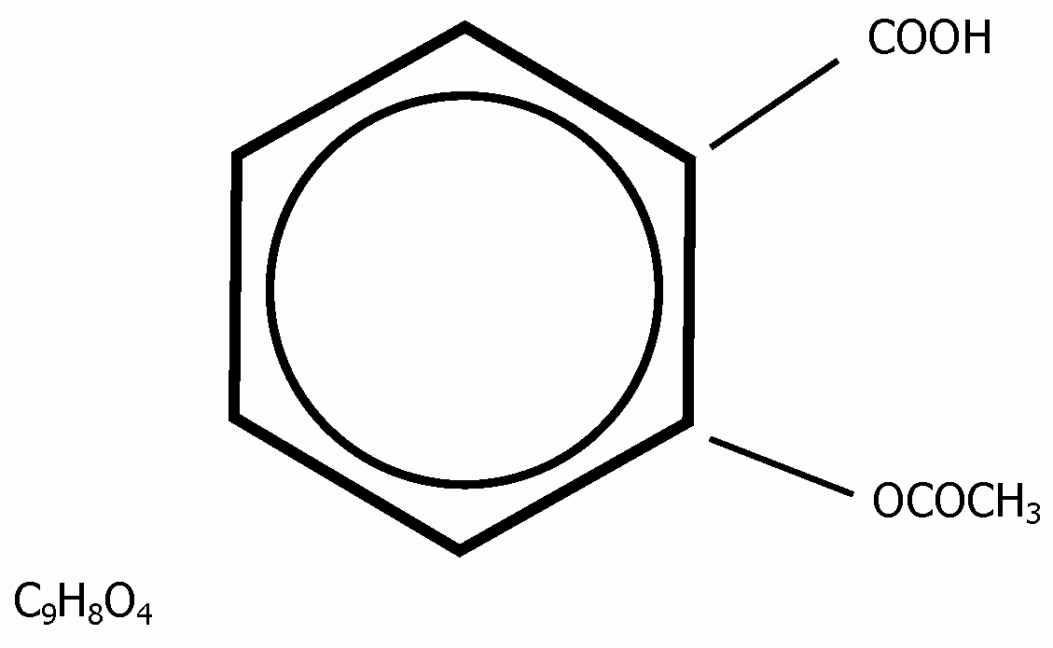

Continued

RM 2–SU: You Be the Judge (Continued)
Benefits
The drug is used to
  - relieve the symptoms of rheumatoid arthritis
  - reduce fever and relieve mild to moderate pain from headaches, menstrual cramps, arthritis, colds, toothaches, and muscle aches
  - prevent heart attacks in people who have had a heart attack in the past or who have angina (chest pain that occurs when the heart does not get enough oxygen)
  - reduce the risk of death in people who experience, or have recently experienced, a heart attack
  - prevent ischemic strokes (strokes that occur when a blood clot blocks the flow of blood to the brain) or mini-strokes (strokes that occur when the flow of blood to the brain is blocked for a short time) in people who have had this type of stroke or mini-stroke in the past
Risks
Minor side effects include
  - diarrhea
  - nausea, vomiting
  - reduced amount of urine passed
  - stomach gas, heartburn
Serious side effects include
  - black, tarry stools
  - confusion
  - difficulty breathing, wheezing
  - dizziness, drowsiness
  - ringing in the ears
  - seizures (convulsions)
  - skin rash
  - stomach pain
  - unusual bleeding or bruising, red or purple spots on the skin
  - vomiting blood, or what looks like coffee grounds
Levels ranging from 150 mg/kg to 300 mg/kg can be dangerous, depending on the person’s weight.

