Lesson 3: Understanding Your Personal Motivation for Physical Activity

Introduction
In this lesson students learn about intrinsic and extrinsic motivation and apply that understanding to their own physical activity motivation. The suggested learning experiences reinforce students’ understanding of the different types of motivation and provide them with opportunities to assess their own motivation related to physical activity and exercise.

________________________________________________________________________________

Specific Learning Outcomes
11.FM.2 Examine factors that have an impact on the development and implementation of and adherence to a personal physical activity plan.
Examples: motivation, barriers, changing lifestyle, values and attitudes, social benefits, finances, medical conditions, incentives, readiness for change
11.FM.3 Examine and evaluate factors that affect fitness and activity choices.
Examples: intrinsic and extrinsic motivation, personal interests, personal health, family history, environment, finances, culture, level of risk
________________________________________________________________________________


Key Understandings
  - Motivation can be classified as intrinsic or extrinsic motivation.
  - Physical activity participation is affected by different motivational factors.
  - Awareness of personal motivation helps to strengthen, regulate, or change a person’s behaviour.

________________________________________________________________________________

Essential Question

- What intrinsic and extrinsic factors motivate you to exercise and to be active?
________________________________________________________________________________

Background Information

Understanding Motivation for Physical Activity
Self-regulation (or self-control) is an important concept for understanding why individuals are motivated to exercise or to be physically active. Factors that influence self-control can be organized into two categories: intrinsic motivators and extrinsic motivators. Intrinsic motivation represents our internal drive toward behaviour, while extrinsic motivation includes factors such as rewards or punishment. Understanding what best motivates individuals requires awareness of both the intrinsic and extrinsic factors that regulate behaviour. Both intrinsic and extrinsic regulators of motivation are important to consider when attempting to achieve or maintain an active healthy lifestyle.
Intrinsic Motivation
Internal motivators produce a long-lasting commitment to exercise. Making exercise or physical activity more internally motivating might be a practical way of enhancing persistence to exercise. There are many intrinsic motivators to exercise, such as improved health, enhanced personal skill and ability, increased energy, and decreased stress.
People who successfully maintain a physical activity plan learn to shift their focus from long-term external outcomes, such as losing weight, to more positive internal experiences that occur in the short term, such as feeling good or performing better. Intrinsically motivated exercisers, by being physically active, have discovered things that hold true value for them. While some individuals may be exercising because they enjoy the actual movement, others may find that each exercise session holds a personal challenge for them. Whatever the reasoning behind the motivation to exercise, it must come from within a person for true meaning to be attached to it.
People who are intrinsically motivated do physical activity for its own sake and because they want to. They like the positive feelings of success and enjoyment that come from doing it well.
Extrinsic Motivation
Many people begin an exercise or physical activity plan because they are motivated by extrinsic factors, such as a desire to lose weight or to get in better shape. Unfortunately, body-related motives are not usually sufficient to sustain regular exercise programs, and, therefore, should not be made the most important reasons for engaging in exercise.
Examples of extrinsically motivated exercisers could be those who are inspired to begin an exercise program by the promise that it will help them lose weight. Those focusing on the goal of losing weight will likely be excited and motivated by the early results. They may experience significant weight loss early in the exercise program, largely due to water loss. With continued exercise, however, they will not continue to see the same degree of weight loss as their bodies become accustomed to the new activity. Individuals will often become unmotivated and drop out of an exercise program because they are no longer seeing the reward (weight loss) for their effort.
________________________________________________________________________________


Suggestion for Instruction / Assessment
Types of Motivation: Mini-Biographies
Have students read the mini-biographies of fictitious individuals in RM 3–FM. Then ask students to decide which type of motivation is regulating each person’s behaviour and explain their decision.

Refer to RM 3–FM: Mini-Biographies.
________________________________________________________________________________

Suggestion for Instruction / Assessment
Motivation Questionnaires
To help students find out what motivates them to participate in physical activity, have them complete the questionnaires provided in RM 4–FM. After students have completed the questionnaires, have a class discussion to examine possible strategies that could be used to move a person from extrinsic motivation to intrinsic motivation.
Refer to RM 4–FM: Motivation for Physical Activity and Exercise/Working Out—Questionnaires (available in Word and Excel formats).
RM 3–FM: Mini-Biographies*
Read the following fictitious mini-biographies. Each mini-biography illustrates a different form of motivation (i.e., intrinsic or extrinsic) for behaviour in an exercise context. Identify the motivation shown by each individual and give reasons for your choice.
Beth
Beth is a high school student. She has not taken any regular exercise since Grade 10 and has unhappy memories of cold, wet, and windy days on the school playing field. She feels that exercising would have little effect on her fitness and health, and so sees no point in taking it up now. Beth says: “I think I am pretty fit for my age, anyway. And I’ve never had any serious health problems. I don’t smoke or drink and I eat well. I think those things are far more important than exercise as far as health is concerned. In any case, you hear all the time about these fitness fanatics who are always in the gym or jogging or something and then they drop down dead in their thirties from a heart attack. I think exercising is likely to do you more harm than good.”
_________________________________________________________________________________
_________________________________________________________________________________
_________________________________________________________________________________
_________________________________________________________________________________
_________________________________________________________________________________
_________________________________________________________________________________
_________________________________________________________________________________
_________________________________________________________________________________
_________________________________________________________________________________
_________________________________________________________________________________

Continued

__________
* Source: Markland, David. “The Behavioural Regulation in Exercise Questionnaire—The Theory.” Exercise Motivation Measurement. 2007. <www.bangor.ac.uk/~pes004/exercise_motivation/breq/theory.htm>. Adapted with permission.
RM 3–FM: Mini-Biographies (Continued)
Paul
Paul is a recent high school graduate who has just reluctantly signed up for a workout program at his local gym. He passed his basic paramedic training, but two weeks ago had to take a fitness test before he could proceed to the next stage. Unfortunately, he failed the test. He does not see himself as a sporty type and has never done much exercise except when he had to in his school days. After the fitness test, the station commander called him into his office and told him in no uncertain terms that if he fails to pass the test within three months he will be out. Paul is not too happy about it: “I really don’t see why you have to be all that fit to be a paramedic. Alright, the job can be physically demanding at times, lugging patients up and down stairs and things, but I think I am well capable of handling it as I am. I mean, it’s not as if I’m training for the Olympics, is it? Still, I have no choice really but to do as I am told.”
_________________________________________________________________________________
_________________________________________________________________________________
_________________________________________________________________________________
_________________________________________________________________________________
_________________________________________________________________________________
_________________________________________________________________________________
_________________________________________________________________________________
_________________________________________________________________________________
_________________________________________________________________________________
_________________________________________________________________________________

Continued
RM 3–FM: Mini-Biographies (Continued)
Hans
Hans is a civil engineer in his forties. He works out at a local gym a couple of times a week and is trying, fairly successfully, to go jogging regularly. He has two young children. Hans has a family history of heart disease and this has been weighing heavily on his mind in recent years. Although he was quite physically active in his youth, as an adult he did little exercise for many years until the children came along. He gave up smoking at around the same time. Hans says: “My father, uncle, and grandfather all died of heart disease in their early sixties. I can’t afford to let it happen to me, what with a wife and two young kids to worry about. So I exercise as much as I reasonably can. I can’t say I particularly enjoy it, and I usually have to push myself to go. But if I feel like skipping a session, I just think about the kids and what would happen if I had a heart attack. That makes me feel really bad if don’t go, like I’m guilty of letting them down.”
_________________________________________________________________________________
_________________________________________________________________________________
_________________________________________________________________________________
_________________________________________________________________________________
_________________________________________________________________________________
_________________________________________________________________________________
_________________________________________________________________________________
_________________________________________________________________________________
_________________________________________________________________________________
_________________________________________________________________________________

Continued
RM 3–FM: Mini-Biographies (Continued)
David
David had a hard time socially as a child and as an adolescent. He was timid, small, and skinny and was frequently bullied. Although he liked sports in school, he never got the chance to participate outside of compulsory physical education lessons because the school coaches didn’t consider him to be capable enough. He always looked up to his older brother, who was a competitive weightlifter and wrestler. On graduating from high school a few years ago, David was taken to a gym a few times by his brother, and he also became interested in bodybuilding. He now trains hard and regularly and his social life has been transformed from his high school days. He has lots of friends, both male and female, and seems to others to be a very confident and self-assured young man. David says: “I hated it as a youngster, being smaller than everyone and never being taken seriously. Now I’m strong and, well, I think I look good and I’m proud of that. It’s important to me to look fit and strong and have a good physique. People give me respect and sort of look up to me now like they never did before. When I was a kid it was like I wanted to be someone else all the time. You know, to be like one of the bigger boys who was good at sports and popular and all that. Now it’s other people who look at me and say to themselves, ‘Hey, look at him, I wish I could look like that.’ I would never have come to feel so good about myself if it weren’t for the bodybuilding.”
_________________________________________________________________________________
_________________________________________________________________________________
_________________________________________________________________________________
_________________________________________________________________________________
_________________________________________________________________________________
_________________________________________________________________________________
_________________________________________________________________________________
_________________________________________________________________________________
_________________________________________________________________________________
_________________________________________________________________________________

Continued
RM 3–FM: Mini-Biographies (Continued)
Darlene
Darlene is a Grade 12 student who also works part time after school and on weekends. Despite her busy work schedule, she finds time to exercise for half an hour on most days, either in the school’s fitness centre or at the local YMCA. Darlene feels it is absolutely vital for her to keep fit and sees this as an essential ingredient in the success of her future career: “For me, keeping fit is so important. It’s tough, you know, making time to get to the gym every day. But in my last year at school, with the long hours, I have to keep as sharp as I can, and exercising regularly helps me to do that. I really don’t think I would have gotten to where I am today without it.”
_________________________________________________________________________________
_________________________________________________________________________________
_________________________________________________________________________________
_________________________________________________________________________________
_________________________________________________________________________________
_________________________________________________________________________________
_________________________________________________________________________________
_________________________________________________________________________________
_________________________________________________________________________________
_________________________________________________________________________________

Continued
RM 3–FM: Mini-Biographies (Continued)
Sheila
Sheila was a teacher but retrained a few years ago as a fitness instructor. She runs classes every evening and on weekends and also trains in the gym most days. She is highly committed to exercise and sees it as the centre point of her lifestyle: “For years, working as a teacher, I used to exercise as much as I possibly could but never felt I was doing enough. So that’s why I gave up teaching and got into this new career. I know what you’re thinking, but it’s definitely not that I am addicted to exercise or obsessive about it or anything like that. It’s just that, well, it’s hard to explain, but being an exerciser, being a fit person, is a big part of who I am, if you see what I mean. If I had to stop tomorrow, it wouldn’t exactly be the end of the world but it would mean that I’d have to do some serious thinking about my life and I’d find it difficult to readjust. It sounds silly, but it’d be a bit like losing my name or something. I wouldn’t know who I was any more.”
_________________________________________________________________________________
_________________________________________________________________________________
_________________________________________________________________________________
_________________________________________________________________________________
_________________________________________________________________________________
_________________________________________________________________________________
_________________________________________________________________________________
_________________________________________________________________________________
_________________________________________________________________________________
_________________________________________________________________________________

Continued
RM 3–FM: Mini-Biographies (Continued)
Lenin
Lenin is a construction worker. He loves physical activity of all sorts. He usually plays basketball or racquetball once a week, runs often (he takes part in his city’s annual 10 km fun run every year). “I’ve always been into sport and exercise,” he says. “It’s not as if I’m really all that good at it. I mean, I never had any illusions about playing professionally or anything like that. It’s just great to go out and kick a ball around or run in the park or whatever, have a laugh with your friends, and just forget about work and everything for a bit. I love it.” When asked if he thinks exercising is good for your health, he says: “Well, yeah, I suppose it must be. But that’s not what it’s all about for me, to be honest. I don’t worry too much about the future and all that, you know. I just like having a good time. I mean, if I started thinking like, ‘Oh, this’ll stop me from getting a heart attack,’ or whatever, I think it would end up being just like work. I’d hate to get all obsessed about it like some people. It wouldn’t be any fun then, would it?”
_________________________________________________________________________________
_________________________________________________________________________________
_________________________________________________________________________________
_________________________________________________________________________________
_________________________________________________________________________________
_________________________________________________________________________________
_________________________________________________________________________________
_________________________________________________________________________________
_________________________________________________________________________________
_________________________________________________________________________________

RM 3–FM: Mini-Biographies*
(Answer Key)
Regulatory Behaviours Reflected in the Mini-Biographies
Clearly, the people featured in the mini-biographies all have very different feelings and beliefs about exercise. Apart from Beth, they are all engaging in exercise but the motivational forces driving their behaviour differ markedly. In other words, their exercise behaviour (or lack of it) is regulated in quite diverse ways.
Beth lacks intrinsic motivation to change. Beth is said to be amotivated, a completely non-self-determined form of regulation. This is a state of lacking any intention to engage in a behaviour. It results from not valuing the activity, not feeling competent to engage in it, and/or not feeling that it will produce any desired outcomes. Beth’s school history probably left her feeling incompetent with regard to exercise. She does not believe that she would benefit from exercising and, in fact, she thinks that it might actually be harmful to her health. Consequently, it is not surprising that she does not value physical activity and chooses not to exercise at all.
Paul is extrinsically motivated. Paul has started to exercise, but it is very obvious that, like Beth, he does not value it as a worthwhile activity. His exercise behaviour can be described as externally regulated and is also not self-determined. He is exercising simply because he has been told by someone in authority that he has to, even though he thinks that it is not necessary. When regulated in this way, people may be motivated to comply with the external pressure to act but they do so unwillingly, even resentfully, and are unlikely to continue with the activity if the external pressures are relaxed.
Hans has extrinsic motivation and some intrinsic motivation. Hans is not exercising because of externally imposed pressures but because he is putting the pressure on himself. Thus, his behavioural regulation is somewhat internalized and can be said to be introjected. He acts because of his anxieties about heart disease and an anticipated sense of guilt that if he does become ill he will be letting down his young family. Thus, although Hans is internally driven, his behaviour is only somewhat self-determined.
David has strong intrinsic motivation. David’s story demonstrates how introjection can also manifest itself as a need to engage in an activity in order to demonstrate one’s ability or worth and maintain one’s sense of self-esteem. David believes that bodybuilding has changed his life and given him the popularity with his peers that he always wanted, but only because it has made him look good. So, although he now has a strong sense of self-worth, it is highly dependent on his bodybuilding activities. If he were unable to continue with this activity for some reason, it seems likely that his self-esteem would soon begin to suffer.
Continued
__________
* Source: Markland, David. “The Behavioural Regulation in Exercise Questionnaire—The Theory.” Exercise Motivation Measurement. 2007. <www.bangor.ac.uk/~pes004/exercise_motivation/breq/theory.htm>. Adapted with permission.
RM 3–FM: Mini-Biographies: Answer Key (Continued)
Darlene has strong intrinsic motivation. Darlene’s exercise behaviour is less controlled and shows much greater self-determination. Her behavioural regulation is identified. Identification involves a conscious acceptance of the behaviour as being important in order to achieve personally valued outcomes. The importance of the outcomes provides a strong incentive that overrides any difficulties or obstacles to the behaviour. Thus, Darlene manages to find time to exercise regularly even though she finds it difficult to fit it into her busy school and work life.
Sheila has strong intrinsic motivation. Sheila is obviously a very committed exerciser—so much so that she changed careers in order to be able to exercise more. Her regulation can be described as integrated. Integration involves the internalization of identified regulation so that engaging in the behaviour matches one’s sense of self and who one is. Integration is similar to intrinsic regulation in that the behaviour is engaged in willingly, with no sense of coercion, and is therefore fully self-determined. However, it differs from intrinsic regulation because the behaviour is still engaged in for separable outcomes rather than for the enjoyment inherent in the activity itself. Note the subtle difference between Sheila’s feelings about why she exercises and David’s feelings about his exercising. Although exercising is so important to Sheila’s sense of who she is, her self-esteem is not on the line in the way that it is for David.
Lenin has strong intrinsic motivation. Lenin’s motivation for exercise is purely intrinsic and fully self-determined. Although he recognizes the health benefits of exercise, he is not concerned about such extrinsic outcomes of exercising; he just loves doing it as a social and aesthetic experience. Notice also that his competence in physical activities is not a big issue for him. The immediate rewards of taking part in exercise are the only important factors, and if exercising were to become a chore or like work, as he puts it, there would no longer be any point in doing it.

RM 4–FM: Motivation for Physical Activity and Exercise/
Working Out—Questionnaires*
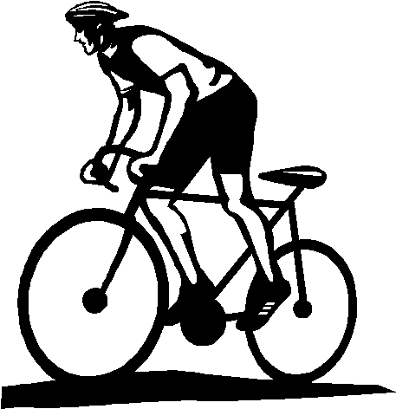
Motivation for Physical Activity*
People are active regularly for a variety of reasons. Using the rating scale provided below, please
indicate how true each of the following reasons is for why you are, or would like to be, active regularly.
Rating Scale 1 2 3 4 5 6 7
not at all true somewhat true very true

 |  |  | Example
I try, or would like to try, to be physically active regularly | Rating |  | Extrinsically Motivated | Intrinsically Motivated
1. because I would feel bad about myself if I did not |  |  | 2 | 6
2. because others would be angry at me if I did not |  |  | 6 | 2
3. because I enjoy physical activities |  |  | 3 | 7
4. because I would feel like a failure if I did not |  |  | 6 | 2
5. because I feel as if it’s the best way to help myself |  |  | 3 | 5
6. because people would think I’m a weak person if I did not |  |  | 7 | 1
7. because I feel as if I have no choice about being active; others make me do it |  |  | 6 | 1
8. because it is a challenge to accomplish my goal |  |  | 2 | 6
9. because I believe physical activity helps me feel better |  |  | 3 | 6
10. because it’s fun |  |  | 3 | 6
11. because I worry that I would get into trouble with others if I did not |  |  | 6 | 2
12. because it feels important to me personally to accomplish this goal |  |  | 3 | 5
13. because I feel guilty if I am not regularly active |  |  | 5 | 5
14. because I want others to acknowledge that I am doing what I have been told I should do |  |  | 6 | 2
15. because it is interesting to see my own improvement |  |  | 3 | 6
16. because feeling healthier is an important value for me |  |  | 3 | 7
External Regulation: Questions 2, 7, 11, 14 |  |  | 6.0 | 1.8
Introjected Regulation: Questions 1, 4, 6, 13 |  |  | 5.0 | 3.5
Identified Regulation: Questions 5, 9, 12, 16 |  |  | 3.0 | 5.8
Intrinsic Motivation: Questions 3, 8, 10, 15 |  |  | 2.8 | 6.3
Relative Autonomy Index |  |  | -8.5 | 11.3
Autonomy index indicates the relative impact of intrinsic and extrinsic factors in your motivation to be active.
- Negative numbers reflect that you are extrinsically motivated for change; that is, external factors are important in regulating your behaviour.
- Positive numbers reflect that intrinsic motivation is primarily involved in your behaviour.
Continued
__________
* Source: Deci, Edward L., and Richard M. Ryan. “Exercise Self-Regulation Questionnaires.” Self-Determination Theory: An Approach to Human Motivation and Personality—The Self-Regulation Questionnaires. 2004. <www.psych.rochester.edu/SDT/measures/selfreg_exer.html>. Adapted with permission.

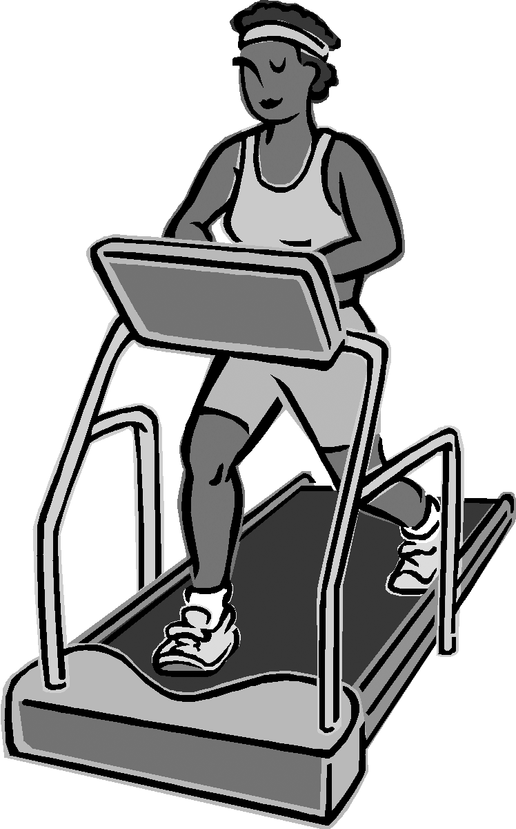
RM 4–FM: Motivation for Physical Activity and Exercise/
Working Out—Questionnaires* (Continued)
Motivation for Exercise/Working Out*
People exercise/work out for a variety of reasons. Using the rating scale provided below, please
indicate how true each of the following reasons is for why you work out or would like to work out.
Rating Scale 1 2 3 4 5 6 7
not at all true somewhat true very true

 |  |  | Example
I exercise/work out (or would like to work out) | Rating |  | Extrinsically Motivated | Intrinsically Motivated
1. because I simply enjoy working out |  |  | 2 | 7
2. because working out is important and beneficial for my health and lifestyle |  |  | 2 | 6
3. because I would feel bad about myself if I didn’t do it |  |  | 4 | 4
4. because it is fun and interesting |  |  | 2 | 6
5. because others like me better when I am in shape |  |  | 5 | 2
6. because I’d be afraid of falling too far out of shape if I didn’t |  |  | 2 | 3
7. because it helps my image |  |  | 5 | 2
8. because it is personally important to me to work out |  |  | 2 | 6
9. because I feel pressured to work out |  |  | 5 | 2
10. because I have a strong value for being active and healthy |  |  | 2 | 7
11. because I find pleasure in discovering and mastering new training techniques |  |  | 2 | 6
12. because I want others to see me as physically fit |  |  | 6 | 3
External Regulation: 5, 7, 12 |  |  | 5.3 | 2.3
Introjected Regulation: 3, 6, 9 |  |  | 3.7 | 3.0
Identified Regulation: 2, 8, 10 |  |  | 2.0 | 6.3
Intrinsic Motivation: 1, 4, 11 |  |  | 2.0 | 6.3
Relative Autonomy Index |  |  | -8.3 | 11.3
Autonomy index indicates the relative impact of intrinsic and extrinsic factors in your motivation to be active.
- Negative numbers reflect that you are extrinsically motivated for change; that is, external factors are important in regulating your behaviour.
- Positive numbers reflect that intrinsic motivation is primarily involved in your behaviour.

__________
* Source: Deci, Edward L., and Richard M. Ryan. “Exercise Self-Regulation Questionnaires.” Self-Determination Theory: An Approach to Human Motivation and Personality—The Self-Regulation Questionnaires. 2004. <www.psych.rochester.edu/SDT/measures/selfreg_exer.html>. Adapted with permission.

