Lesson 3: Implementing the Safety and Physical Activity Plan

Introduction
In this lesson students begin the process of identifying inherent risks in the physical activities that they have selected for their physical activity practicum. In addition, students demonstrate the ability to access appropriate information to make informed decisions about managing risk and safety related to participation in physical activity. They also begin to implement their physical activity plan and record their physical activity participation.

________________________________________________________________________________

Specific Learning Outcomes
11.PA.2 Demonstrate an understanding of the risk-management process and responsibilities related to physical activity participation.
11.PA.3 Demonstrate the ability to access and use information for making informed decisions about safety and risk management related to physical activity participation.
Includes: level of instruction, level of supervision, facilities/environment, equipment, clothing/footwear, and personal and other considerations
11.PA.4 Apply movement skills and concepts in selected physical activities that meet the goals of a personal physical activity plan.
11.PA.5 Participate in physical activities at a moderate to vigorous intensity level.
11.PA.6 Record and report the frequency, intensity, time, and type of the physical activities, as indicated in the personal physical activity plan, and reflect on physical activity participation.
________________________________________________________________________________

Background Information
Personal Physical Activity Plan
Now that students have identified the activities in which they will participate for their physical activity practicum, they need to start putting together the components in a manner that they understand and can adhere to.
________________________________________________________________________________

Suggestion for Instruction / Assessment

Putting Together the Physical Activity Plan
Have students begin putting together their personal physical activity plan for approval and sign-off, using a physical activity planner such as the one provided in RM 4–PA. This tool can be used to identify to parents the physical activities that students have selected as part of their physical activity plan.

Refer to RM 4–PA: Personal Physical Activity Plan.
________________________________________________________________________________

Background Information
Safety and Risk Management
The risk-management process is an essential part of a personal physical activity plan. Risk management is not about eliminating risk or injury. Rather, the process of risk management involves identifying the risk inherent in any physical activity and then identifying strategies to deal with the identified risk. By doing this, the risk is minimized and, if an injury does occur, the injury is minimized because of the proactive risk management.
________________________________________________________________________________

Suggestion for Instruction / Assessment
Planning for Risk Management
Note to Teacher
Physical Activity Safety Checklists
Teachers must provide students either with copies of the individual Physical Activity Safety Checklists or with access to OUT-of-Class Safety Handbook: A Resource for Grades 9 to 12 Physical Education/Health Education (Manitoba Education, Citizenship and Youth) in which the checklists appear. Physical Activity Safety Checklists must be included with the student’s physical activity plan that goes home for parent approval.
Addition of Physical Activities
The process of adding new activities to a physical activity plan once a plan has been signed by the teacher and parent will be unique to each school/division. The process of including activities not identified in the Physical Activity Inventory or on the school/division-approved activities list will also be unique to each school/division. Teachers are encouraged to be familiar with these processes and outline them for students and parents as necessary.
Have students complete at least two Safety and Risk-Management Planner sheets (provided in RM 5–PA) for physical activities that they have chosen for their physical activity plan that have the highest risk factor rating.
Refer to RM 5–PA: Safety and Risk-Management Planner.
Once students have completed the Safety and Risk-Management Planner sheets, they must compare their physical activity plan to the appropriate Physical Activity Safety Checklists (available from the teacher) to check for accuracy.

New physical activities may be added to a physical activity plan once the original plan has been signed by the teacher and approved by the parent. Activities may also be included that are not listed on the Physical Activity Inventory (see RM 3–PA).
References

For additional information, refer to the following resources:
Manitoba Education, Citizenship and Youth. Guidelines for Fitness Assessment in Manitoba Schools: A Resource for Physical Education/Health Education. Winnipeg, MB: Manitoba Education, Citizenship and Youth, 2004.
---. Implementation of Grades 11 and 12 Physical Education/Health Education: A Policy Document. Winnipeg, MB: Manitoba Education, Citizenship and Youth, 2007.
---. OUT-of-Class Safety Handbook: A Resource for Grades 9 to 12 Physical Education/Health Education. Winnipeg, MB: Manitoba Education, Citizenship and Youth, 2008.
These resources are available online at <www.edu.gov.mb.ca/k12/cur/physhlth/curriculum.html>.

________________________________________________________________________________

Background Information
Finalizing the Physical Activity Plan
The following steps outline a process to be considered when finalizing and obtaining approval for a student’s physical activity plan:
- The physical activity plan, developed in accordance with the specified criteria, should include
- selected physical activities that contribute to cardiorespiratory endurance plus one or more of the other health-related fitness components (muscular strength, muscular endurance, and flexibility)
- a risk-management plan
- Physical Activity Safety Checklists for the selected physical activities
- Once the plan is developed, the teacher signs a letter addressed to the parents explaining the information they are receiving.
Refer to RM 6–PA: Sample Cover Letter for Physical Activity Practicum.
- The Parent Declaration and Consent Form and the Student Declaration Form must be completed, as applicable, before a student begins implementing the OUT-of-class physical activity plan. As these forms will be specific to each school/division, teachers need to be aware of their content and location. These forms need to be signed by the parent for students under 18. There is also a Student Declaration and Consent Form for students 18 and over.
- The personal physical activity plan, the Parent Declaration and Consent Form, and the Student Declaration Form are to be returned to the school. The teacher records that the appropriate forms have been signed and collected and keeps these until the end of the course.
Implementing the Physical Activity Plan
Note to Teacher
Teachers are encouraged to confer regularly with individual students to monitor and discuss their progress related to their physical activity plan and other elements of the course.
Now it is time for students to begin implementing their physical activity plan and enjoying the physical activities they have chosen. Students also need to have a tool to record their physical activity participation.
Recording Physical Activity Participation
Students need to record their participation in physical activities and submit the record to the teacher. The students’ record will include
  - details of the physical activity participation on a schedule decided upon by the teacher
  - an assessment of the amount of time spent in the development of health-related fitness components
  - daily reflections of satisfaction with certain health habits. (Reflections may provide possible explanations for the level of satisfaction or feelings about the day in general.)
The following tools are provided to assist students with recording their participation.
Refer to RM 7–PA: Physical Activity Log (available in Word and Excel formats).
The Excel version of the Physical Activity Log is a more comprehensive log than the Word version. It is available on the CD-ROM version of this document, as well as online at <www.edu.gov.mb.ca/k12/cur/physhlth/curriculum.html>.
Completing the Physical Activity Plan
At the conclusion of the course, parents will need to sign a form indicating that the information that the students have provided to the teacher is an accurate record of the students’ participation in the OUT-of-class physical activity practicum. Students who are 18 years of age or older will need to have their sign-off form signed by their parents or an authorized adult.
Refer to RM 8–PA: Sample Sign-off Form for Completion of OUT-of-Class Physical Activity Practicum (Form for Parent/Guardian).
Refer to RM 9–PA: Sample Sign-off Form for Completion of OUT-of-Class Physical Activity Practicum (Form for Authorized Adult).
________________________________________________________________________________
RM 4–PA: Personal Physical Activity Plan
Name ______________________________________ Date __________________ Class _____________
Physical Activity |  | Frequency of Activity | Estimated Time  (in Minutes) | Risk Factor Rating (RFR) | Safety Checklists Included
Examples: | Indoor Soccer | 3 practices + 1 game per week |  | 2 | ✓
 | Inline Skating | 5 days—to and from school |  | 2 | ✓
Student Comments:
Teacher Comments:

___________________________________ ________________________________
Teacher Signature Date
The teacher’s signature is an acknowledgement of the following:
- The student has met the criteria for formulating his or her personal physical activity plan.
- The student has demonstrated an understanding of how to manage risk and take appropriate steps to participate safely in physical activity.
- The student is aware of the safety guidelines information and associated responsibilities for discussion with and approval by his or her parent/guardian.

RM 5–PA: Safety and Risk-Management Planner
Name ______________________________________ Date __________________ Class ___________
Taking responsibility for safety is a very important part of the OUT-of-class component of the Grade 11 Active Healthy Lifestyles course. The following questions will assist you in managing the risks while participating in any physical activity:
  - Do you understand the safety rules related to the physical activity?
  - Is the activity suitable to your age, ability, and physical condition?
  - Is the activity suitable to any medical conditions or special health care needs that you might have?
  - Do you understand the correct form or technique of the exercises or skills needed to practise?
  - Do you understand the risks associated with the physical activity and ways to avoid the dangers?
  - Is the equipment you will be using suitable and in good condition?
  - Is the facility or playing area you will be using safe?
  - Will appropriate instruction and/or supervision be provided to you in light of the danger or risk associated with the physical activity?
  - Have you discussed your choice of physical activities with your parent and physical education/health education teacher?
I understand the risks associated with (name of physical activity) _________________________ , which has a risk factor rating (RFR) of _____ , and I intend to respect the following strategies to minimize some of the potential risks I can anticipate during my participation in this activity.
Risk Areas | Potential Risks Involved | Personal Strategies to Minimize Risks
Level of Instruction

Level of Supervision

Equipment

Facility/Environment
Clothing/Footwear

Personal and Other Considerations*
__________
* Special health care needs, skill level, experience, accessibility, and so on.
Continued
RM 5–PA: Safety and Risk-Management Planner (Continued)
Risk Factor Rating (RFR) Scale
RFR | Level of safety concerns; recommended instruction and supervision. | Examples
1 | There are few safety concerns for this physical activity; little or no qualified instruction or adult supervision required. | Walking  Stretching
2 | There are some safety concerns for this physical activity; qualified instruction is recommended, and little or no adult supervision is required. | Racquetball  Ice Skating
3 | There are several safety concerns for this physical activity; qualified instruction is required, and adult supervision is recommended. | Snowboarding  Field Hockey
4 | There is a high level of safety concerns for this physical activity; qualified instruction and adult supervision are required. | Swimming  Karate

Reference:
For more information on safety and risk management for physical activities, go to the following school/division website to access the OUT-of-Class Safety Handbook: A Resource for Grades 9 to 12 Physical Education/Health Education (Manitoba Education, Citizenship and Youth):
_____________________________________________________________________________________
(Insert school/division website address where this safety information may be found.)

If you do not have access to the Internet, ask your teacher for a print copy of the Physical Activity Safety Checklists for the selected physical activities.

RM 6–PA: Sample Cover Letter for Physical Activity Practicum
Date ___________________________
Dear Parent/Guardian:
The health of our students is a responsibility that our school and Physical Education/ Health Education Department take very seriously. Taking part in physical education/ health education and being physically active can have a positive impact on students’ health and well-being. To this end, our department’s goal is to empower your son/daughter to adopt an active healthy lifestyle by providing the tools he/she needs to succeed.
Grade 11 Active Healthy Lifestyles Course
The goal of this physical education/health education course is to have parents, students, and schools work together to help youth
  - take greater ownership of their physical fitness
  - promote the discovery of activities suited to their own individual interests
  - encourage active healthy lifestyles that persist into their futures
As part of this course, your son/daughter will be involved in learning activities in the following core areas:
  - fitness management
  - social impact of sport
  - mental-emotional health
  - substance use and abuse prevention
Your son/daughter will also be required to plan, implement, and record his/her participation in the OUT-of-class physical activity practicum for a minimum of 55 hours. The details are contained within the attached physical activity plan.
Based on the physical activities your son/daughter has chosen for the OUT-of-class component of this course, safety guidelines have been provided, as part of the attached plan, to inform you and your son/daughter of the safety concerns and/or standards to consider when selecting and participating in the physical activities. The intent is not to restrict your son’s/daughter’s physical activity participation, but rather to assist in the process of identifying inherent or potential risks and recommending strategies/safest practices to manage these risks and to minimize the possibility of injury during participation.
Continued
RM 6–PA: Sample Cover Letter for Physical Activity Practicum (Continued)
The suggested risk-management strategies are considered minimum standards for physical activity in an organized or formal setting. However, some of these strategies may not apply to all situations (e.g., home-based, recreational, or modified physical activities). Many variables will need to be taken into consideration when determining what level of instruction or supervision is appropriate for your son’s/daughter’s participation in selected physical activities, as well as determining appropriate safety practices related to the facilities/environment, the equipment, and the clothing/footwear used for the activities. Examples of personal and other variables include level of risk, medical/physical condition, skill level, experience, accessibility, intensity, and type of pursuit (e.g., competitive/recreational, individual/group).
Your involvement is important!
Your son’s/daughter’s success in the Grade 11 Active Healthy Lifestyles course will require coordinated and supportive communication between you and your son/daughter as well as with me, as the teacher of this course. The first step is to review the attached physical activity plan with your son/daughter. Then, once you approve of the specified intentions, please sign the attached Parent Declaration and Consent Form. Your son/daughter also needs to sign the Student Declaration Form. Once these forms have been signed, the plan and forms are to be returned to me promptly.
Throughout the duration of the course I will be meeting at predetermined times with your son/daughter. The nature of these individual meetings will be to check on the progress of your son’s/daughter’s OUT-of-class physical activity practicum as well as review his/her understanding of related topics discussed in class.
I encourage you to engage your son/daughter in conversation about his/her progress and to encourage him/her in pursuing personal physical activity goals and interests. If at any time you have questions/concerns, please feel free to contact me by telephone (___- _____) or by email at _________________________.

Actively yours,

_________________________________________
Teacher Signature
RM 7–PA: Physical Activity Log*
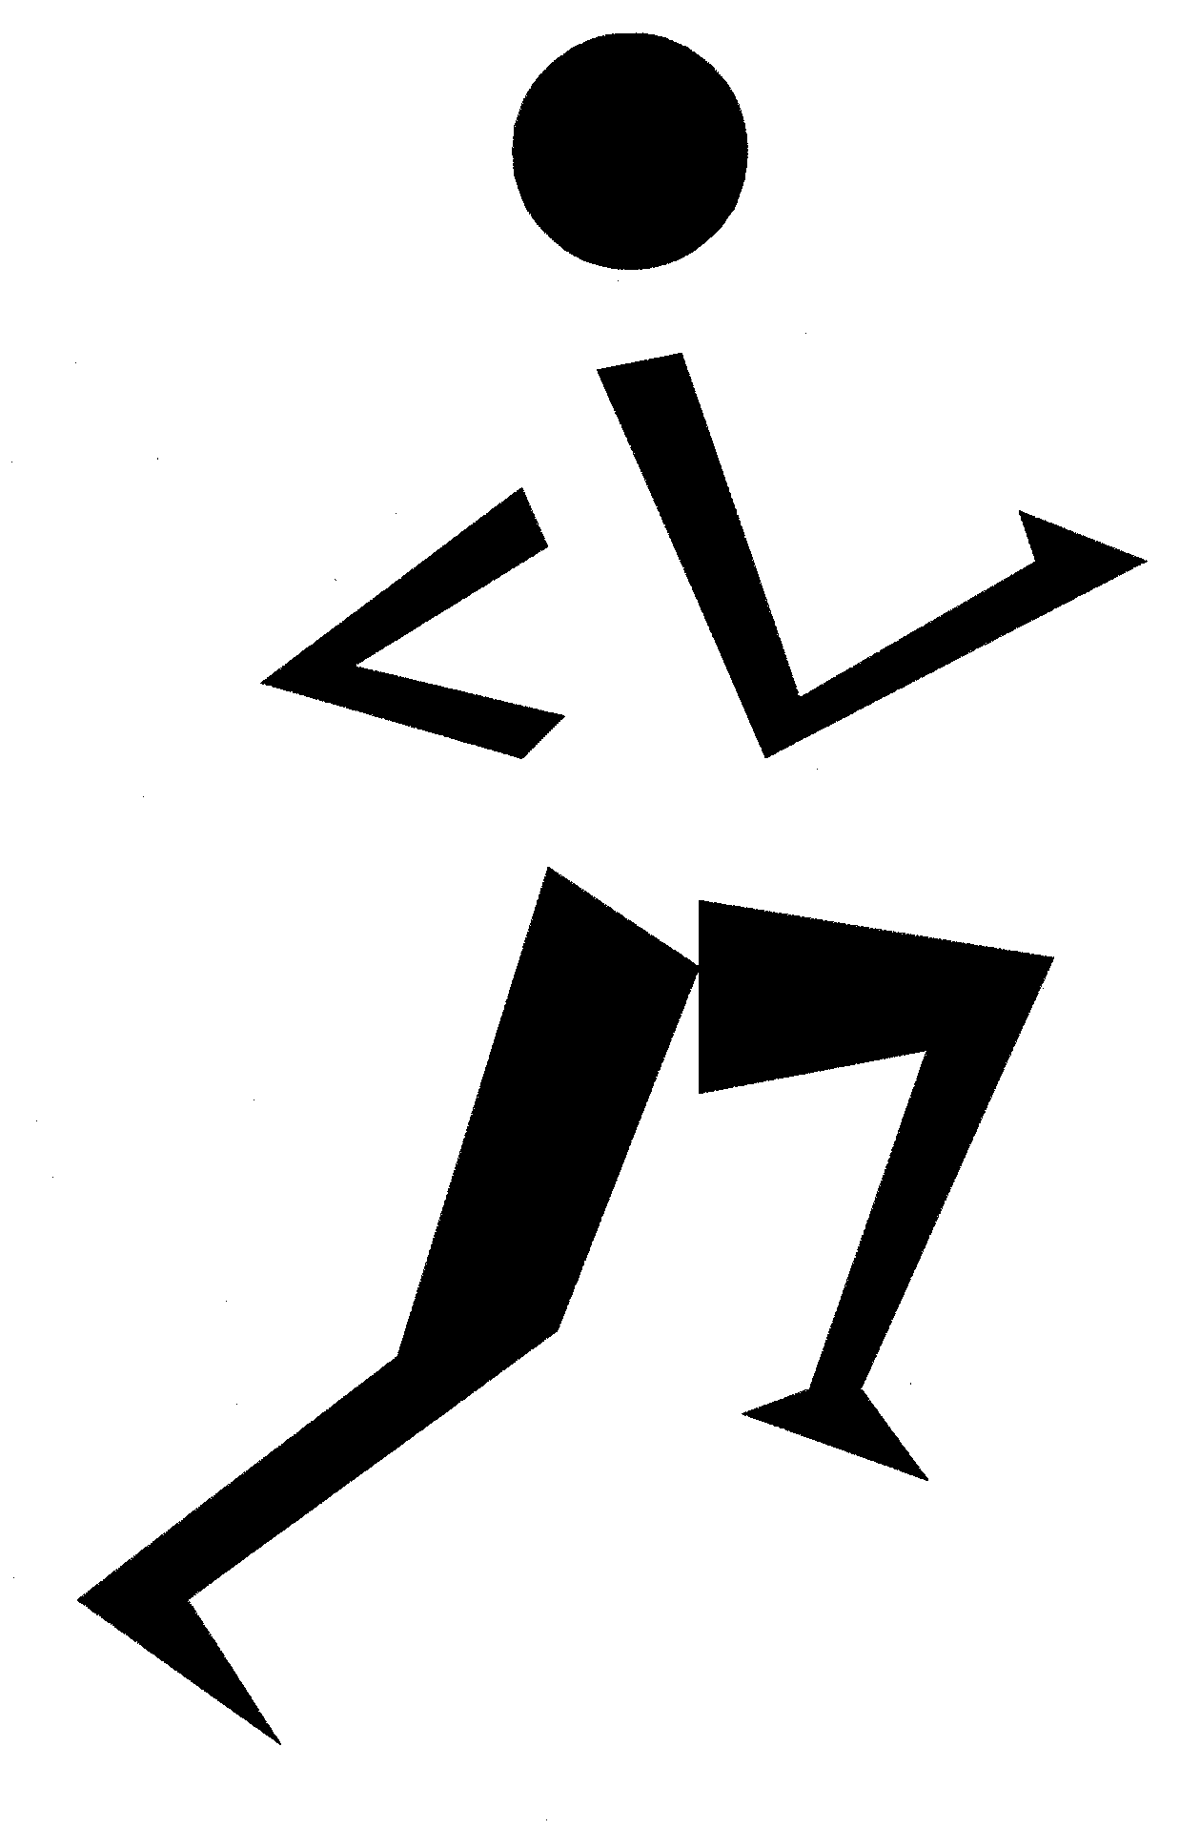
Name _____________________________ Class _________________________
Month _____________________________ Week of ______________________
 | Activity Description | Duration | Intensity  (Light, Moderate, Vigorous) | Personal Reflection
Example | - Walked to school  - Jogged after school  - Mowed the lawn | - 20 min.  - 30 min.  - 15 min. | - Light  - Vigorous  - Moderate | Felt great today. Had a good sleep. Ate too much at dinner. Feel a bit stressed about math test tomorrow.
Day 1
Day 2
Day 3
Day 4
Day 5
Day 6
Day 7
Totals
Consider ways to increase your physical activity:
  - Add activity. Find a new activity that you enjoy. Walk for 15 to 30 minutes before you sit down for your favourite TV show or as a break during your work day.
  - Trade active time for inactive time. Take a walk after dinner, ride an exercise bike or do curl-ups while watching TV, walk to return video rentals or to pick up small grocery items.
  - Do more of what you are already doing. Walk at a faster pace, walk for 30 minutes instead of 20, or walk five times a week instead of three times.
  - Work a little harder. Turn your walks into power walks or jogs.
__________
* Source: Dairy Council of California. “Physical Activity Journal.” Meals Matter: Eating for Health—Health Topics. 2005. <www.mealsmatter.org>. Adapted with permission of Dairy Council of California.
RM 8–PA: Sample Sign-off Form for Completion of
OUT-of-Class Physical Activity Practicum
(Form for Parent/Guardian)
Dear Parent/Guardian:
Please review this form and, upon agreement, provide your signature.
I _______________________________ parent/guardian of _____________________________
Name of Parent/Guardian Name of Son/Daughter
do hereby certify and acknowledge the following:
  - My son/daughter has participated in the physical activities as selected for his/her
OUT-of-class physical activity practicum.
  - My son/daughter has accurately recorded his/her participation in the selected physical activities for the OUT-of- class physical activity practicum.

_________________________________ _____________________________
Parent/Guardian Signature Date

Student Sign-off
I ________________________________
Name of Student
certify that this record is an accurate account of my physical activity participation in the
OUT-of-class physical activity practicum.

__________________________________ ______________________________
Student Signature Date

Date Received _____________________________________________________________________
RM 9–PA: Sample Sign-off Form for Completion of
OUT-of-Class Physical Activity Practicum
(Form for Authorized Adult)
Dear Authorized Adult:
Please review this form and, upon agreement, provide your signature.
I _______________________________ the authorized adult for __________________________
Name of Authorized Adult Name of Student

do hereby certify and acknowledge the following:
  - The above-named student has participated in the physical activities as selected for his/her OUT-of-class physical activity practicum.
  - The above-named student has accurately recorded his/her participation in the selected physical activities for the OUT-of-class physical activity practicum.

_________________________________ _____________________________
Authorized Adult Signature Date
Please indicate your relationship with this student (e.g., parent, aunt, uncle, coach, instructor):
_________________________________________________________________________________

Student Sign-off
I _________________________________
Name of Student
certify that this record is an accurate account of my physical activity participation in the
OUT-of-class physical activity practicum.

___________________________________ _____________________________
Student Signature Date

Date Received _____________________________________________________________________

