RM 7–PA: Physical Activity Log*
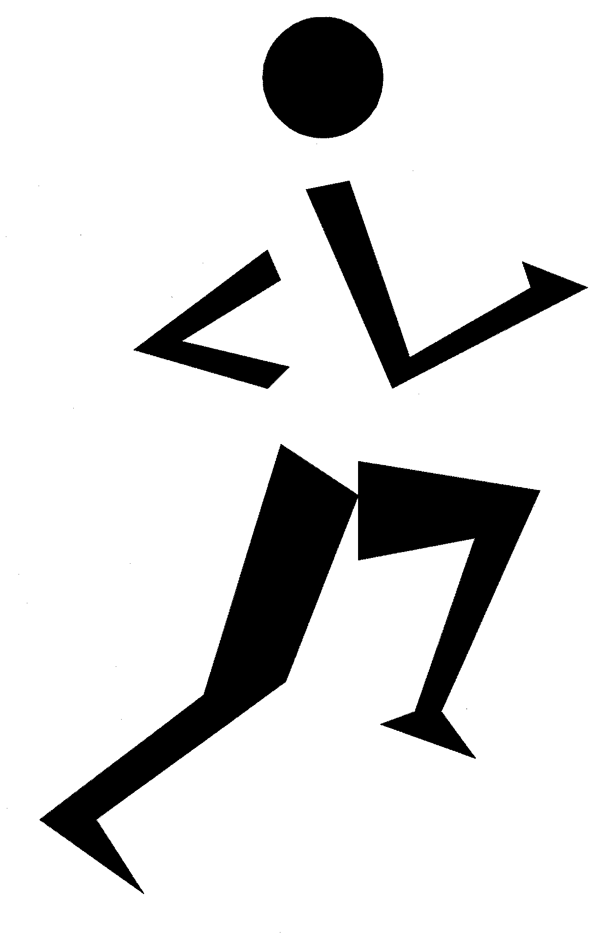
Name _____________________________ Class _________________________
Month _____________________________ Week of ______________________
 | Activity Description | Duration | Intensity  (Light, Moderate, Vigorous) | Personal Reflection
Example | - Walked to school  - Jogged after school  - Mowed the lawn | - 20 min.  - 30 min.  - 15 min. | - Light  - Vigorous  - Moderate | Felt great today. Had a good sleep. Ate too much at dinner. Feel a bit stressed about math test tomorrow.
Day 1
Day 2
Day 3
Day 4
Day 5
Day 6
Day 7
Totals
Consider ways to increase your physical activity:
  - Add activity. Find a new activity that you enjoy. Walk for 15 to 30 minutes before you sit down for your favourite TV show or as a break during your work day.
  - Trade active time for inactive time. Take a walk after dinner, ride an exercise bike or do curl-ups while watching TV, walk to return video rentals or to pick up small grocery items.
  - Do more of what you are already doing. Walk at a faster pace, walk for 30 minutes instead of 20, or walk five times a week instead of three times.
  - Work a little harder. Turn your walks into power walks or jogs.
__________
* Source: Dairy Council of California. “Physical Activity Journal.” Meals Matter: Eating for Health—Health Topics. 2005. <www.mealsmatter.org>. Adapted with permission of Dairy Council of California.

