RM 4–FM: Motivation for Physical Activity and Exercise/
Working Out—Questionnaires*
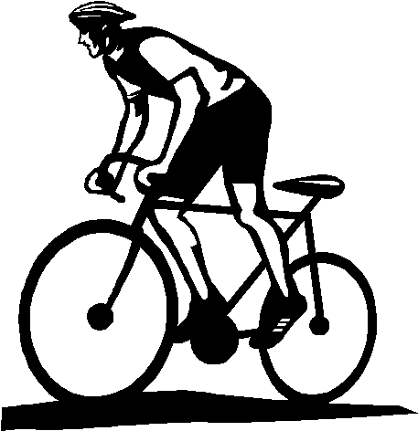
Motivation for Physical Activity*
People are active regularly for a variety of reasons. Using the rating scale provided below, please
indicate how true each of the following reasons is for why you are, or would like to be, active regularly.
Rating Scale 1 2 3 4 5 6 7
not at all true somewhat true very true

 |  |  | Example
I try, or would like to try, to be physically active regularly | Rating |  | Extrinsically Motivated | Intrinsically Motivated
1. because I would feel bad about myself if I did not |  |  | 2 | 6
2. because others would be angry at me if I did not |  |  | 6 | 2
3. because I enjoy physical activities |  |  | 3 | 7
4. because I would feel like a failure if I did not |  |  | 6 | 2
5. because I feel as if it’s the best way to help myself |  |  | 3 | 5
6. because people would think I’m a weak person if I did not |  |  | 7 | 1
7. because I feel as if I have no choice about being active; others make me do it |  |  | 6 | 1
8. because it is a challenge to accomplish my goal |  |  | 2 | 6
9. because I believe physical activity helps me feel better |  |  | 3 | 6
10. because it’s fun |  |  | 3 | 6
11. because I worry that I would get into trouble with others if I did not |  |  | 6 | 2
12. because it feels important to me personally to accomplish this goal |  |  | 3 | 5
13. because I feel guilty if I am not regularly active |  |  | 5 | 5
14. because I want others to acknowledge that I am doing what I have been told I should do |  |  | 6 | 2
15. because it is interesting to see my own improvement |  |  | 3 | 6
16. because feeling healthier is an important value for me |  |  | 3 | 7
External Regulation: Questions 2, 7, 11, 14 |  |  | 6.0 | 1.8
Introjected Regulation: Questions 1, 4, 6, 13 |  |  | 5.0 | 3.5
Identified Regulation: Questions 5, 9, 12, 16 |  |  | 3.0 | 5.8
Intrinsic Motivation: Questions 3, 8, 10, 15 |  |  | 2.8 | 6.3
Relative Autonomy Index |  |  | -8.5 | 11.3
Autonomy index indicates the relative impact of intrinsic and extrinsic factors in your motivation to be active.
- Negative numbers reflect that you are extrinsically motivated for change; that is, external factors are important in regulating your behaviour.
- Positive numbers reflect that intrinsic motivation is primarily involved in your behaviour.
Continued
__________
* Source: Deci, Edward L., and Richard M. Ryan. “Exercise Self-Regulation Questionnaires.” Self-Determination Theory: An Approach to Human Motivation and Personality—The Self-Regulation Questionnaires. 2004. <www.psych.rochester.edu/SDT/measures/selfreg_exer.html>. Adapted with permission.

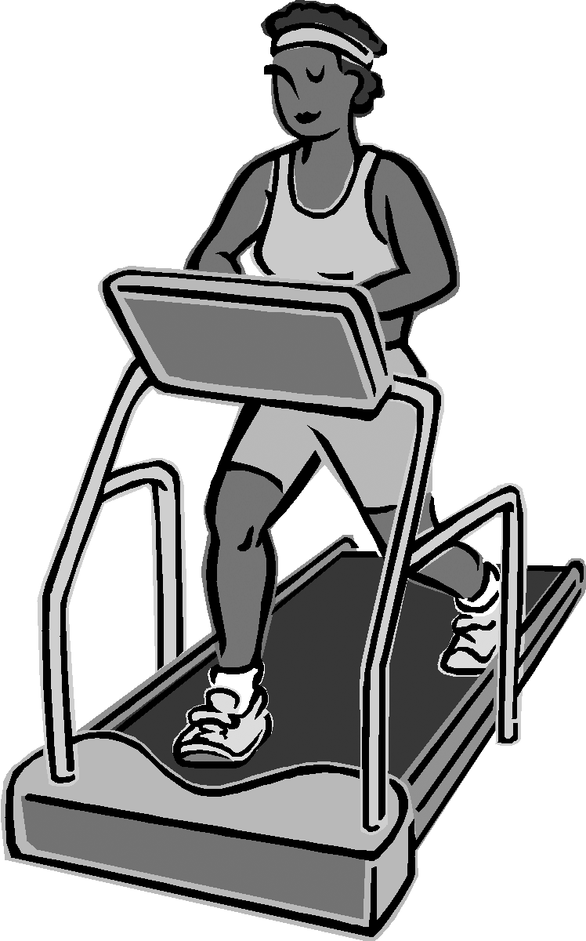
RM 4–FM: Motivation for Physical Activity and Exercise/
Working Out—Questionnaires* (Continued)
Motivation for Exercise/Working Out*
People exercise/work out for a variety of reasons. Using the rating scale provided below, please
indicate how true each of the following reasons is for why you work out or would like to work out.
Rating Scale 1 2 3 4 5 6 7
not at all true somewhat true very true

 |  |  | Example
I exercise/work out (or would like to work out) | Rating |  | Extrinsically Motivated | Intrinsically Motivated
1. because I simply enjoy working out |  |  | 2 | 7
2. because working out is important and beneficial for my health and lifestyle |  |  | 2 | 6
3. because I would feel bad about myself if I didn’t do it |  |  | 4 | 4
4. because it is fun and interesting |  |  | 2 | 6
5. because others like me better when I am in shape |  |  | 5 | 2
6. because I’d be afraid of falling too far out of shape if I didn’t |  |  | 2 | 3
7. because it helps my image |  |  | 5 | 2
8. because it is personally important to me to work out |  |  | 2 | 6
9. because I feel pressured to work out |  |  | 5 | 2
10. because I have a strong value for being active and healthy |  |  | 2 | 7
11. because I find pleasure in discovering and mastering new training techniques |  |  | 2 | 6
12. because I want others to see me as physically fit |  |  | 6 | 3
External Regulation: 5, 7, 12 |  |  | 5.3 | 2.3
Introjected Regulation: 3, 6, 9 |  |  | 3.7 | 3.0
Identified Regulation: 2, 8, 10 |  |  | 2.0 | 6.3
Intrinsic Motivation: 1, 4, 11 |  |  | 2.0 | 6.3
Relative Autonomy Index |  |  | -8.3 | 11.3
Autonomy index indicates the relative impact of intrinsic and extrinsic factors in your motivation to be active.
- Negative numbers reflect that you are extrinsically motivated for change; that is, external factors are important in regulating your behaviour.
- Positive numbers reflect that intrinsic motivation is primarily involved in your behaviour.

__________
* Source: Deci, Edward L., and Richard M. Ryan. “Exercise Self-Regulation Questionnaires.” Self-Determination Theory: An Approach to Human Motivation and Personality—The Self-Regulation Questionnaires. 2004. <www.psych.rochester.edu/SDT/measures/selfreg_exer.html>. Adapted with permission.

