RM 2–SU: You Be the Judge*
Objectives
Students will
  - describe the benefits and risks of OTC or prescription medications
  - demonstrate critical thinking skills
  - demonstrate advocacy skills for health education
Procedure
This is a critical-thinking and problem-solving learning activity that includes concepts related to consumerism and drug education. It also enables students to advocate for a particular position related to OTC or prescription medications.
- Have students work in small groups (e.g., four).
- Assign each group member a task: facilitator, reader, recorder, and reporter.
- Use one of the identified websites to gather information regarding the benefits and risks associated with specific OTC or prescription medications. Other drugs can also be used (e.g., crack, crystal meth)
- Addictions Foundation of Manitoba. <www.afm.mb.ca/>.
- Drug Infonet. <www.druginfonet.com/>.
- Medline Plus. Drugs, Supplements, and Herbal Information. <www.nlm.nih.gov/medlineplus/druginformation.html>.
- RxList Inc.: The Internet Drug Index. <www.rxlist.com/script/main/hp.asp>.
- Create a new name for a drug or scramble the name of the drug in question.
Example: Claritin = trial inc.
Consider using an anagram generator, such as the following, to help create new names:
- Wordsmith.org. Internet Anagram Server. <www.wordsmith.org/anagram/>.
It is important to create a new name so that students do not come to the task with preconceived ideas about the benefits and/or risks of the substance selected.
Continued
__________
* Source: Ludwig, Michael. “Thinking Critically about Over-the-counter and Prescription Drugs.” American Journal of Health Education 36.2 (Mar./Apr.): 124–26. Adapted with permission. Permission is granted by the American Association for Health Education/American Alliance for Health, Physical Education, Recreation and Dance which owns and publishes the American Journal of Health Education.
RM 2–SU: You Be the Judge (Continued)
- Provide groups with questions such as those suggested below (or similar ones) and instruct students to answer them collaboratively.
- Do the benefits of this drug outweigh the risks?
- What else would you like to know about this drug to make an informed decision about it?
- If approved, what should the warning label for this drug emphasize?
- Are there other ways to achieve the benefits without using the substance?
- Have the groups share their insights with the class.
- Have students create a public service announcement regarding the substance under review. Give them the information provided on the following page.

You Be the Judge Scenario
You have been selected to serve on Health Canada’s Health Products and Food Branch (HPFB), the drug approval committee for Canada. The manufacturer seeks to market _________________ as a new OTC/prescription medication in three different ways:
  - in combination with pain relief medications (analgesics)
  - as a learning aid marketed under the trade name ___________________
  - as a social stimulant under the trade name Party On!
The manufacturer claims the drug is totally safe and would be a welcome addition to the OTC market. In a drug trial that included over 1 million doses, there were no deaths and very few adverse reactions. The drug will be marketed only to adults and is not recommended for use by children. You have received the following information from a drug manufacturer.
Example  Drug Name  SCAD CALL TEA ICILY ICY  (Acetylsalicylic acid – Aspirin) | 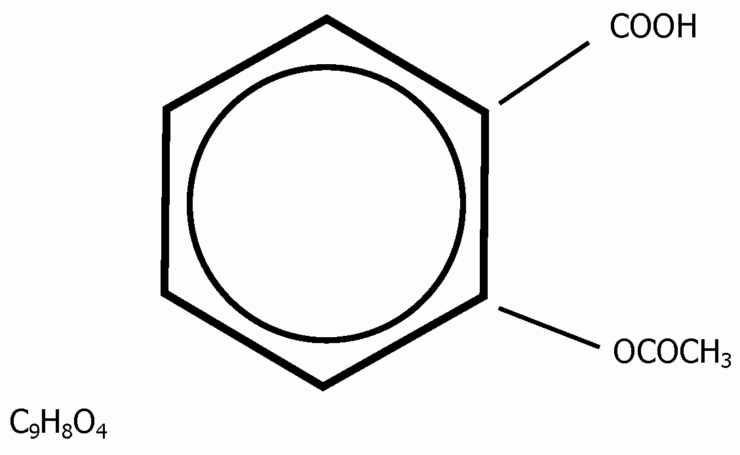

Continued

RM 2–SU: You Be the Judge (Continued)
Benefits
The drug is used to
  - relieve the symptoms of rheumatoid arthritis
  - reduce fever and relieve mild to moderate pain from headaches, menstrual cramps, arthritis, colds, toothaches, and muscle aches
  - prevent heart attacks in people who have had a heart attack in the past or who have angina (chest pain that occurs when the heart does not get enough oxygen)
  - reduce the risk of death in people who experience, or have recently experienced, a heart attack
  - prevent ischemic strokes (strokes that occur when a blood clot blocks the flow of blood to the brain) or mini-strokes (strokes that occur when the flow of blood to the brain is blocked for a short time) in people who have had this type of stroke or mini-stroke in the past
Risks
Minor side effects include
  - diarrhea
  - nausea, vomiting
  - reduced amount of urine passed
  - stomach gas, heartburn
Serious side effects include
  - black, tarry stools
  - confusion
  - difficulty breathing, wheezing
  - dizziness, drowsiness
  - ringing in the ears
  - seizures (convulsions)
  - skin rash
  - stomach pain
  - unusual bleeding or bruising, red or purple spots on the skin
  - vomiting blood, or what looks like coffee grounds
Levels ranging from 150 mg/kg to 300 mg/kg can be dangerous, depending on the person’s weight.

