RM 1–SU: How to Read a Prescription Drug Label

Sample of Prescription Drug Label
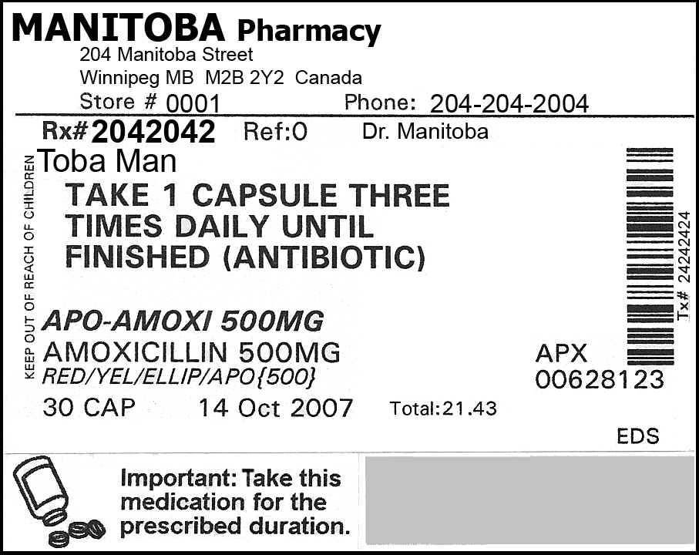

Continued
RM 1–SU: How to Read a Prescription Drug Label (Continued)
Using the sample label provided, answer the following questions to determine what important information must be included on a prescription drug label.
- What is the name of the pharmacy?
- What is the address of the pharmacy?
- What is the store number of the pharmacy?
- What is the phone number of the pharmacy?
- What is the prescription number?
- What is the physician’s name?
- What is the date that the prescription was filled?
- What is the name of the person for whom the drug is prescribed?
(Prescription drugs should be used only by the person for whom the drugs were prescribed.)
- What is the brand name of this drug?
(Various manufacturers or companies may make the same generic drug but will call it by their own brand or trade name.)
- What is the name of the medication or the main ingredient?
- What is the strength of the medication?
- What do the letters APX mean?
- What does the number listed below the company code represent?
- How much is in the package?
- What are the directions or instructions for taking the medication?
- Are there any cautions or warnings on the label?
- Do prescription drug labels often include any additional information that is not on this one?

Continued
RM 1–SU: How to Read a Prescription Drug Label (Continued)
(Answer Key)
- What is the name of the pharmacy? | Manitoba Pharmacy
- What is the address of the pharmacy? | 204 Manitoba Street, Winnipeg MB M2B 2Y2 Canada
- What is the store number of the pharmacy? | Store: #0001
- What is the phone number of the pharmacy? | Phone: 204-204-2004
- What is the prescription number? | Rx: #2042042
- What is the physician’s name? | Dr. Manitoba
- What is the date that the prescription was filled? | October 14, 2007
- What is the name of the person for whom the drug is prescribed?  (Prescription drugs should be used only by the person for whom the drugs were prescribed.) | Toba Man
- What is the brand name of this drug?  (Various manufacturers or companies may make the same generic drug but will call it by their own brand or trade name.) | APO–Amoxi
- What is the name of the medication or the main ingredient? | Amoxicillin is the generic name for the drug.
- What is the strength of the medication? | 500 mg
- What do the letters APX mean? | The letters indicate the manufacturer’s/company’s code.
- What does the number listed below the company code represent? | This number indicates the drug identification number (DIN).
- How much is in the package? | 30 cap (capsules)
- What are the directions or instructions for taking the medication? | Take 1 capsule three times daily until finished (antibiotic).
- Are there any cautions or warnings on the label? | Important: Take this medication for the prescribed duration.  Keep out of reach of children.
- Do prescription drug labels often include any additional information that is not on this one? | Expiry date, refill information, and additional information, on stickers, such as Take with food.

