K.5.S2.C.1b |  | “Nutrivia” |  |  |  | 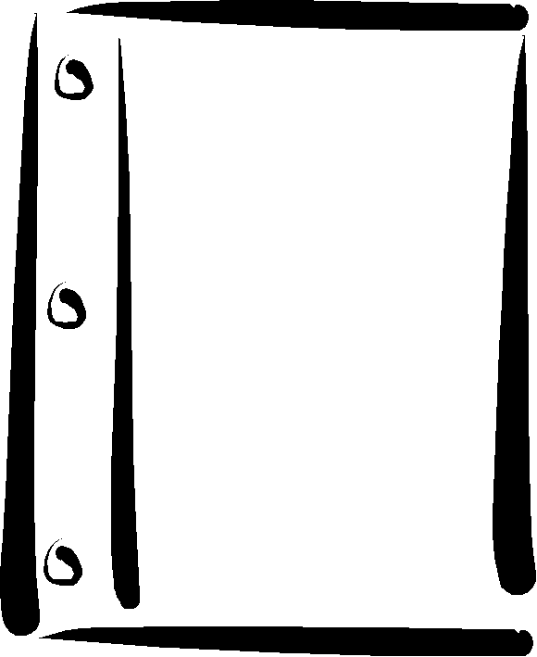  RM  S2-5
This entire game may take 25 to 30 minutes to play. Choose 5 to 10 minutes’ worth on any given day.

Categories
Questions from six categories (and point values) are suggested on the following pages. Questions can also be added or substituted, based on a monthly theme (e.g., Thanksgiving).

“NUTRIVIA”
General | Vitamins/ Minerals |  | Canada’s Food Guide | Fat | Grains |  | Physical Activity
100 | 100 |  | 100 | 100 | 100 |  | 100
200 | 200 |  | 200 | 200 | 200 |  | 200
300 | 300 |  | 300 | 300 | 300 |  | 300
400 | 400 |  | 400 | 400 | 400 |  | 400
500 | 500 |  | 500 | 500 | 500 |  | 500

Procedure
- Divide the class into teams. Each team chooses a team name representing a type of food (e.g., Red Hot Chili Peppers).
- Read out questions from a given list of categories, such as those presented on the following pages.
- The captain of each team needs a “bell” or “buzzer” to indicate when the team has the required answer.
- The team captain must wait to “buzz in” until the entire question is read—otherwise, answers will not count.

(continued)
K.5.S2.C.1b | “Nutrivia”: Questions | RM  S2-5

General
- What is called the most important meal of the day?
- What stimulant increases respiration rate, heart rate, blood pressure, and the secretion of hormones?
- What word describes a person who does not consume any animal products in his or her diet?
- What is the practice of eating five or six small portions of healthy food throughout the day called?
- What nutrients provide 4 cal/g, 9 cal/g, and
4 cal/g respectively?

Vitamins/Minerals
1. What mineral is required for developing strong bones?
2. What vitamin controls the way your body uses calcium?
3. What are the water-soluble vitamins?
4. What mineral is part of the hemoglobin in the blood that carries oxygen?
5. The lack of antioxidant vitamins in our diet has been associated with increasing the risk of what disease?

Canada’s Food Guide to Healthy Eating
1. According to Canada’s Food Guide to Healthy Eating, one should eat five to twelve servings daily from what food group?
2. One 100-gram serving of tofu and an egg would meet the lower recommendation for what food group?
3. One cup of juice counts as one serving (out of a possible five to ten servings) from what food group?
4. Gravy, mayonnaise, and potato chips fall into what category?
- What food group contains the richest natural food source of calcium?

Fat
1. Our daily diet should be composed of what percentage of fat?
2. What can be removed from chicken, making it one of the leanest meats?
3. The fat content in a sandwich can be reduced if you replace butter with what?
4. The diet should be composed of 10% from each of which three fats?
What type of fat is most connected with heart disease?

Grains
1. What energy nutrient is the major component of cereals, breads, grains, fruit, and vegetables?
2. What non-energy-yielding component of breads, cereals, fruit, and vegetables is digested by bacteria in the colon and helps increase cholesterol clearance?
3. High-fibre foods may help prevent colon and breast cancer and are generally low in what energy nutrients?
4. The majority of grains in an individual’s daily diet should not be simple, but should be what?
- A slice of whole rye bread, as opposed to a slice of “white” bread, releases its energy into the bloodstream at a slow rate. The index identifying this is called what?

Physical Activity
1. The physically active person’s diet should be higher in what energy-yielding nutrient?
2. What non-energy-yielding nutrient should be higher during physical activity to prevent dehydration?
3. What type of exercise helps increase the amount of good cholesterol (high-density lipoprotein [HDL]) in the body?
4. What type of regular physical activity helps prevent osteoporosis?
5. As you exercise, what increases in the body that causes you to burn more calories?
(continued)

