 | Active Learning Strategies |   RM  G-2

Carousel Brainstorming

Carousel Brainstorming activates students’ prior knowledge of a topic or topics through movement and conversation, which provides scaffolding for learning new information and ideas. Students move and rotate around the classroom in small groups, stopping at various stations for a designated amount of time. Students can move in different ways (e.g., walk, run, hop, shuffle-step) and for various time allotments (set amount of time or number of laps). At each station, students generate ideas on different topics or different aspects of a single topic through conversation with peers. Ideas are posted at each station for all groups to read.

Procedure
- Introduce the topic.
- Divide the class into small groups.
- At various locations around the room, place markers and blank posters/sheets, each identified with a category of the topic. (The number of posters/sheets should correspond with the number of groups.)
- Each group starts at one of the posters and writes down any ideas team members have about a given topic.
- On a given signal, students move around the room in a predetermined direction to the next poster and write down their ideas.
- Students continue this process until they have visited all posters.

(continued)

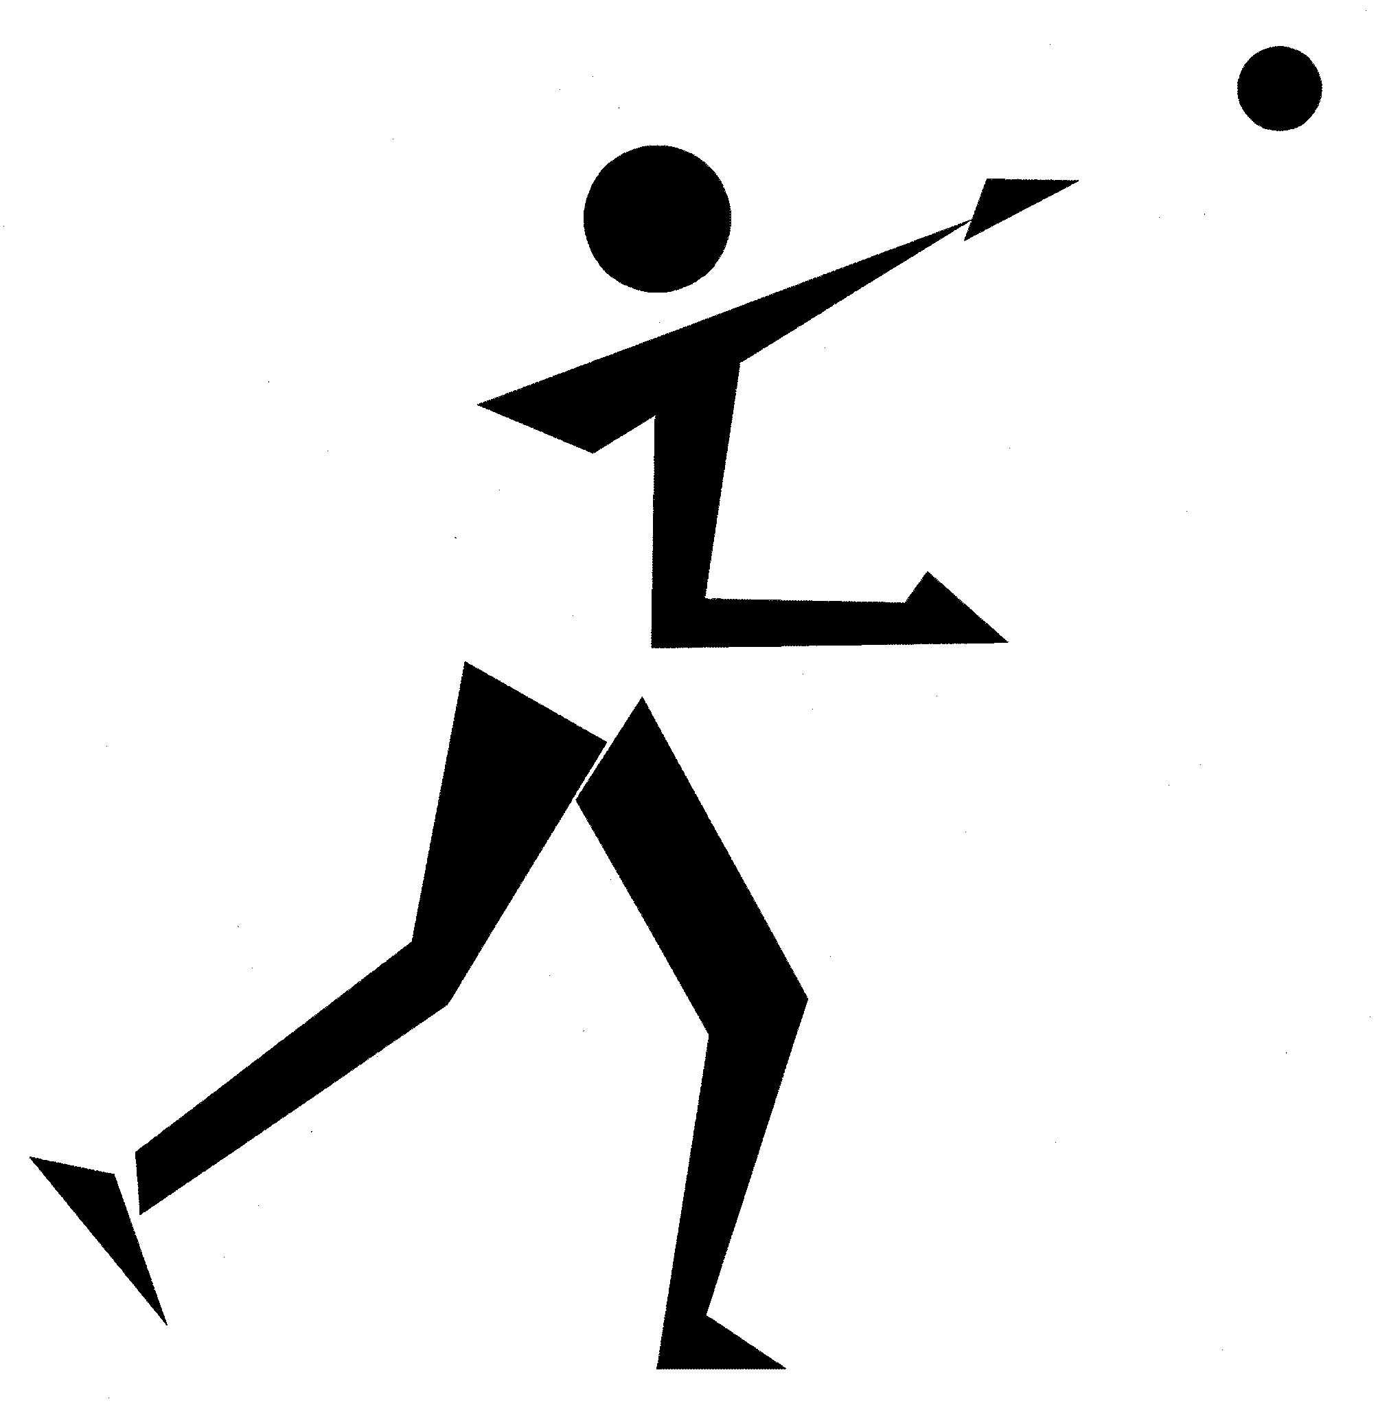 | 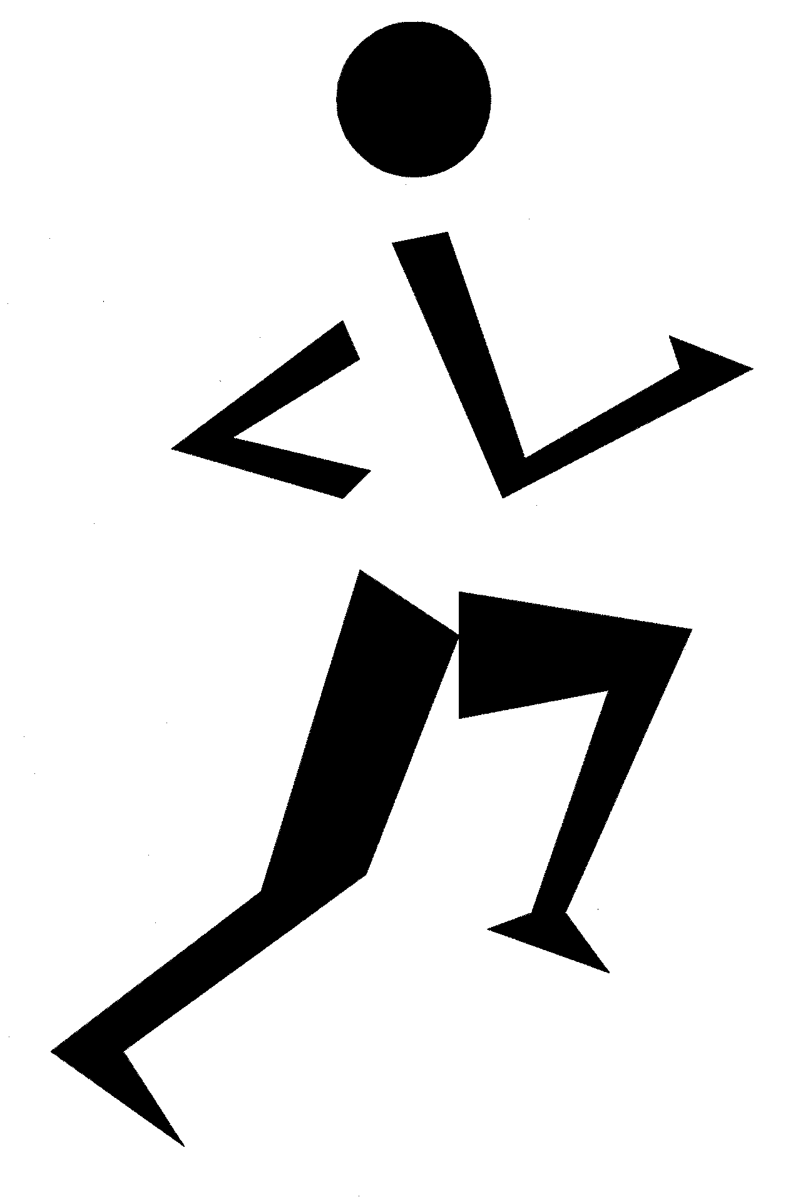 |  |  | 

 | Active Learning Strategies  (continued) | RM  G-2
Jigsaw: A Cooperative Learning Strategy

Jigsaw (Aronson et al.) is a cooperative learning strategy that enables students to become experts on part of a topic (determined by the teacher), which they share within their group.

Procedure
- Arrange students in small home groups, with a minimum of three in each group. Provide students with a specific topic or task (e.g., discuss how movement skill patterns transfer from one activity to another).
- Home group: Each student within a group selects and explores a different component of the specified topic/task. (Ensure that the same sub-topics are selected in each group.)
- Expert group: After completing the assigned task, each team member joins students from other teams who have chosen the same sub-topic, forming an expert group. Students share their information, synthesize group discussions, and expand on ideas.
- Home group: Students return to their original home groups and share their “expertise” with each other.
A graphic representation of the Jigsaw strategy follows.

Home Groups

Expert Groups

Home Groups

(continued)

 | Active Learning Strategies  (continued) | RM  G-2

Opinion Line

The Opinion Line strategy helps students to recall information and express opinions. It involves movement, decision making, responsible social behaviours, and use of communication skills and styles in a safe environment. Students respond to questions by moving to a designated area.

Procedure
- Have students line up in the centre of the teaching space (e.g., classroom, gym, blacktop).
- Have one side of the area represent “Agree,” another side “Disagree,” and a third side "Neutral" or “Unsure.”
- Ask questions to which students can agree, disagree, or remain neutral/unsure. Students move to the area that represents their opinion, at which time they may be asked to justify their opinion/answer to the class.
- Students return to centre line after every response.

People Search

People Search involves movement, conversation, and questioning, and activates prior knowledge of a topic. Students find other students who can answer statements on a grid (e.g., Bingo card, questionnaire, chart). The teacher confirms the required responses.

Procedure (for a Bingo Card)
- Make a list of 25 statements. For example,
Find someone who…
- eats a minimum of two servings of dairy products daily
- belongs to a “fitness club”/team
- ate a minimum of five servings of fruit/vegetables yesterday
- exercised for a minimum of one hour yesterday
- Place each statement on one square of a five-by-five-square grid.
- Provide each student with a grid/card.
- Students obtain the signatures of other students who can answer the statements on the grid.
- Play until someone fills one row, forms the letter “T” or “X,” or completes the entire grid with signatures.
(continued)
 | Active Learning Strategies  (continued) | RM  G-2

Rotating Reel

Rotating Reel helps students to recall information and discuss it in small- and large-group settings. This strategy involves movement, communication, discussion, and responsible social behaviours. Questions are posed and small-group members rotate in a circular fashion, sharing their answers with the new group.

Procedure
- Have students form groups of three and assign each person a number (e.g., 1, 2, 3).
- Have students in each small group distribute themselves evenly on a large circle.
- Ask the class a question and have each group discuss it to determine a small-group answer.
- Choose a number and ask the person with that number to move in a specific direction (e.g., clockwise, counter-clockwise, skip a group) to the next group.
- The moving person shares the answer with the new group, thereby generating discussion.
- Students present the answer to the large group.
- Clarify the answer to ensure that all groups have the correct response.
- Continue the sequence of asking/answering a question, selecting a number to identify the “messenger” who should move in a specified direction to the next group, and sharing the answer.

X
X
X
X
X
X
X
X
X
X
X
X

X
X
X
X
X
X

(continued)

 | Active Learning Strategies  (continued) | RM  G-2
Scavenger Hunt

A Scavenger Hunt activates students’ prior knowledge of a topic or topics through movement, critical thinking, problem solving, and conversation (if done in pairs/groups). Students move around to find objects, cards, symbols, and colours, and sort them into categories.

Procedure
- Make cards containing the information related to a given topic (e.g., food groups, safety symbols, rules of a specific game such as badminton).
- Spread cards around a designated area indoors or outdoors (e.g., turned over, placed under pylons, posted on a wall).
- Prepare a recording sheet for students.
- Have students walk/run to find the cards and record the card information on the sheet.
- Upon completion, check students’ results. Alternatively, have students check their own results.

What’s Behind You?

What’s Behind You? helps students recall or activate prior knowledge of a topic or topics through conversation, clarification, and encouragement. Students work in pairs, taking turns asking each other questions and assessing each other’s answers. Teachers can provide the questions or students may generate their own.

Procedure
- Place a poster/sign on the wall or display it on an overhead screen.
- Have pairs of students stand facing each other, with one student having his or her back turned to the poster/screen.
- Have students take turns asking each other questions based on the information on the poster/screen. The person facing the poster/screen asks the questions, while the other person answers the questions without turning around to look.
- Students switch roles after each question/answer.

