BLM  S2-5a  S.2.S2.A.2 | "Strengthalon" | 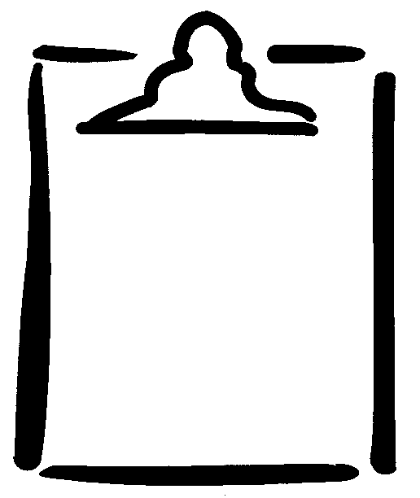
Name
- Spend 2 minutes at each of the 10 stations.
- Take 30 seconds to record points and move to the next station.
Station/Event | Scoring System | Points | Heart Rate  At Start of Task | Heart Rate  At End of Task
- line touches, 10 metres apart | 1 point for every touch
- curl-ups | 1 point for every curl-up
- push-ups | 1 point for every push-up from knees  OR  2 points for every push-up with knees off ground
- step-ups on stair or bench | 1 point for every step-up
- medicine ball tosses to partner | 1 point for every throw
- tricep dips on bench | 1 point for every dip
- jump rope | 1 point for every 2 skips, either 1 foot or 2 feet
- sideways line hops (both feet parallel to the line) | 1 point for one there and back
- chin-ups | 3 points for each chin-up from bent-arm position  OR  5 points for each chin-up from straight-arm position
- star jumps | 1 point for every 2 jumps
Total Points

