BLM  S2-3  K.2.S2.A.1 | Fitness As a Way of Life | 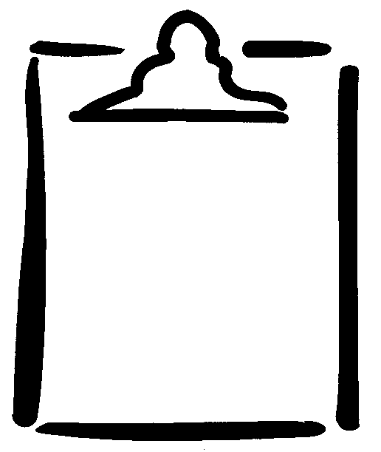
Name

Activity or Exercise | Muscle or Muscle Group | Major Fitness Component(s) | Daily Active Living Contribution
Example:  - arm curls  (high resistance, low repetition) | - biceps | - muscular strength | - carrying a bag of groceries
- cross-country skiing
- plank position
(prone, elbows bent)
- soccer
(70-minute game)
- seated leg extension
- push-ups
- modified hurdler’s stretch
- leg press
- Pilates
- latissimus dorsi pull-down
(low resistance, high repetition)
- your choice:  ______________________ | - deltoids

