BLM  S1-1  K.2.S1.C.1a | Skeletal Muscle Cross-Section  (Labelled) | 

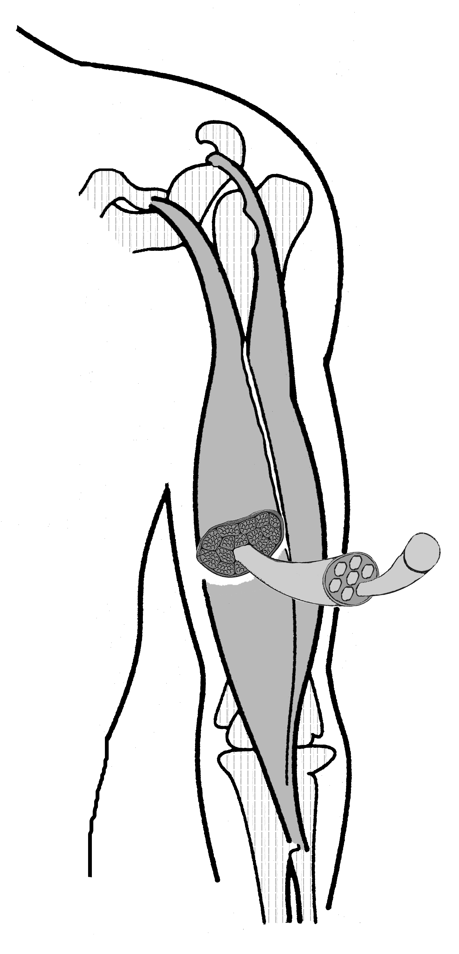
bone
muscle belly—fleshy central portion of a muscle between its origin and insertion onto bone
Tendon (attaches muscle to bone)—white fibrous connective tissue made up of the protein called collagen
connective tissue
bundle—group
of muscle fibres
myofibril—runs parallel to the muscle fibre's length; grouped into bundles called sarcomeres, which are the functional contractile units of muscles
muscle belly

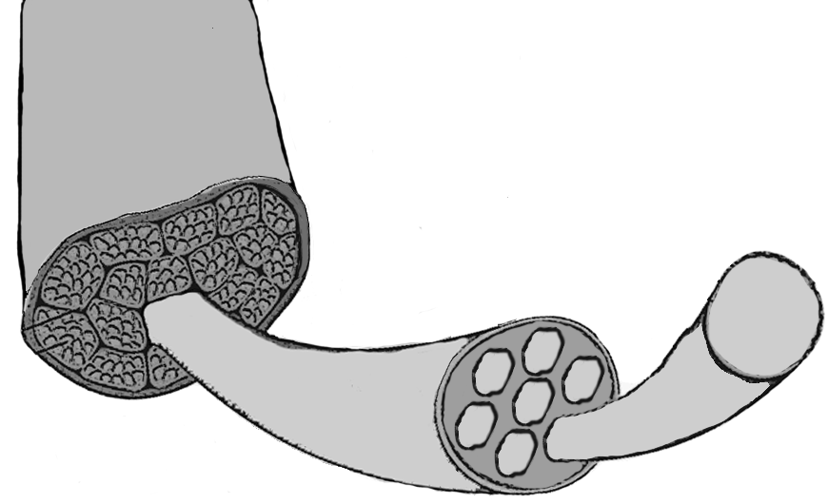

muscle fibre (made up of myofibrils)—elongated thread-like structure that contracts to produce movement; several 100s to 1000s are bound together by a protective sheath within a muscle

