BLM  G-4f  K.5.S1.E.1a  K.5.S2.E.1a | Reproductive System Diagram:  Male Anatomy―Front View  (Labelled) | 

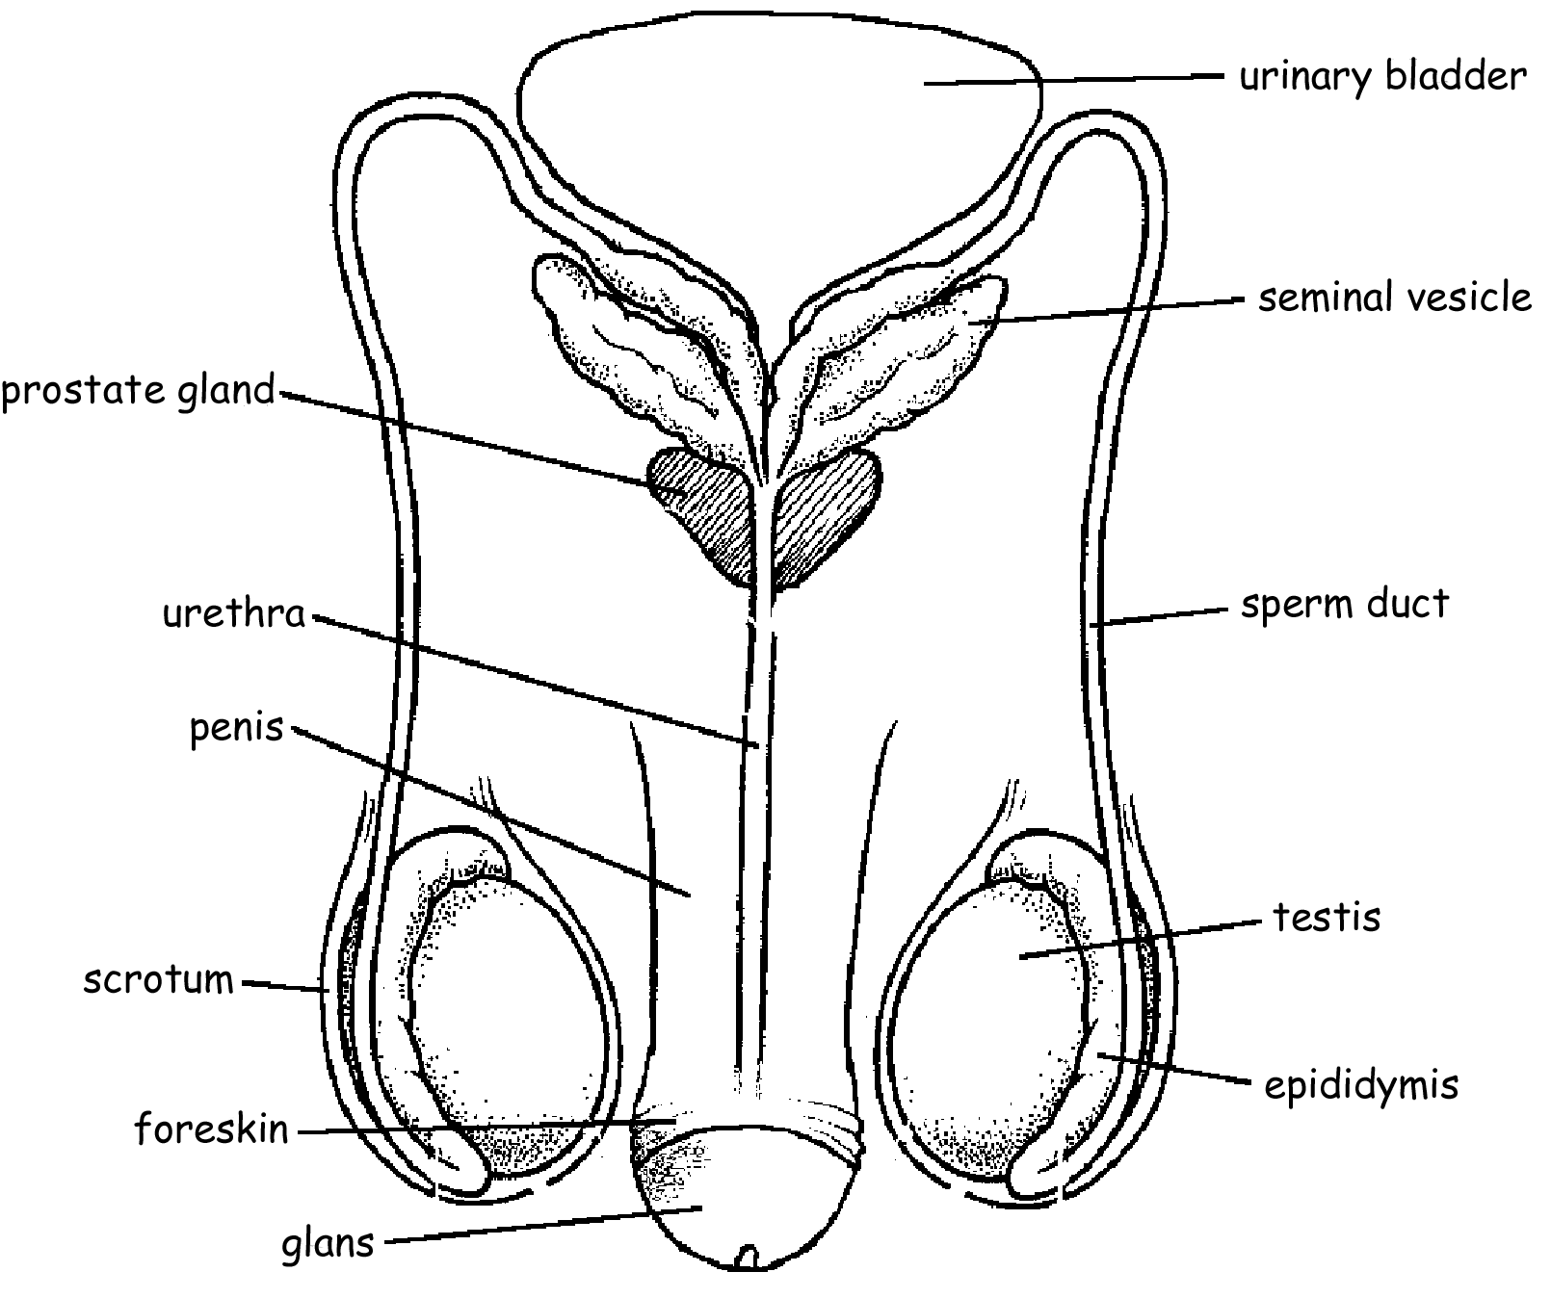

Circumcised
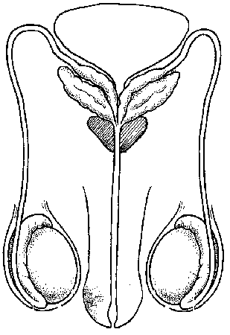

Uncircumcised

