BLM  G-9  K.3.K.B.1  S.5.1.A.4 | Safety Symbols  (Safety Cards) | 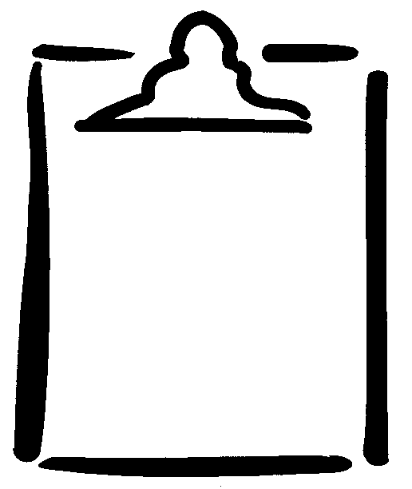

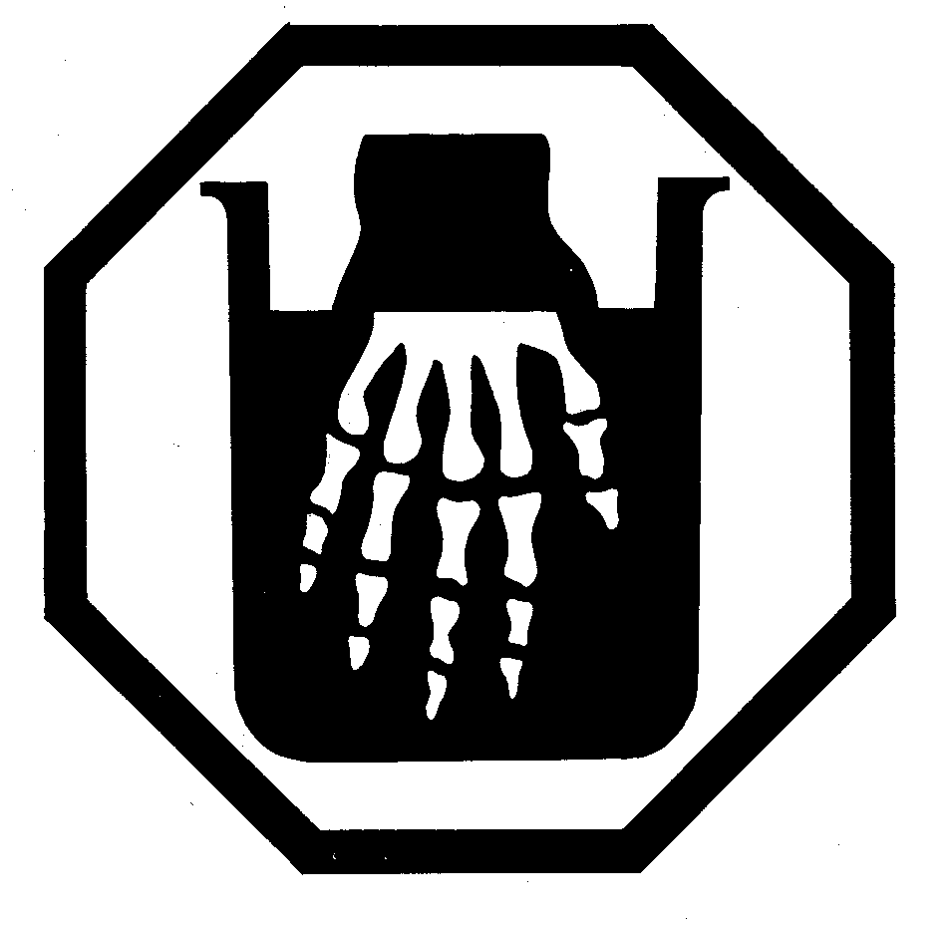 | 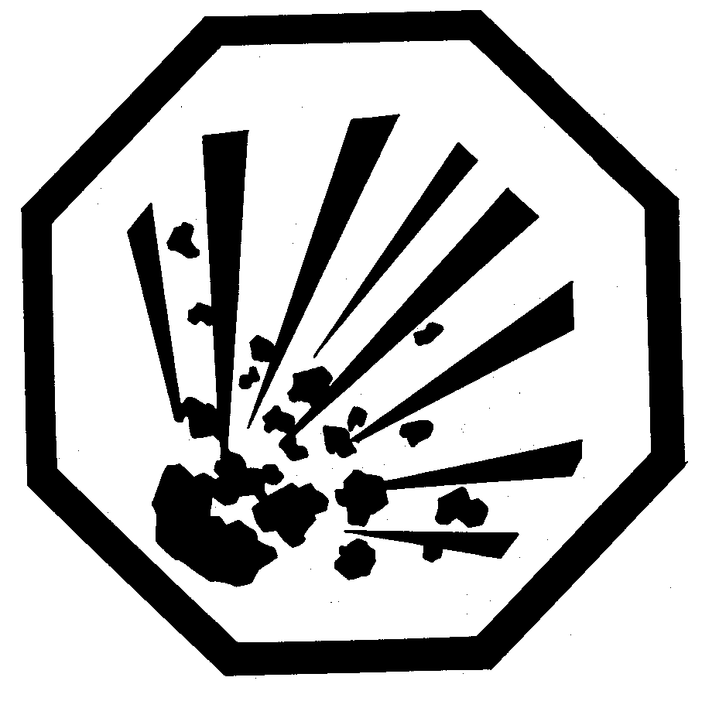
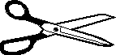  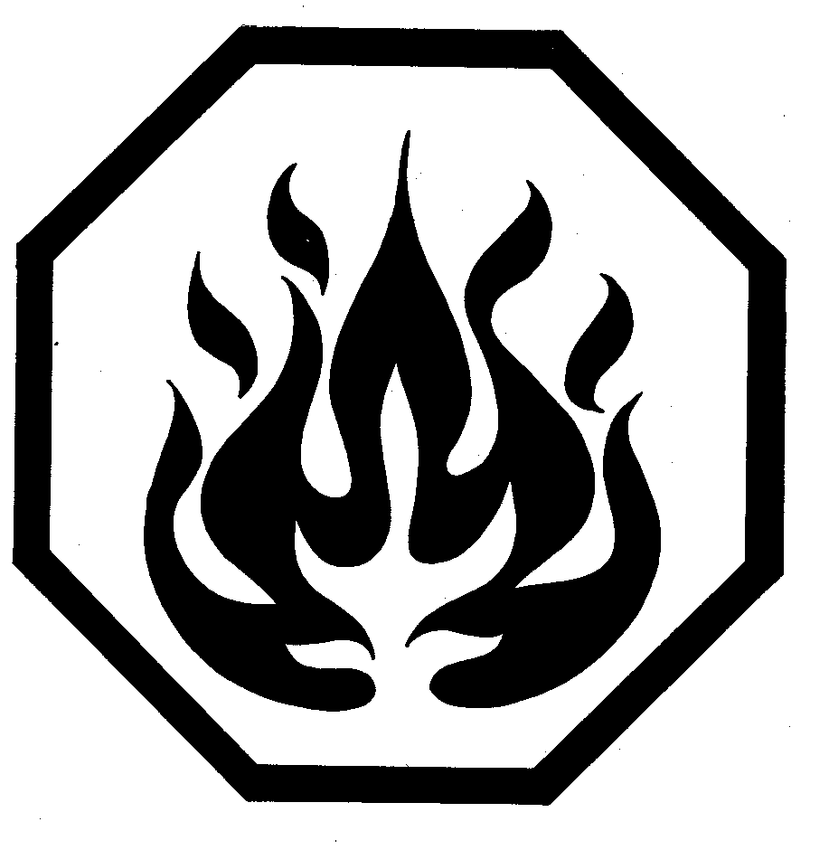 | 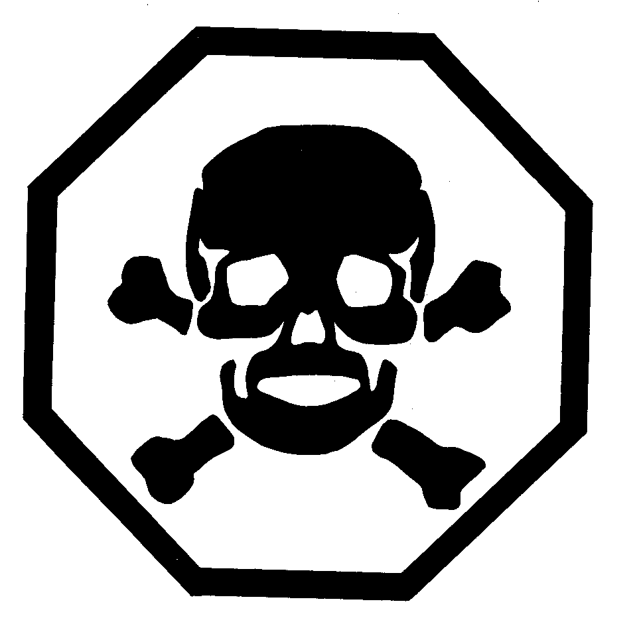
EXPLOSIVE  Can blow up. Do not touch anything marked like this! | CORROSIVE  Can hurt eyes or skin. Do not touch anything marked like this!
FLAMMABLE  Can catch on fire. Do not play with or go near anything marked like this! | POISON  Can make you very sick. Do not eat or drink anything marked like this!

