BLM  G-6  S.1.(K.to 4.).A.2 |  | Manipulation Skills Criteria |  |  |  |  | 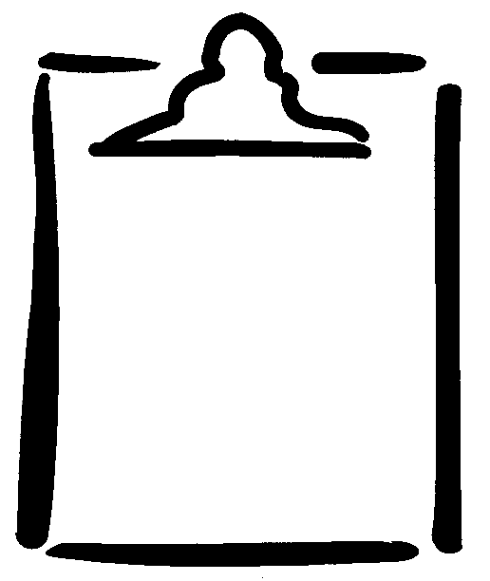

Performance Indicators

What to look for…to strive for…in the basic movement skills:
Rolling | Bouncing |  | Catching | Underhand Throwing | Overhand Throwing | Striking |  | Kicking
A. Focuses eyes on target. | A. Initiates ball contact from fingertips. |  | A. Focuses eyes on the object throughout the catch. | A. Focuses eyes on the target. | A. Focuses eyes on the target. | A. Focuses eyes on object being struck. |  | A. Focuses eyes on the target.
B. Rolls ball with a backward and forward arm swing. | B. Bends and straightens wrist and elbow to push the ball. |  | B. Positions body in the path of the object. | B. Uses a full backward and forward arm swing. | B. Bends and holds elbow back at shoulder height behind ear. | B. Displays preparatory backswing. |  | B. Steps beside the ball with non-kicking foot.
C. Steps forward with leg opposite to the hand holding the ball. | C. Bounces ball in front of and to the side of body. |  | C. Positions one foot slightly ahead of the other in a balanced stance. | C. Transfers weight from back to front. | C. Rotates hips so that opposite shoulder is in line with the target. | C. Rotates hips and trunk in full striking action. |  | C. Bends body at waist, initiating kick from hip.
D. Bends knees and releases the ball along the floor. | D. Performs a rhythmical series of controlled bounces. |  | D. Catches the object with hands. | D. Steps forward with foot opposite to throwing arm. | D. Steps forward with foot opposite to throwing arm. | D. Transfers weight from back to front foot. |  | D. Bends kicking leg (knee over ball) to contact ball with shoelaces.
E. Follows through with hand pointing to the target. |  |  | E. Relaxes arms and absorbs the force of the object. | E. Releases object in front of body at approxi-mately waist level. | E. Shifts weight from back to front foot. | E. Follows through along swinging path. |  | E. Swings arms in opposition to kicking foot.
 |  |  |  | F. Follows through with hand pointing to the target. | F. Leads throw with elbow and follows through down and across the body. |  |  | F. Follows through with kicking leg pointing to the target.
Manipulation Skills Criteria: Reproduced, by permission, from Physical Education K-4: Basic Movement Skills Assessment.
Winnipeg, MB: Movement Skills Committee, 1999.

