BLM  G-5  S.1.(K. to 4.).A.1 |  | Transport Skills Criteria |  |  |  | 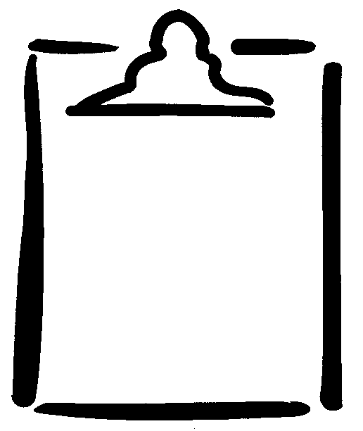

Performance Indicators

What to look for…to strive for…in the basic movement skills:
Running | Jumping |  | Hopping |  | Galloping |  | Skipping
A. Runs with flight, extending supporting leg. | A. Takes off and lands on two feet. (Toe-Ball-Heel) |  | A. Takes off on one foot and lands on same foot. (Toe-Ball-Heel) |  | A. Keeps trail leg behind lead leg. |  | A. Displays a step-hop pattern.
B. Swings arms in a forward-backward motion. | B. Bends knees and body (at waist) in preparation for the jump. |  | B. Holds knee behind body at a 90 degree angle. |  | B. Gallops using either leg as the lead. |  | B. Uses both sides of body alternately.
C. Swings arms in opposition to feet. | C. Swings arms fully in a backward-forward direction. |  | C. Uses arms for lift. |  | C. Displays rhythmical arm movement. |  | C. Swings arms in opposition to feet.
D. Maintains balance. | D. Extends body in flight and lands with bent knees. |  | D. Displays rhythmical hopping. |  | D. Turns hips, shoulders, and eyes to direction of movement. |  | D. Displays a rhythmical pattern.
E. Focuses eyes forward. | E. Focuses eyes forward. |  | E. Maintains balance. |  |  |  | E. Focuses eyes forward.

Transport Skills Criteria: Reproduced, by permission, from Physical Education K-4: Basic Movement Skills Assessment. Winnipeg, MB: Movement Skills Committee, 1999.

