BLM  K-6  K.5.K.A.3 | I Care for My Teeth |  | 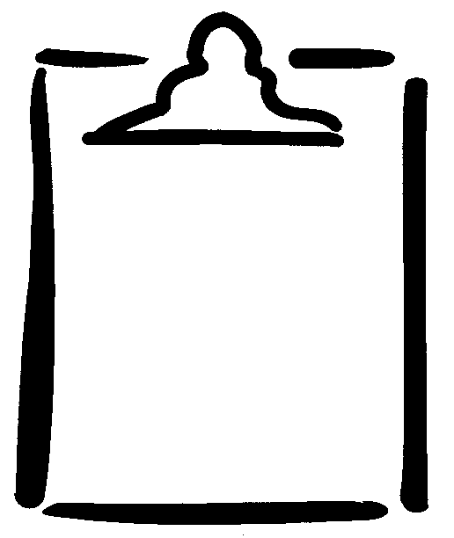
Name |  | Class | Date
Check off () the things you do each time and each day to take care of your teeth.
 | Monday | Tuesday | Wednesday | Thursday | Friday | Saturday | Sunday
Brush teeth
Floss
Drink milk
Eat a healthy snack instead of sweets

