S.2.5.A.2  BLM  G-7  S.2.6.A.2 | Heart-Rate Predictions |  | 
Name |  | Grade | Date
- Identify age-appropriate target heart-rate zones and beats per minute (bpm).

Target Heart-Rate Zones* | Beats per Minute

* Target heart-rate zones are used as a benchmark or reference point. Ranges of heart rates may vary, based on age and/or physical condition.

2. For each activity listed in the chart below, indicate your predicted heart rate and actual beats per minute (bpm), and identify the target heart-rate zone that corresponds with the actual result.

Activity |  | Prediction | Actual | Zone
   | Lie down for two minutes.
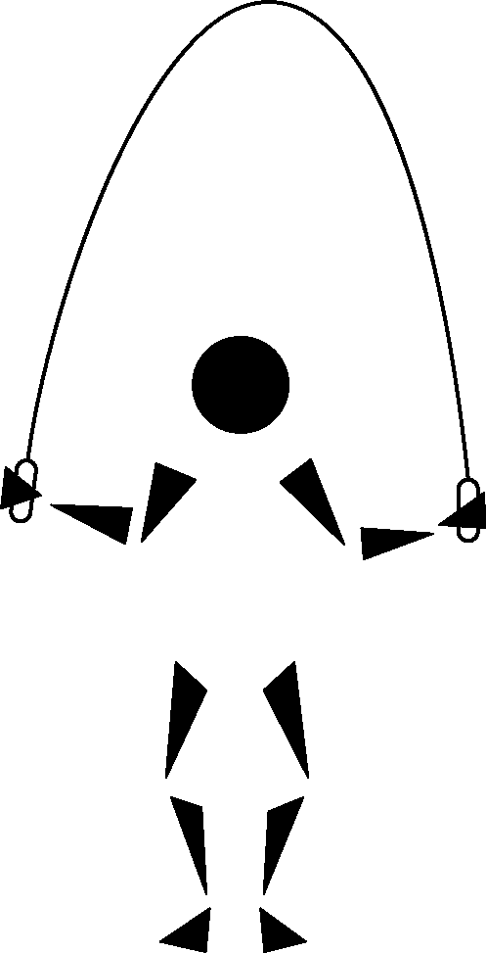 | Walk for two minutes.
 | Jump rope for two minutes.
   | Jog for four minutes.
 | Shoot hoops for two minutes.
 | Sprint the length of the gym.
 | Do cool-down stretches.

