K.2.5.B.1  BLM  G-6  S.2.5.A.3a  S.2.5.A.3b  S.2.6.A.3a  S.2.6.A.3b | Physical Activity Log (PAL) |  | 
Name |  | Grade | Date

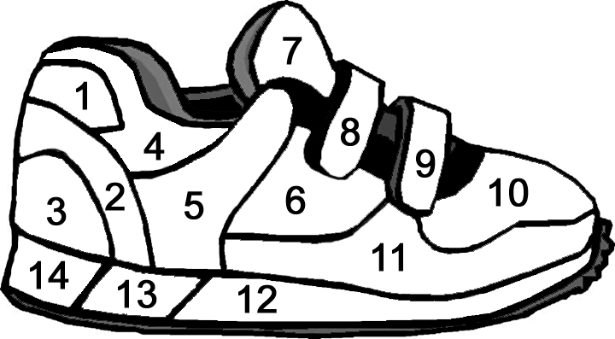

Dear Parents/Guardians,
Students have been learning about the importance of physical activity for health. Please help your son or daughter to keep track of his or her physical activity for two weeks. Students colour in one section of the shoe each day that they are moderately or vigorously active for at least 30 minutes.

