K.2.5.A.1  BLM  G-5  K.2.7.A.1 | Health-Related Fitness  Components Poster | 

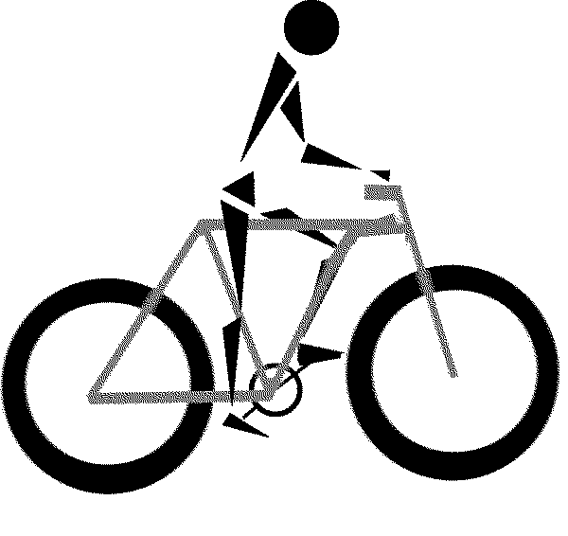 | Cardiovascular Endurance—the ability of the heart, blood vessels, and lungs to provide the working muscles with adequate oxygen during prolonged activity (also called aerobic endurance or capacity).
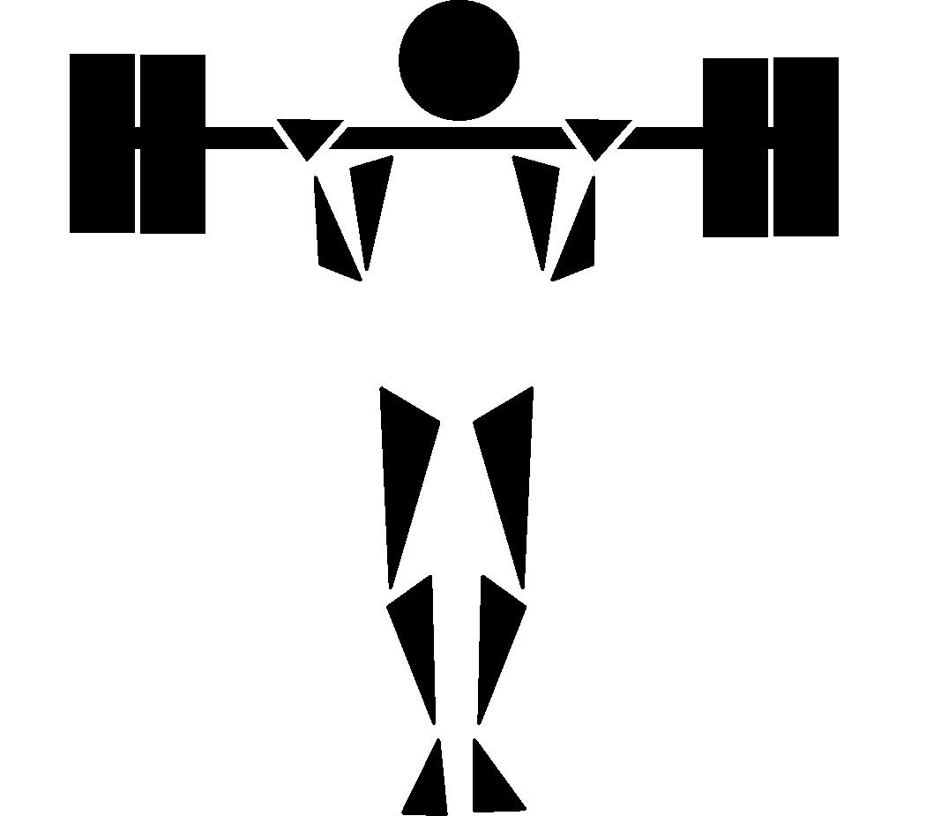 | Muscular Strength—the amount of force that can be exerted by a muscle or group of muscles in a single effort.
 | Muscular Endurance—the ability of a muscle or group of muscles to exert force over an extended period of time without incurring fatigue.
 | Flexibility—the range and ease of movement of a joint (limited by bone, muscles, ligaments, tendons, and the bone-joint capsule).

