K.1.6.C.3  K.1.7.A.1  BLM  G-17  K.1.7.B.3  K.1.7.C.2  K.1.7.C.3 | S.1.7.B.2  K.3.7.A.1  K.1.8.C.3  S.1.8.B.1 | Teaching Games for  Understanding Chart | 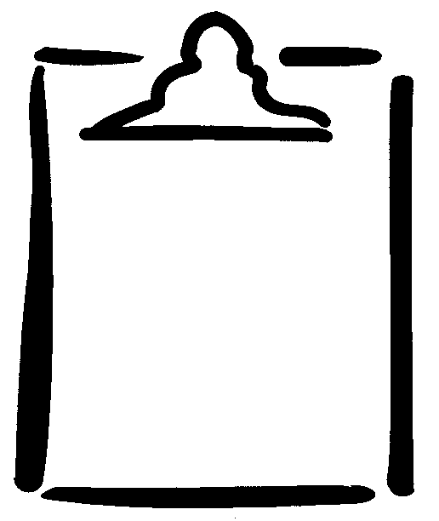

Name ______________________________ Activity _____________________
Game  Category | Primary  Rule/Goal | Tactical Play within Category:  Principles of Play | Examples
Target | - Score by getting the object closer to a target than opponents get theirs, while avoiding any obstacles. | - Aim to target.  - Choose placement in relation to target and other obstacles.  - Spin and/or turn. | - Curling  - Bowling  - Golf
Net/  Wall | - Score by getting the object into the opponents’ areas of play more often than they can return the object. | - Aim for consistency.  - Choose placement and positioning.  - Use power and/or spin (for control and disguise). | - Tennis  - Volleyball  - Squash  - Raquetball
Striking/  Fielding | - Score by striking the ball/object and running within safe areas.  - Prevent opponents from scoring by catching the ball in the air or getting it to a safe area before the batter reaches the safe area.  - Make it difficult for opponents to hit the ball. | Batting:  - Score runs.  - Hit ball/object for accuracy and distance.  - Avoid “getting” out.  Fielding:  - Stop scoring run.  - Make it difficult to hit ball.  - Put batter out. | - Baseball  - Softball  - Cricket
Territory/  Invasion | - Score by getting the object into the opponents’ goal.  - Attempt to prevent opponents from scoring. | With object:  - Score.  - Invade.  - Keep possession.  Without object:  - Prevent scoring.  - Prevent invasion.  - Gain possession. | - Soccer  - Basketball  - Hockey  - Rugby  - Football

Teaching Games for Understanding Chart: Adapted by permission of Timothy F. Hopper, University of Victoria.

