K.2.7.C.1b  BLM  G-13 | Exercise Task Cards | 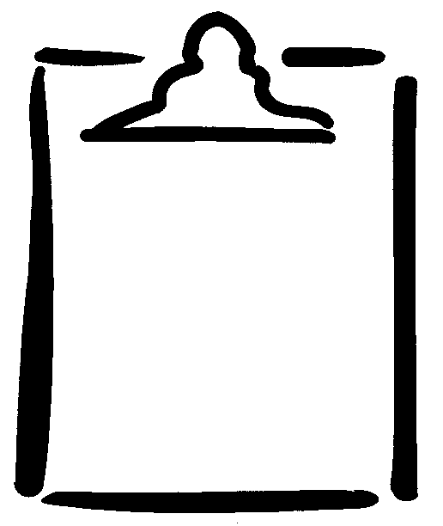

Do six push-ups in every corner of the gym. | Jump sideways back and forth across the centre line of the gym. | Be the encourager.  Tell six students to keep up the good work.
Do five coffee grinders on each arm in the top of the basketball key. | Do 10 jumping jacks at every wall of the gym. | Crab-walk across the gym.
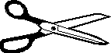  Do five wall squats on two different walls. | Shuffle-step across the gym two times. | Do seven vertical jumps.
Do 15 curl-ups. | Seal-walk across the gym. | Run zigzag through a set of pylons five times.
Jump in and out of a Hula Hoop or skip for one minute. | Do bench-steps for 45 seconds. | Jump over pylons.

