K.1.5.B.3d  BLM  G-1  K.1.7.B.3  K.1.7.C.3  S.1.7.B.2 | Grid Activities |  | 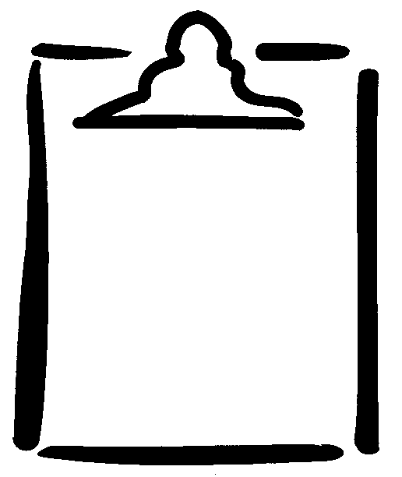
Name |  | Grade | Date

Knee Tag  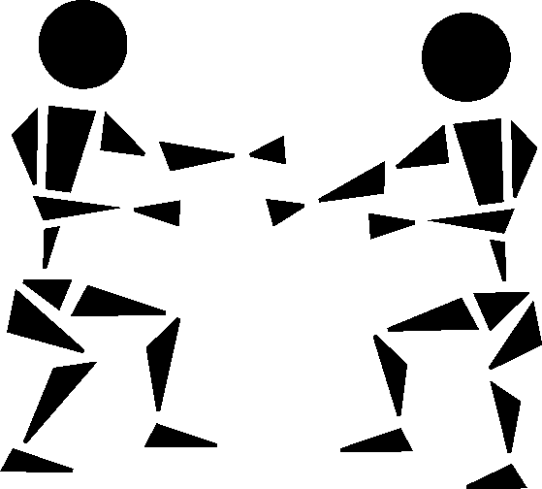  One person tries to tag the partner’s knee with one hand. | Shadows  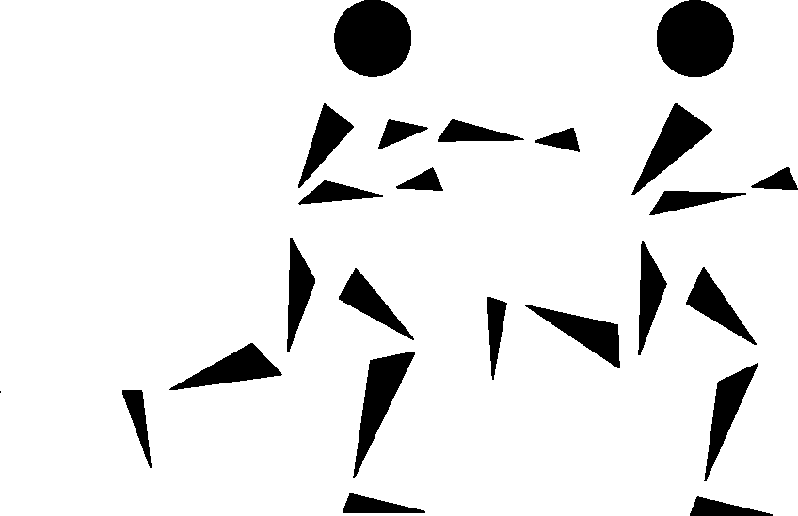  Two people follow and stay within an arm’s reach of each other. | Lose Your Shadow  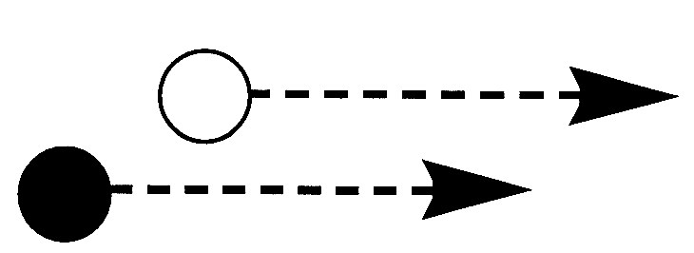  One person stays in front and tries not to let the partner run past. | Stationary Pass  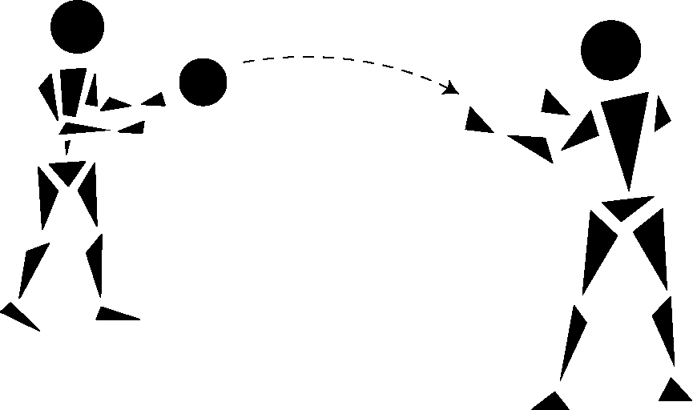  A stationary passer throws to a receiver on the move.
Dynamic Pass  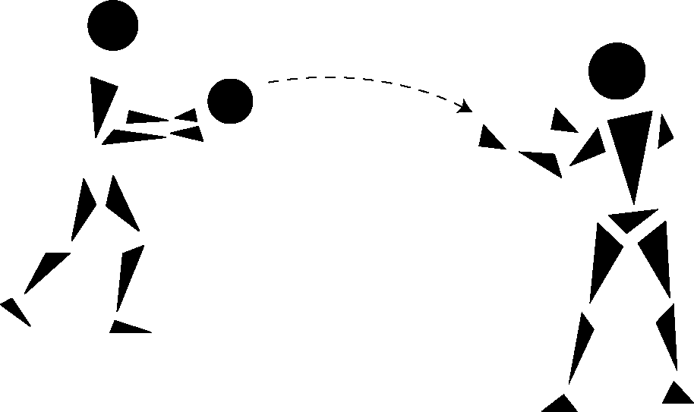  A moving passer throws the ball to a stationary receiver. | Partner Tag  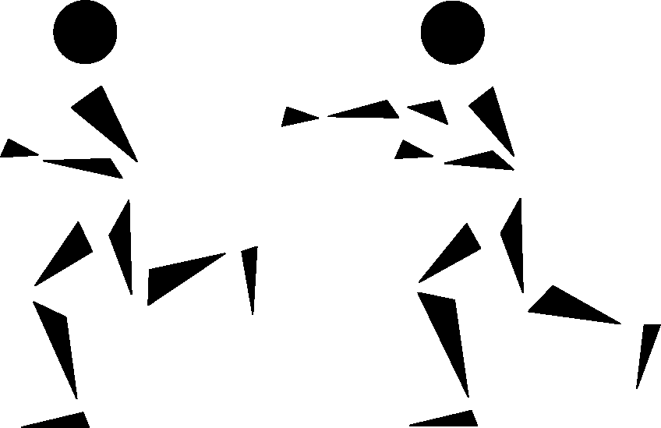  One person tries to tag the partner.  When tagged, the players change roles. | Open Space  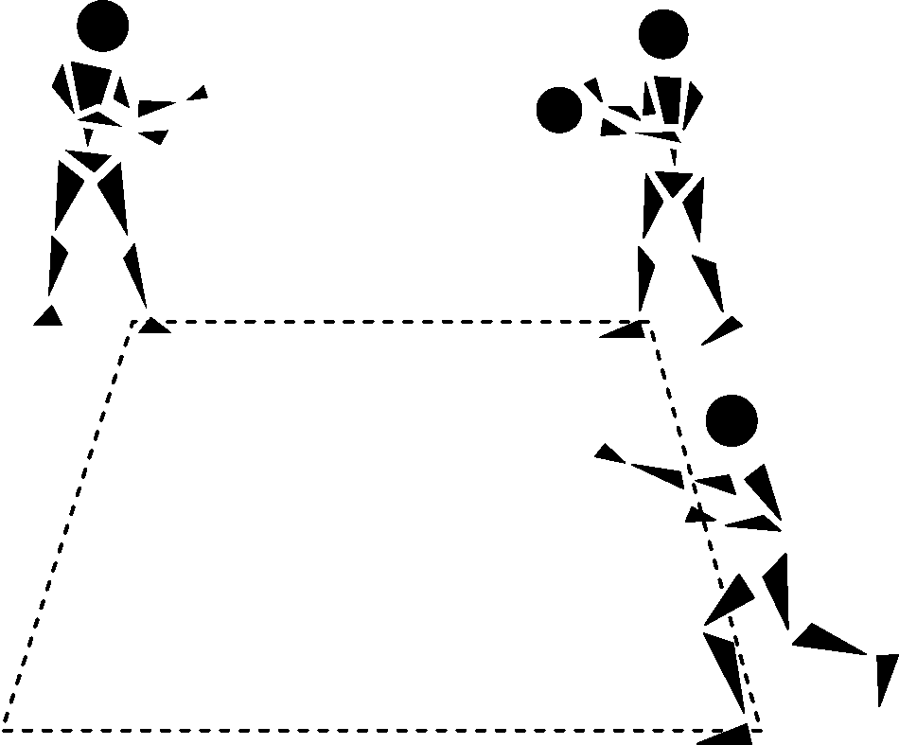  Each team has three players who pass a ball to the person moving into the open corner. | Beat the Pass  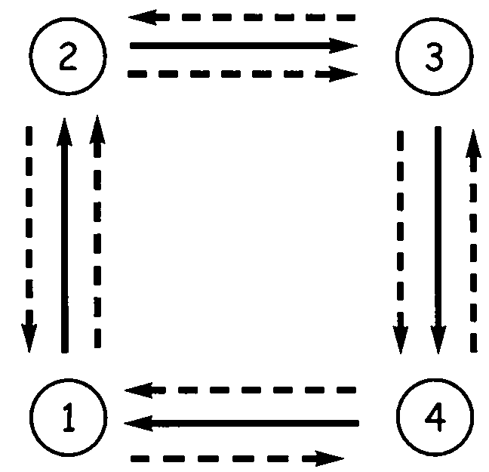  Players take turns passing a ball to the next person. They follow the pass and run back to their original spot.  Ball Player
Frozen Tag  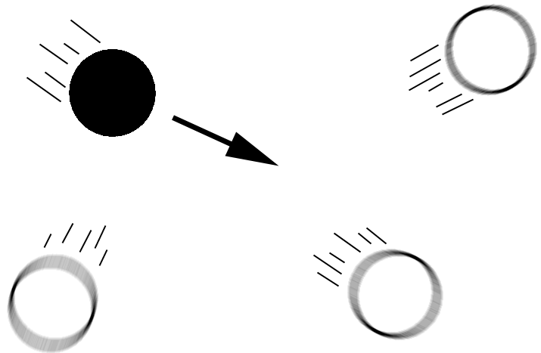  Each team has four players, with one tagger. When tagged, players freeze, with arms out, waiting for someone to go under. Switch roles every 30 seconds. | In the Middle  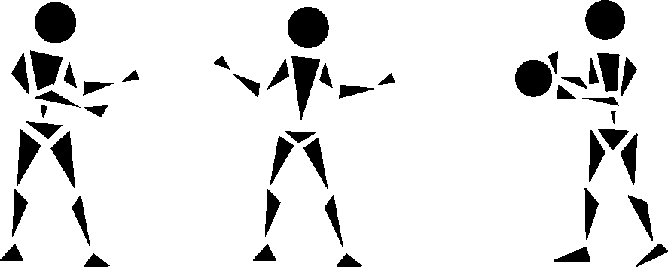  One player tries to pass a ball to a teammate, while the defence tries to intercept. Switch roles every 30 seconds. | Follow the Pass  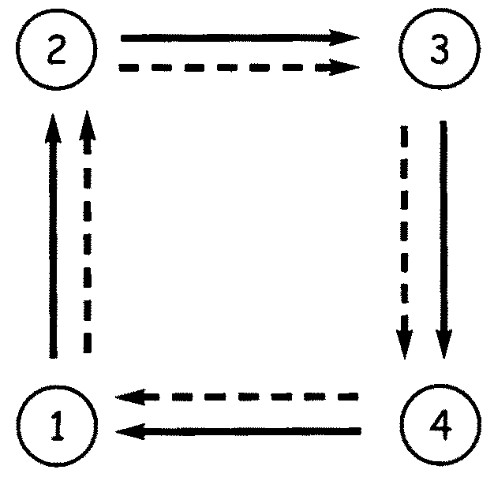  Players take turns throwing to the next person, following the pass from position 1 to 4. | Pass and Cut  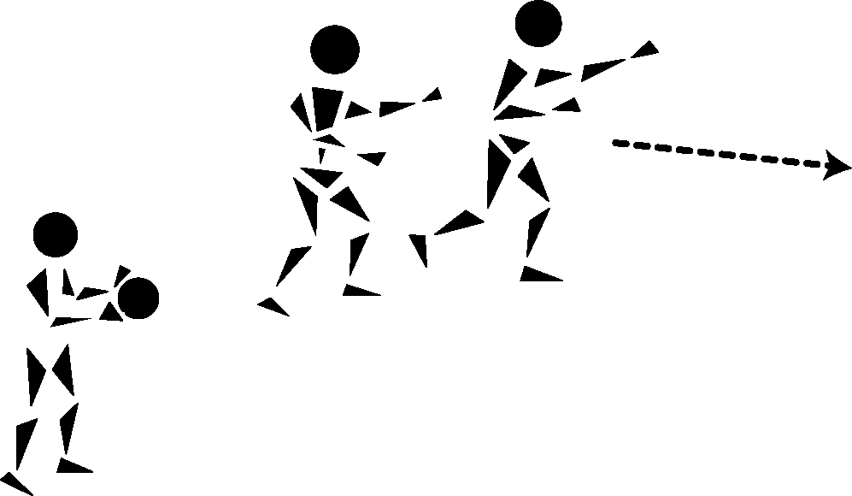  One player tries to pass the ball to a teammate, while the defence tries to intercept.
Play the Post  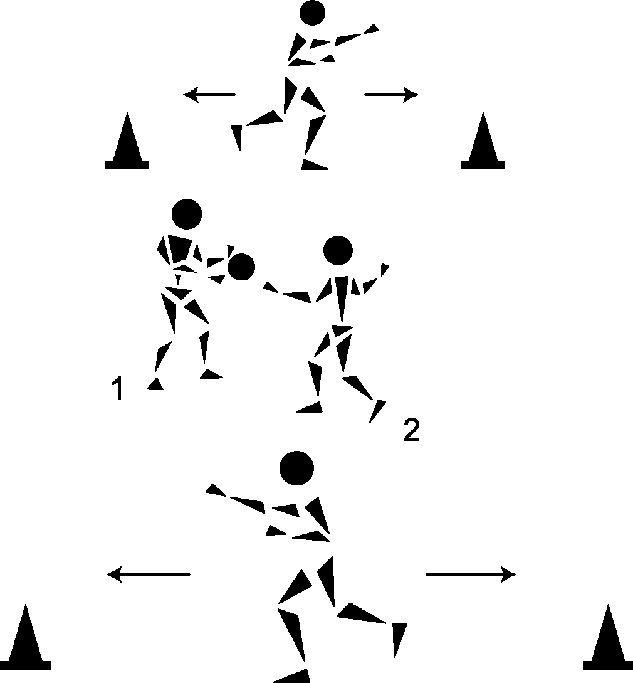  In a game of two on two, players 1 and 2 in the middle try to get the ball to their partners at the end, who can run only between the pylons. | Keep Away  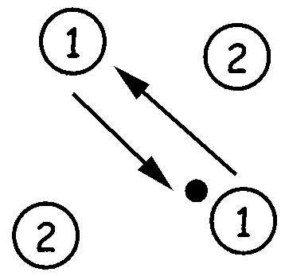  In a game of two on two, players pass the ball, trying to prevent the opposition from getting it. The person with the ball can only pivot, while the others move freely. | 3 Versus 1  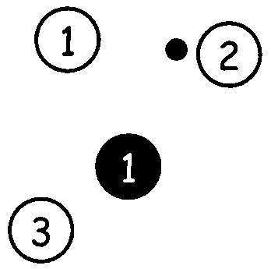  Three players pass to each other, while the defence in the middle tries to intercept. Switch roles every 30 seconds. | 3 Versus 3 Versus 3  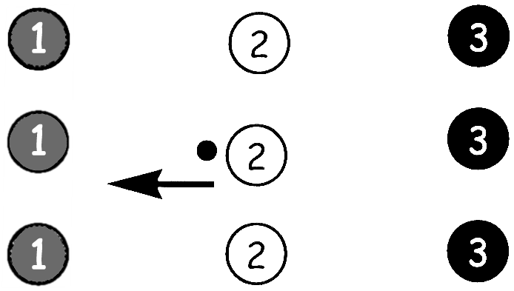  In a game of three versus three, the middle team starts with the ball. If they score or lose possession of the ball, they take the defensive team’s position.

