K.5.8.B.1  BLM  8-8 | Benefits Bubbles | 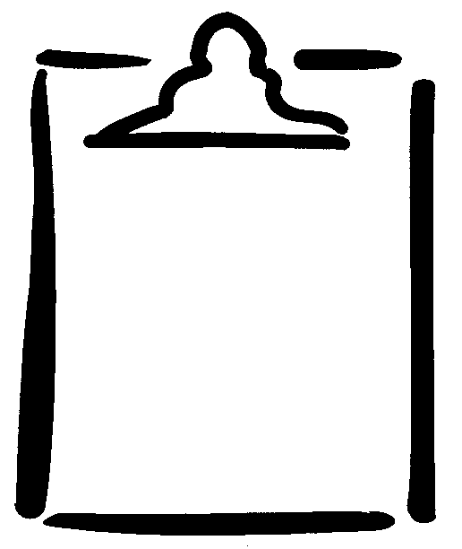

Name _________________________ Class _____________ Date ______________
Intensity | Activities | Benefits
Vigorous   |  | 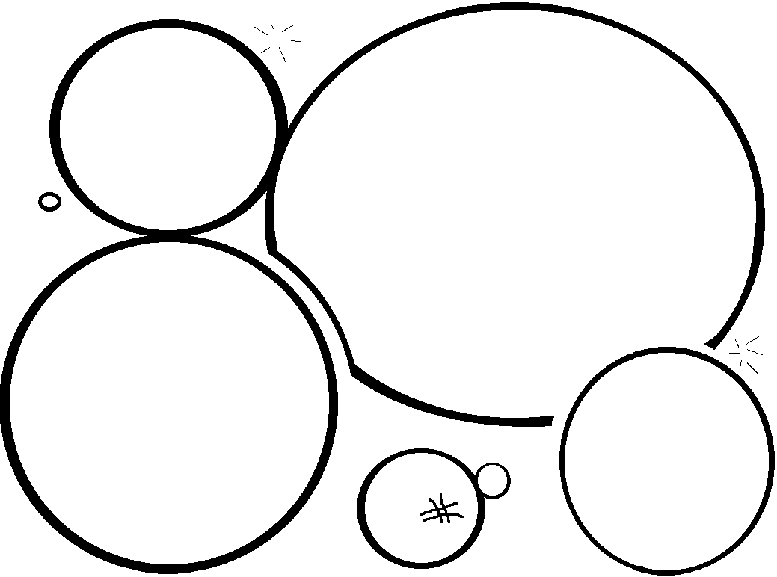
Moderate


Light



