K.3.8.A.2  BLM  8-4 | Examples of Exercise  Do's and Don’ts | 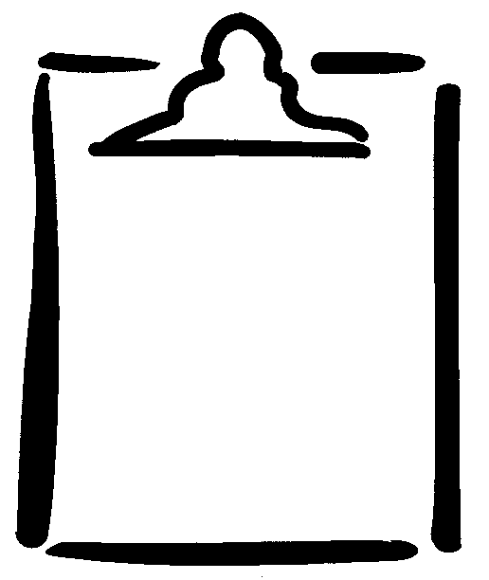

Don't |  | Do
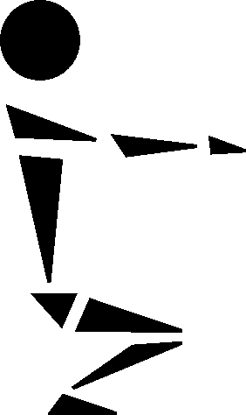 | Avoid knee flexing past 90°. | 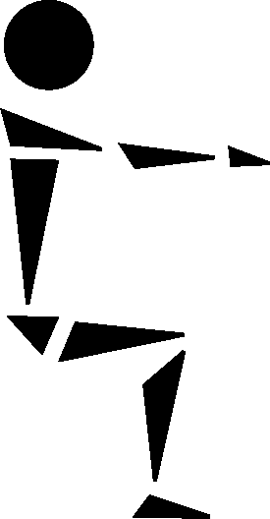
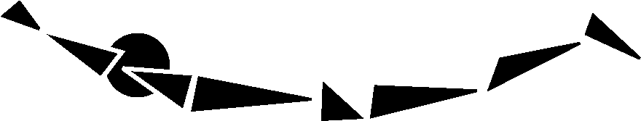 | Avoid back hyperextensions (arching). | 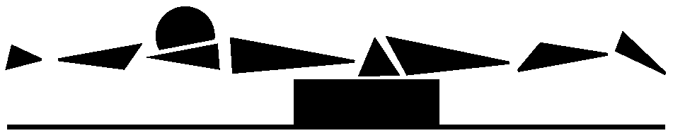
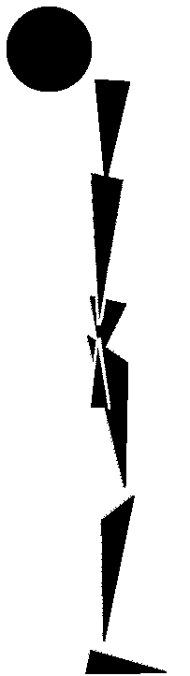 (side view) | Avoid neck hyperextensions and full neck rotations. | Perform forward and lateral neck flexion and frontal half-rotations.  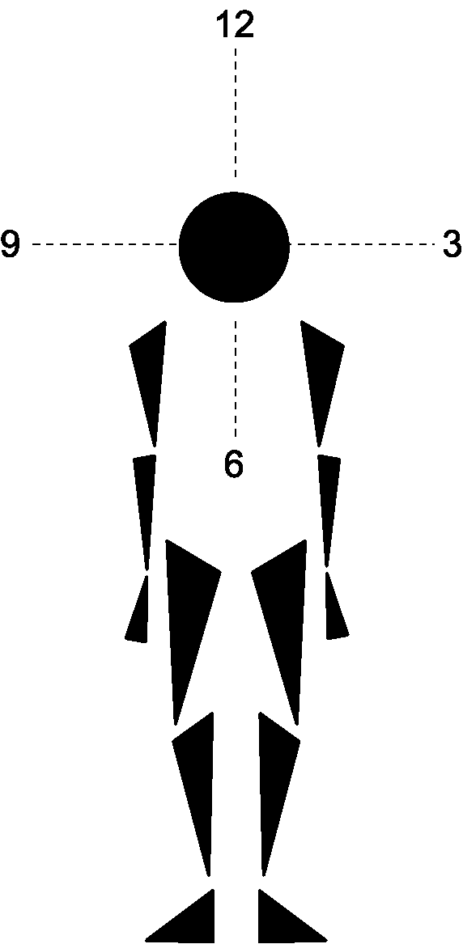
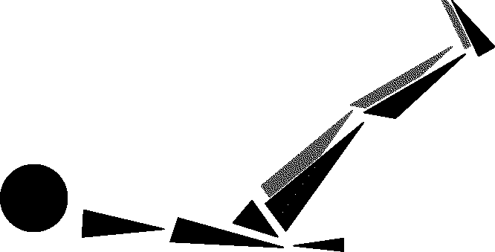 | Avoid double leg raises (compression on disks in back). | 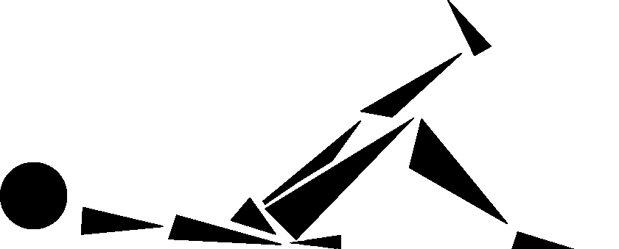
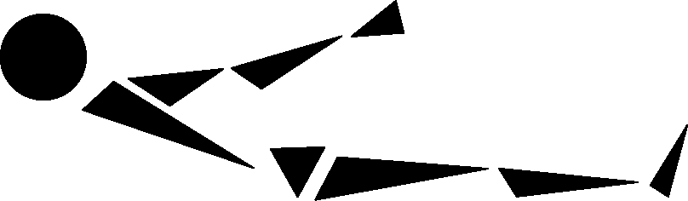 | Avoid straight leg sit-ups. | 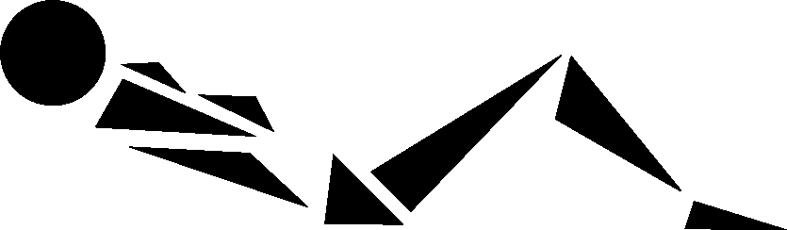
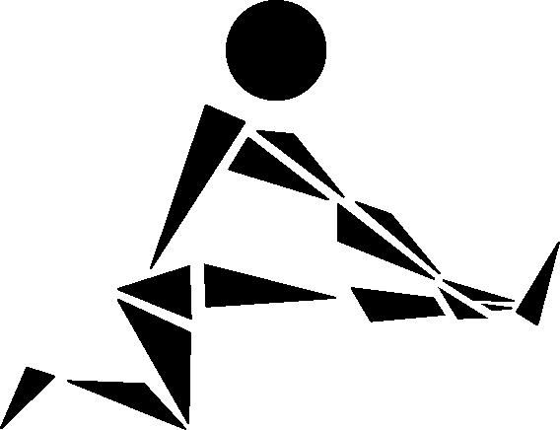 | Avoid knee hyperextensions. | 