S.1.8.D.1  BLM  8-3 | Bench–Step Circuit Cards* | 

V-Step | Basic Step | Run Step | Straddle Step
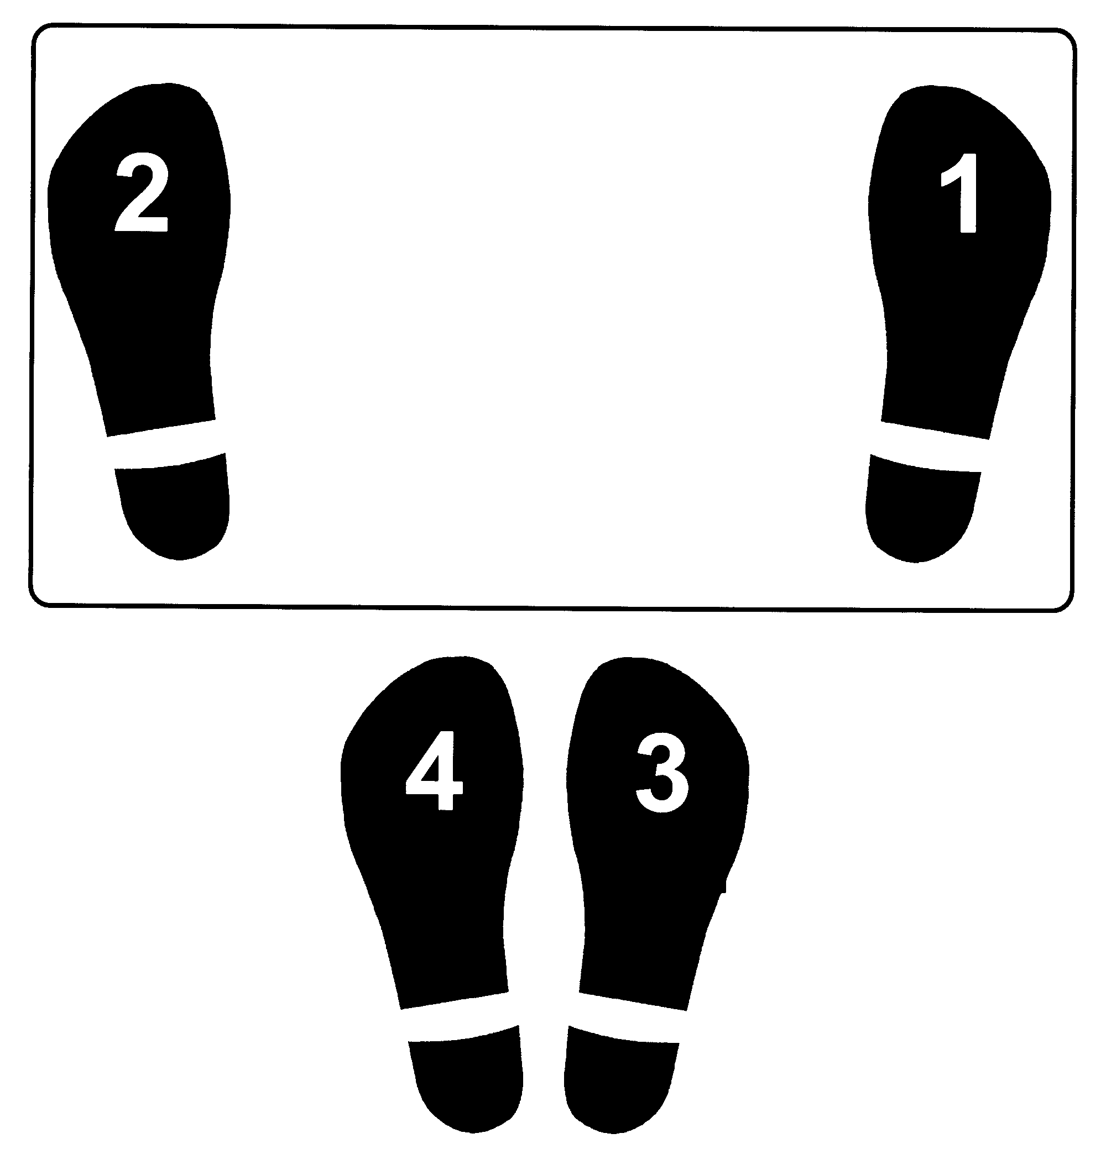 | 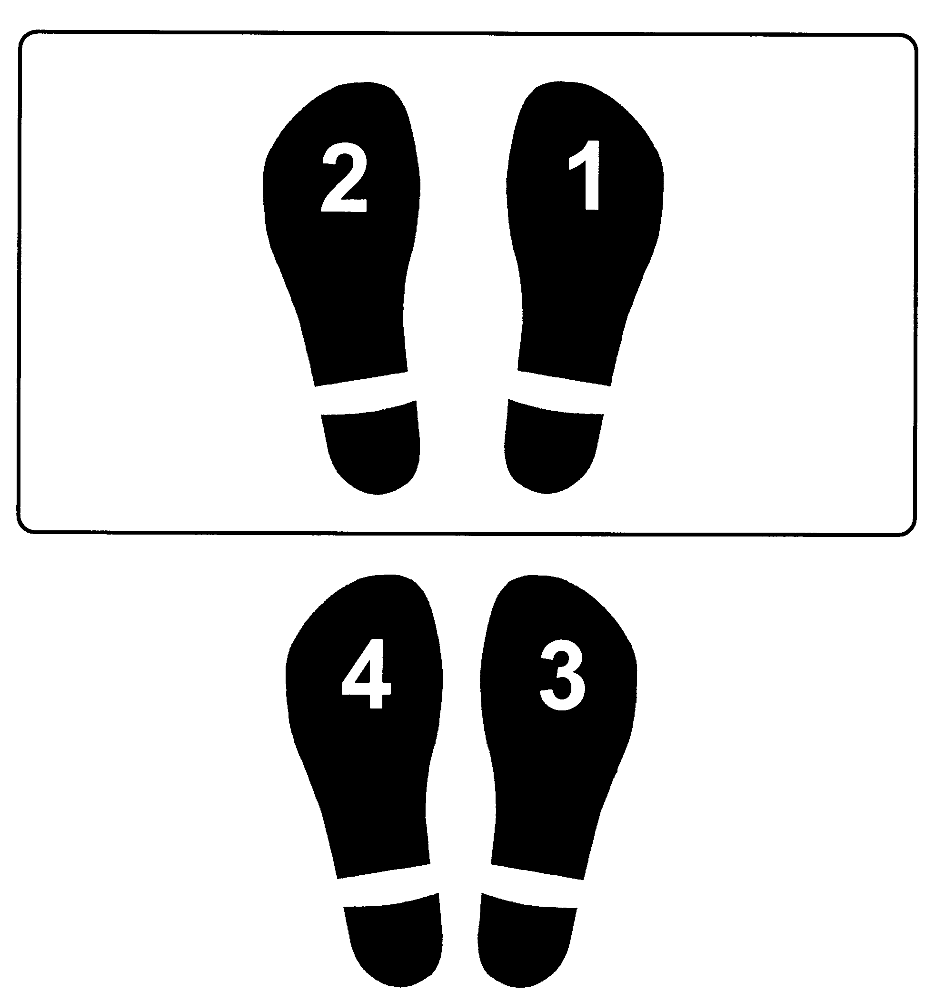 |  | 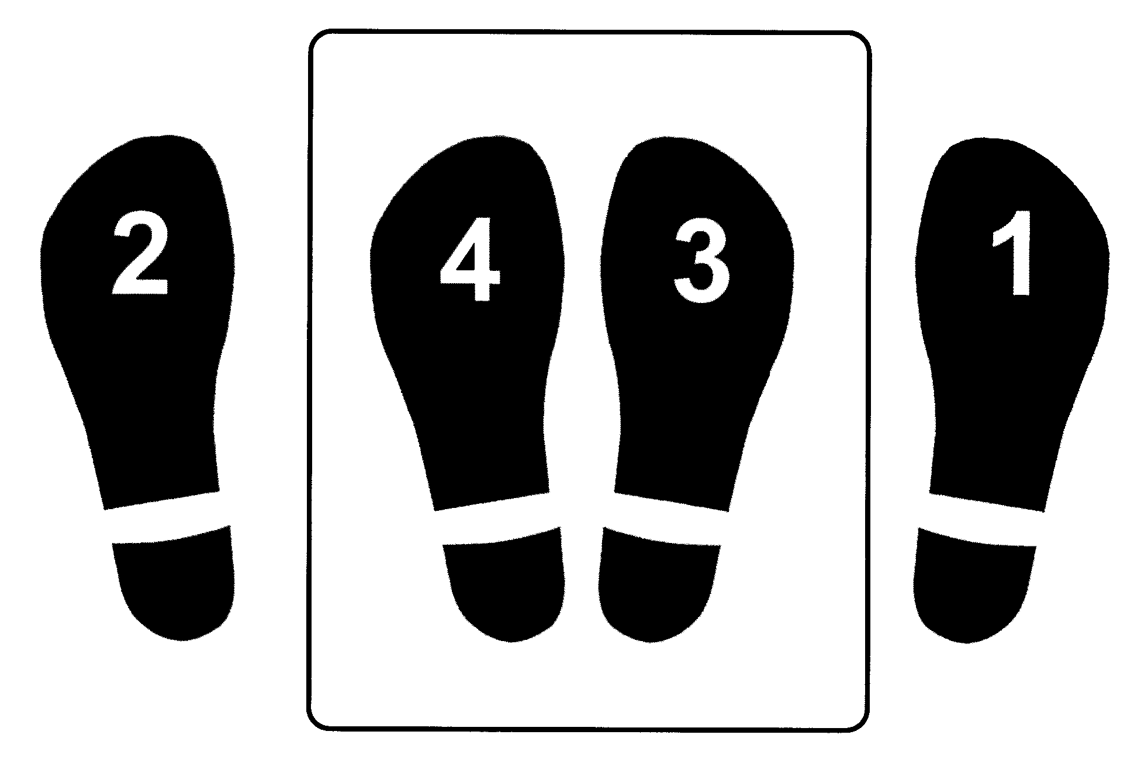
R-L-R-L | R-L-R-L | R-L-R-L | R-L-R-L
Straddle Jump | Lunge | Knee-Up | Side Squat
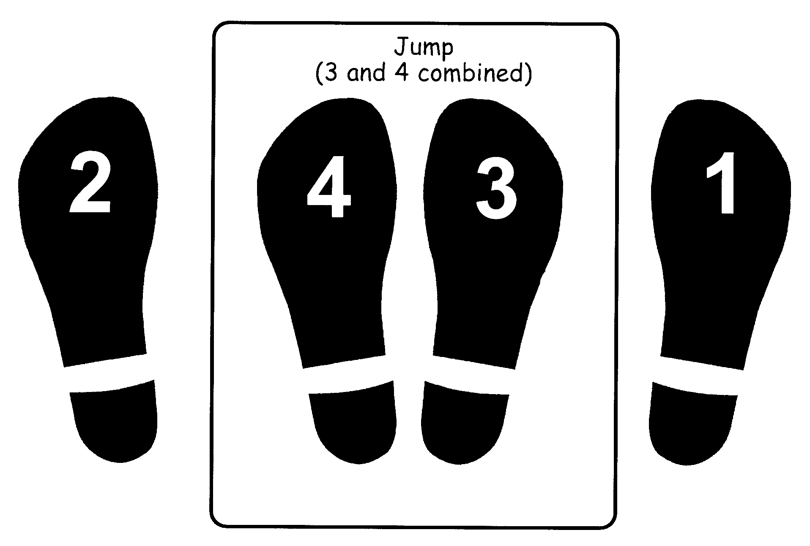 | 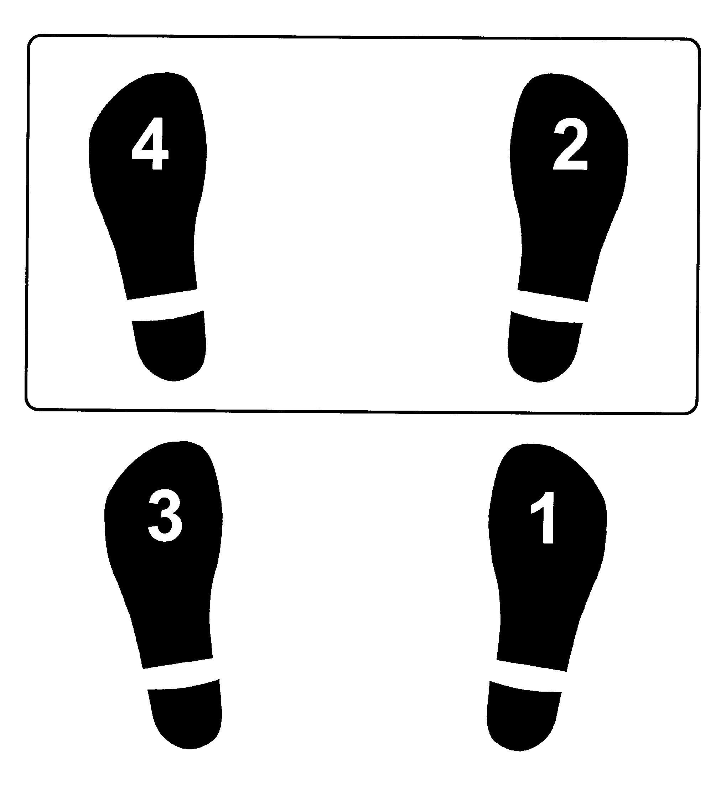 | 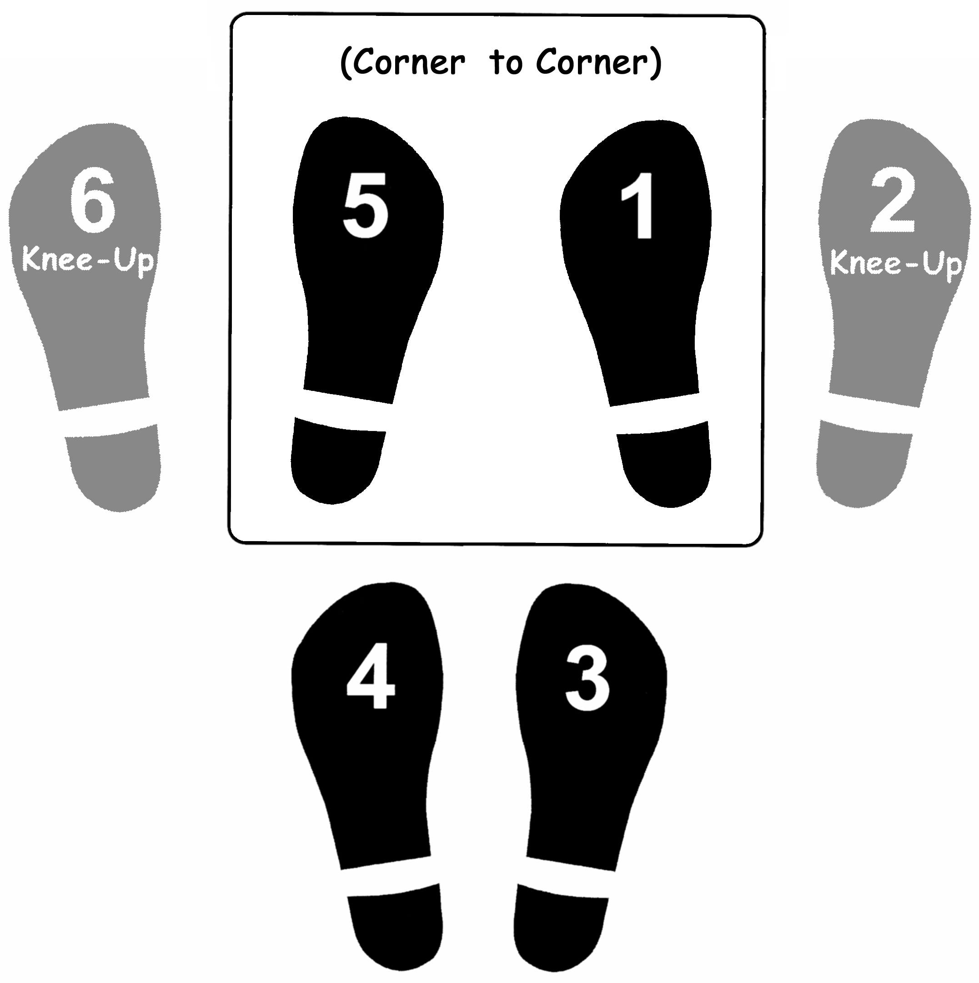 | 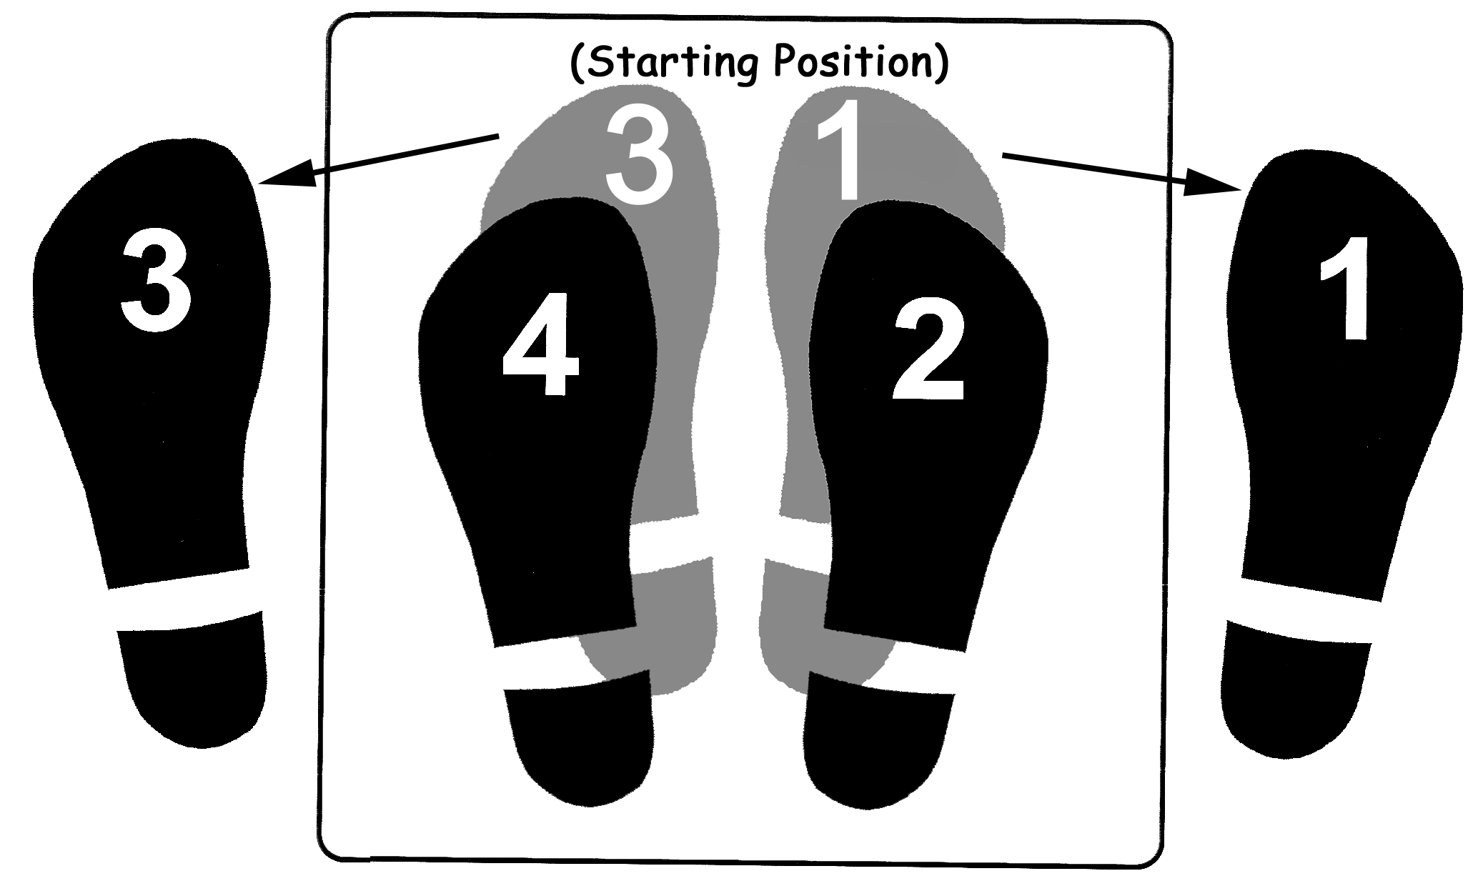
R-L-Jump | R-R-L-L | L-R-R-L-R-L-L | R-R-L-L
Charleston Step | T-Step | Turn Step | Combination
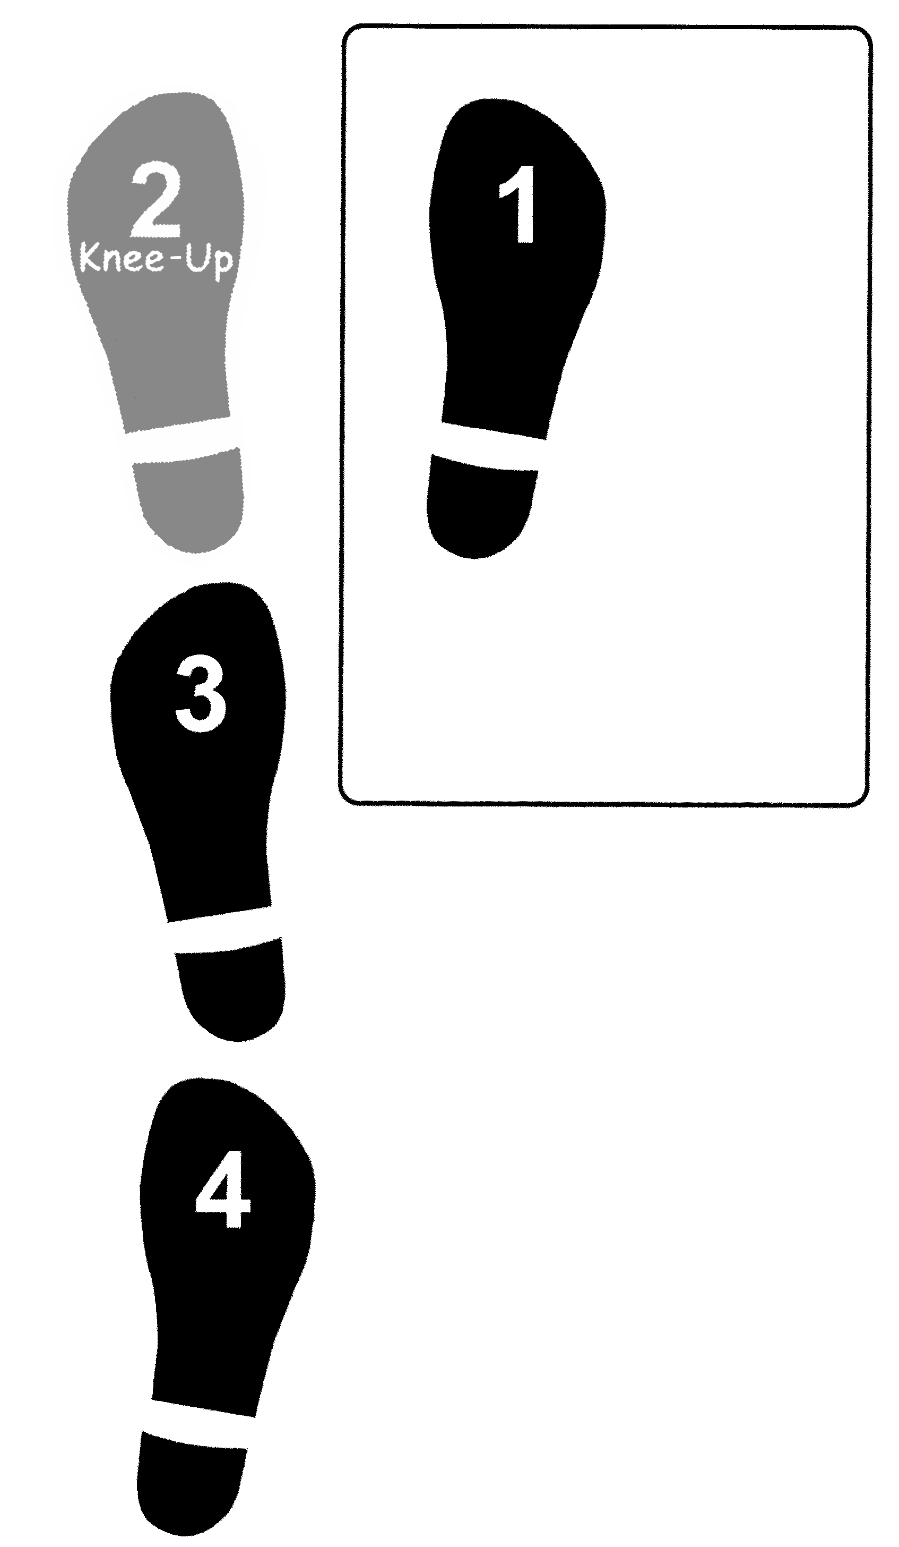 | 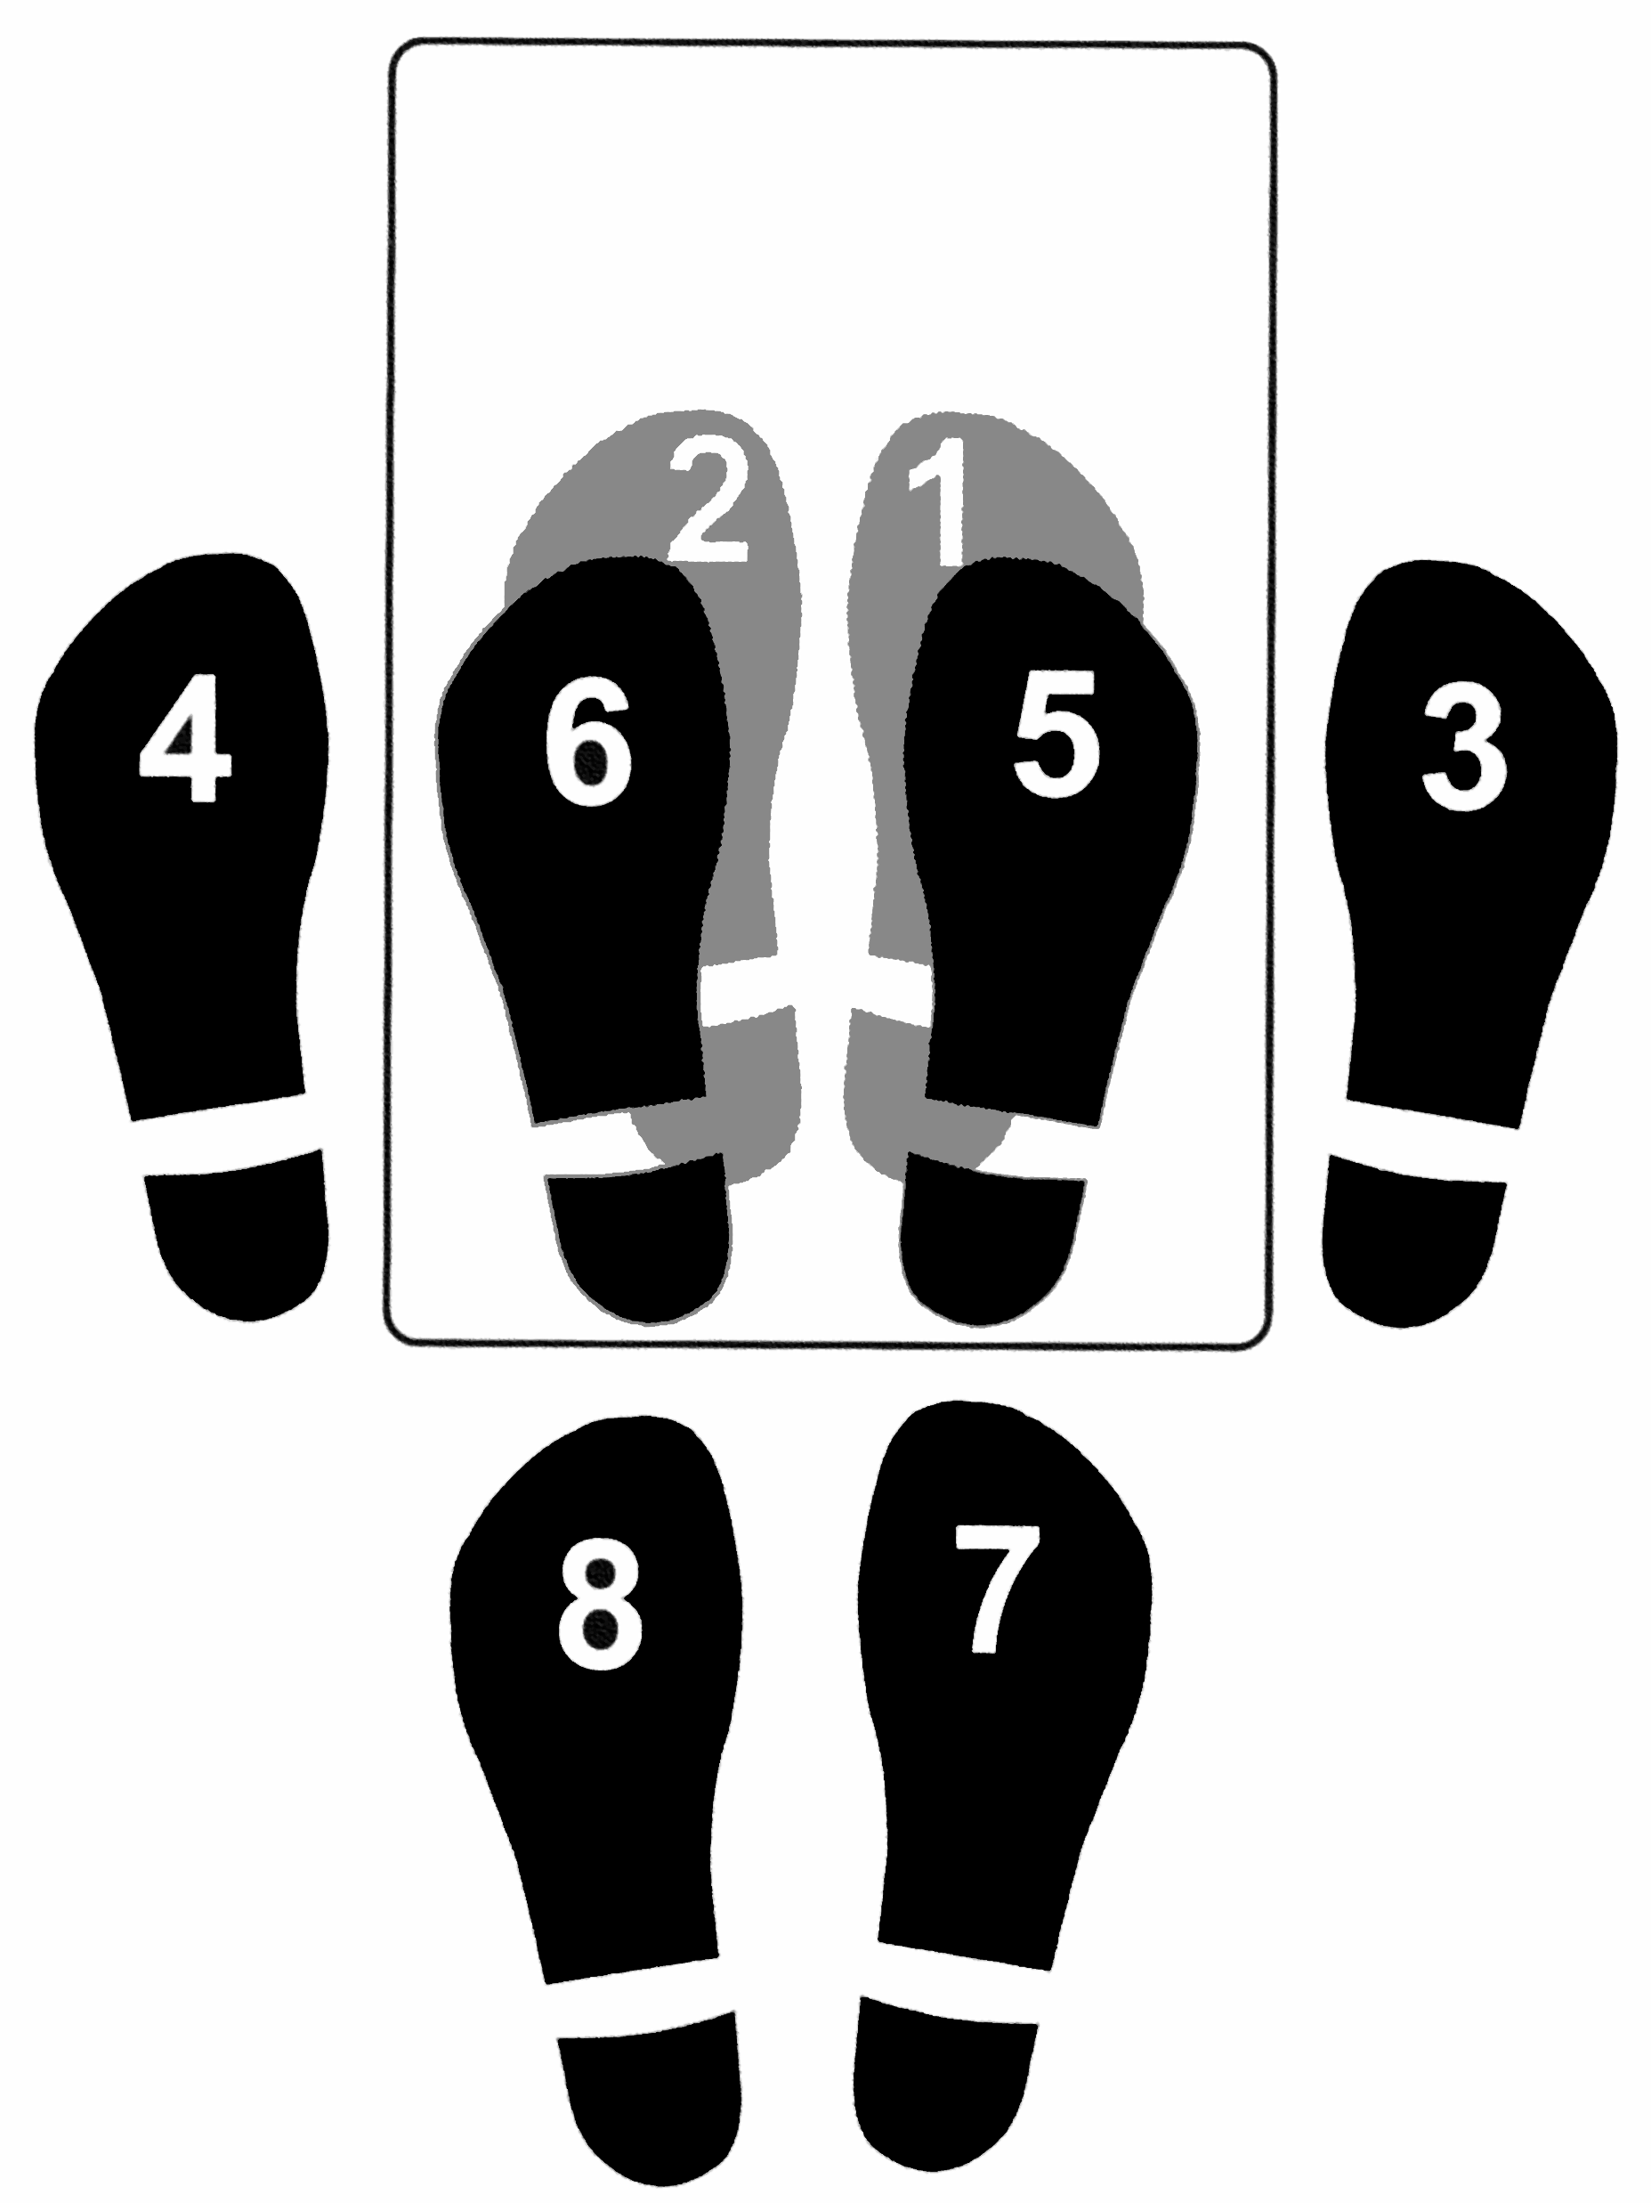 | 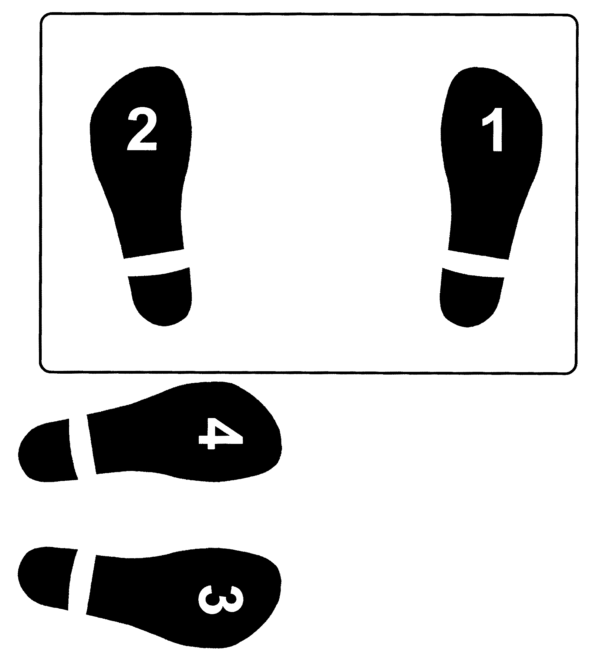 | V-Step (three times)  Jumping Jack  (two times)  
R-L-L-R | R-L-R-L-R-L-R-L | R-L-R-L L-R-L-R
Bench-Step Circuit Cards: Adapted with permission from Cheryl McCombe, Fort Richmond Collegiate, Pembina Trails S.D.
*Note: For larger cards, refer to the Manitoba Education and Youth website: <http://www.edu.gov.mb.ca/ks4/cur>.

