S.1.8.D.1  BLM  8-3l | Bench–Step Circuit Card | 

V-Steps (three times)
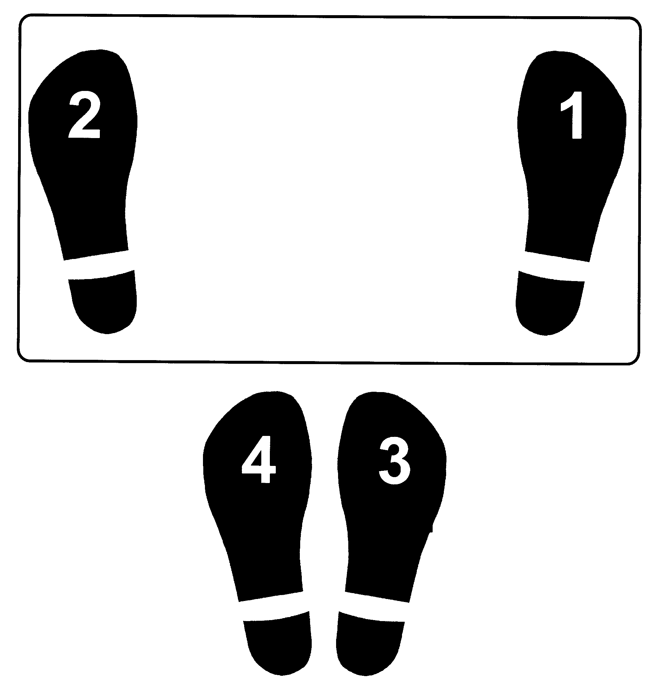

Plus

Jumping Jacks (two times)

(on the floor)


Bench-Step Circuit Cards: Adapted with permission from Cheryl McCombe, Fort Richmond Collegiate, Pembina Trails S.D.

