S.1.8.D.1  BLM  8-3k | Bench–Step Circuit Card | 

Turn Step
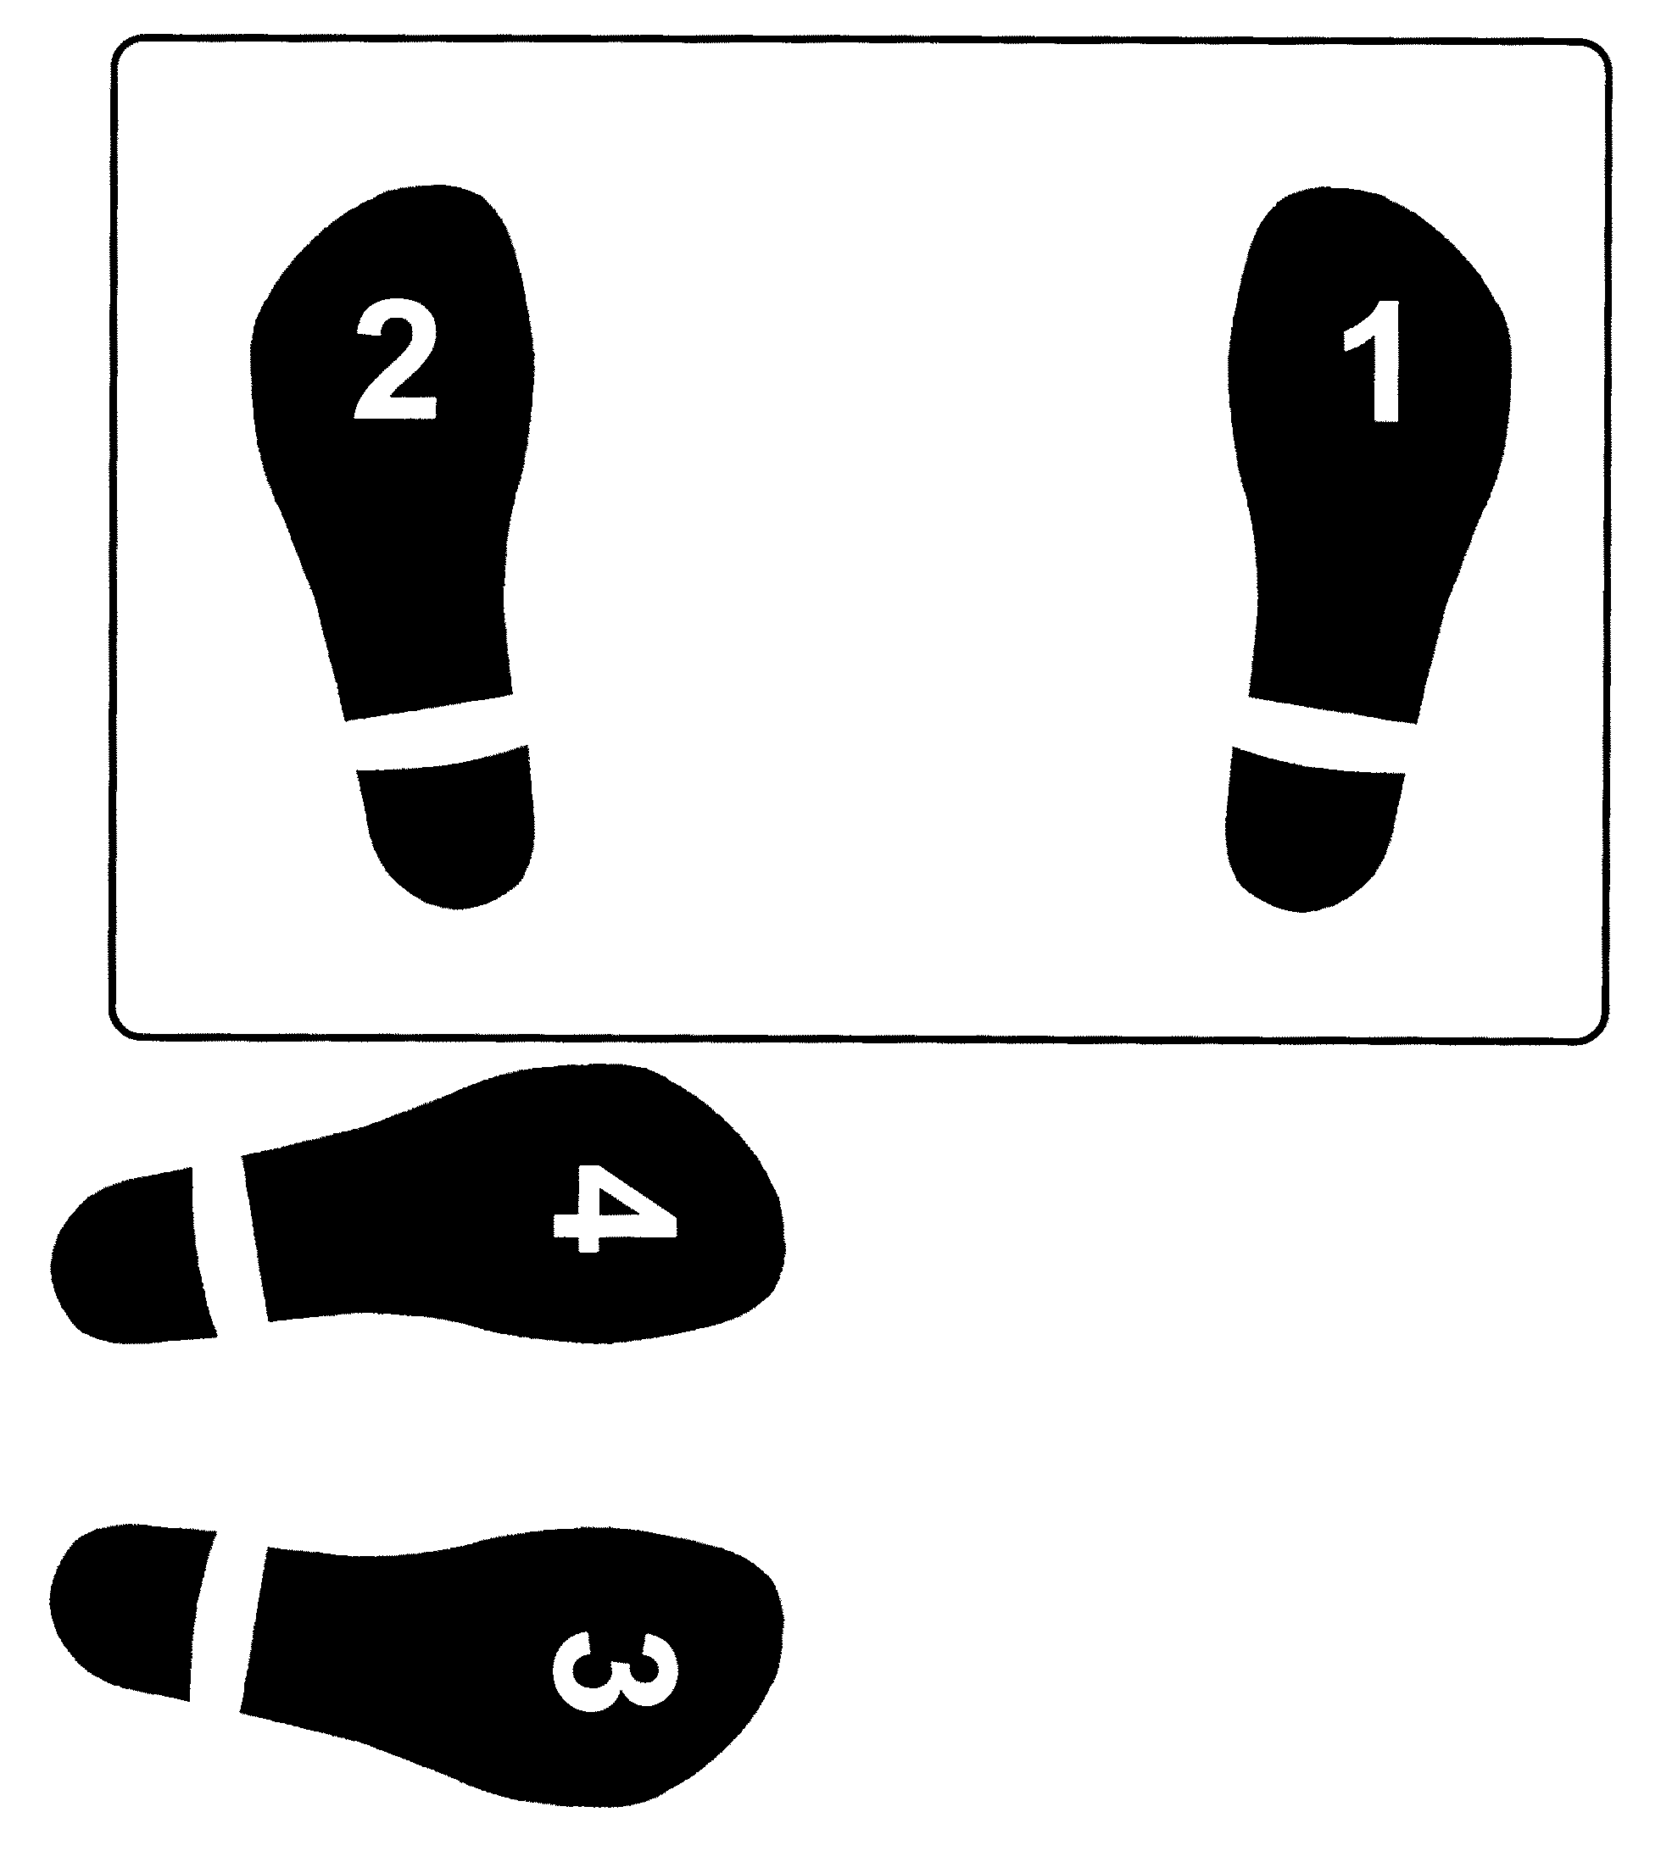

R-L-R-L L-R-L-R

Bench-Step Circuit Cards: Adapted with permission from Cheryl McCombe, Fort Richmond Collegiate, Pembina Trails S.D.

