S.1.8.D.1  BLM  8-3j | Bench–Step Circuit Card | 

T-Step
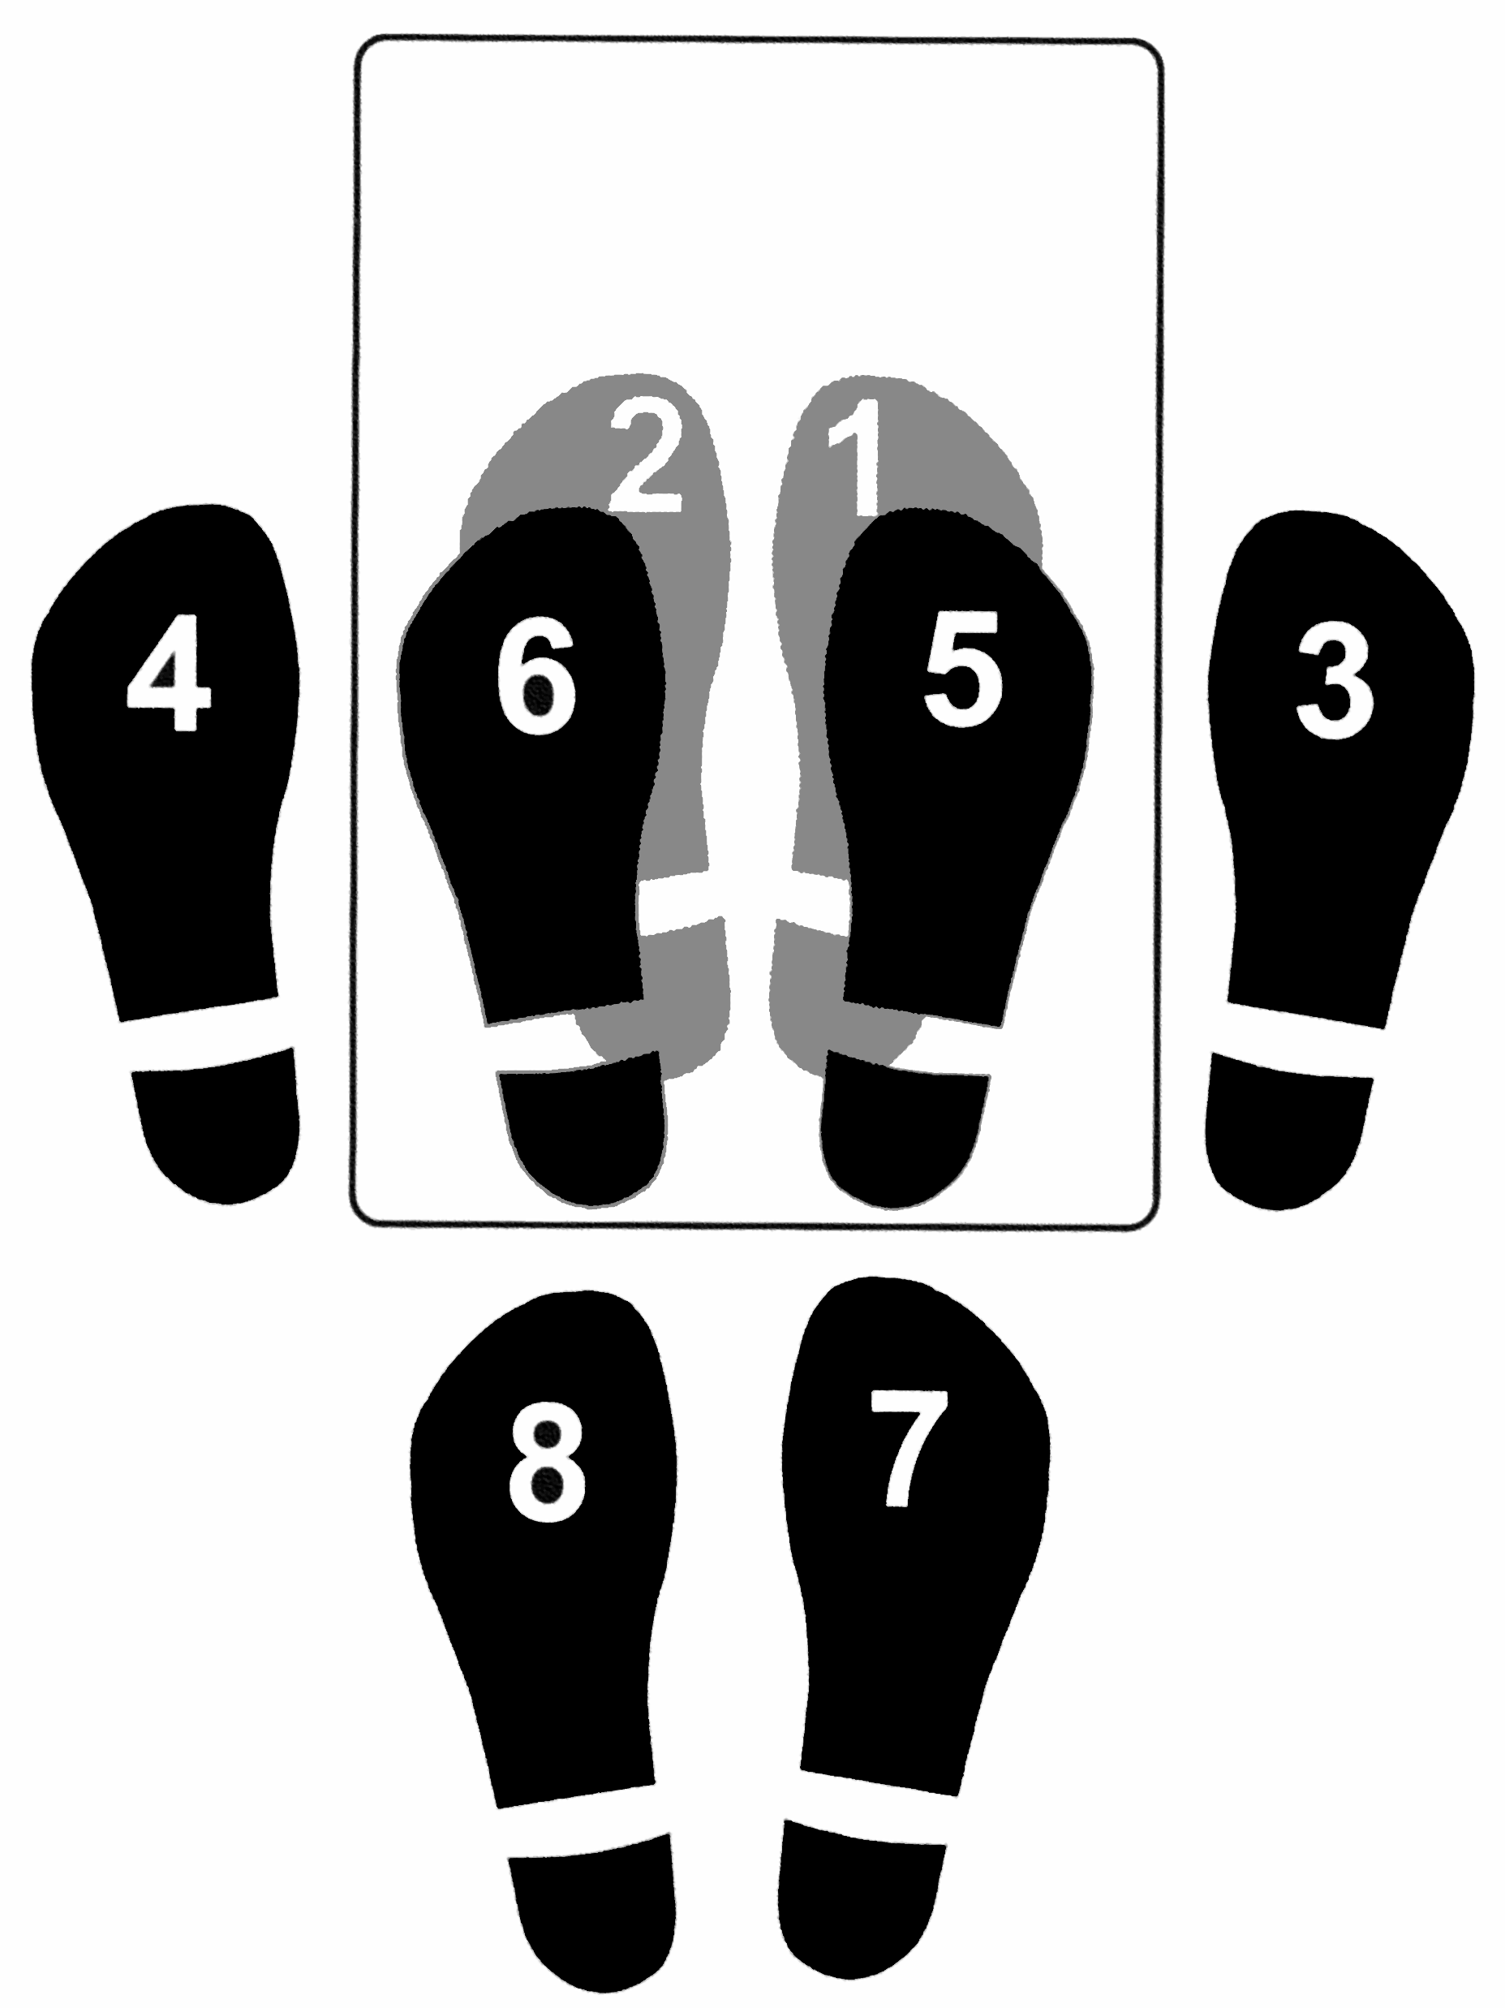

R-L-R-L-R-L-R-L
Bench-Step Circuit Cards: Adapted with permission from Cheryl McCombe, Fort Richmond Collegiate, Pembina Trails S.D.

