S.1.8.D.1  BLM  8-3f | Bench–Step Circuit Card | 

Lunge
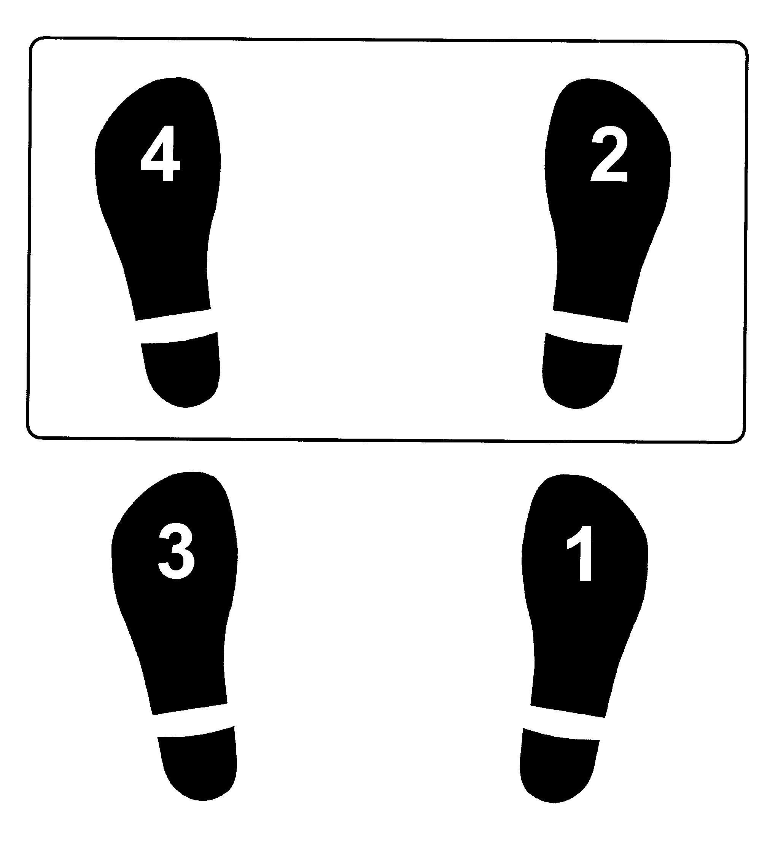

R-R-L-L

