S.1.8.D.1  BLM  8-3e | Bench–Step Circuit Card | 

Straddle Jump
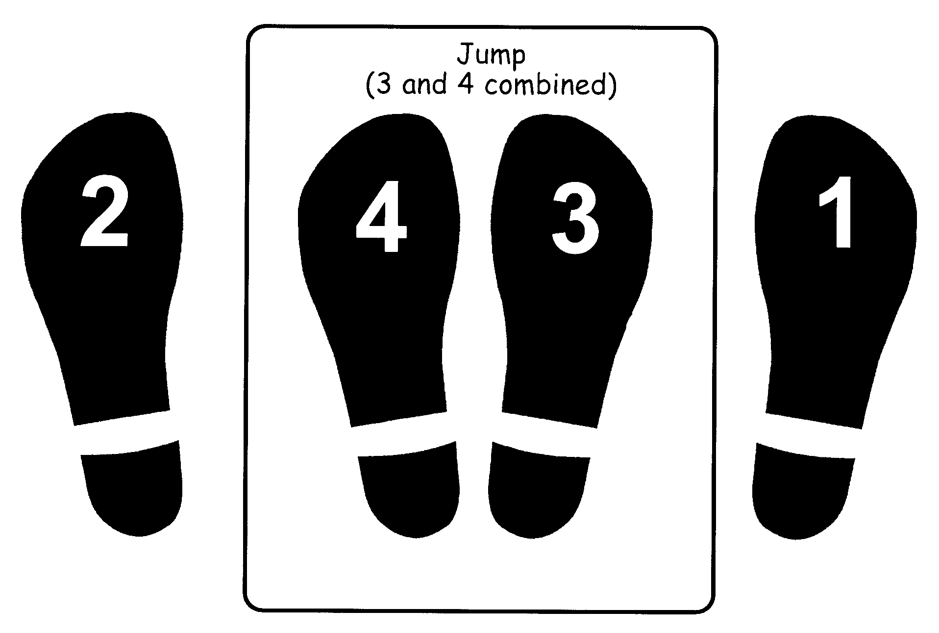

R-L-Jump

