S.1.8.D.1  BLM  8-3d | Bench–Step Circuit Card | 

Straddle Step
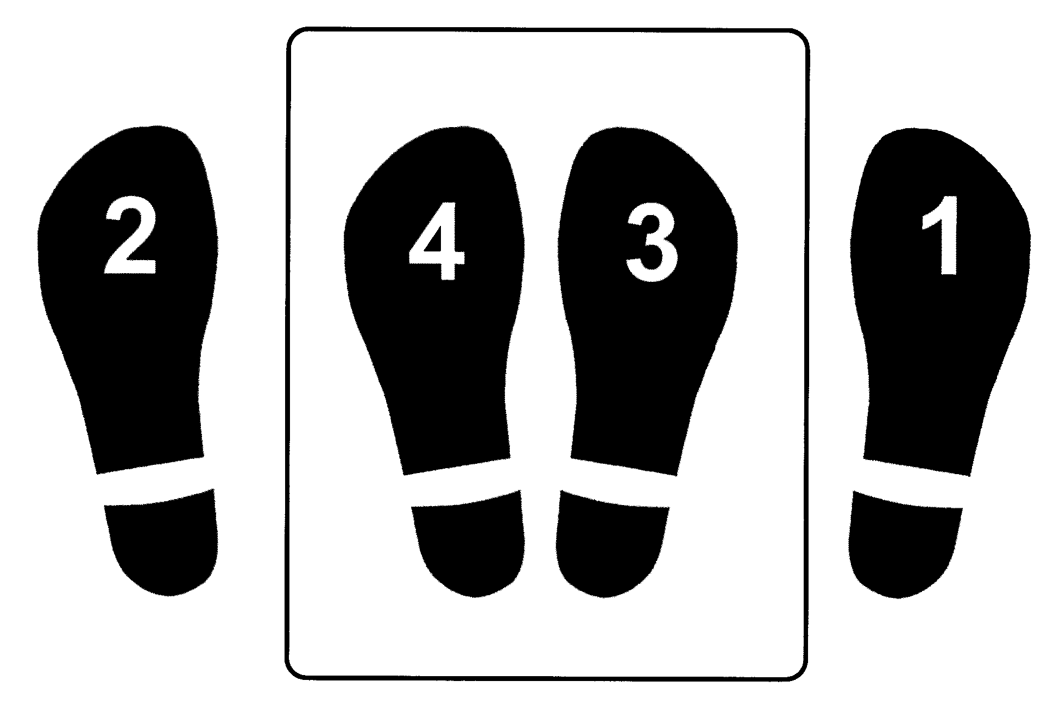

R-L-R-L

