K.5.7.D.2  BLM  7-8 | Consequence Circle |  | 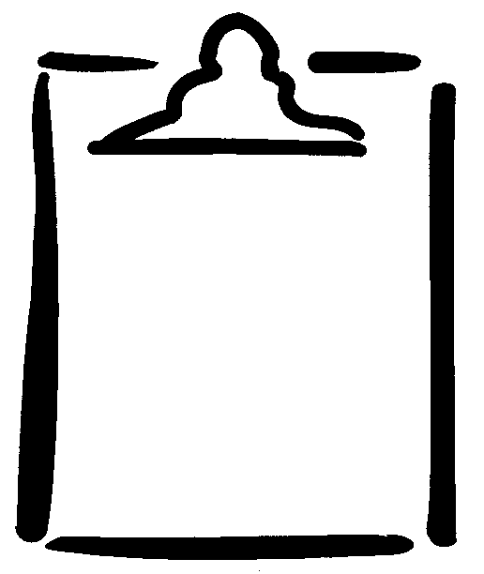
Name |  | Class | Date
Show/list the various consequences/implications of taking harmful or beneficial drugs or other substances.

