S.2.7.A.3a  BLM  7-6  S.2.7.A.3b  K.2.8.C.2  S.2.8.A.1a  S.2.8.A.3a | S.2.8.A.3b  K.4.8.A.2a  S.4.8.A.1  S.5.8.A.2  S.5.8.A.3 | Personal Fitness Record |  | 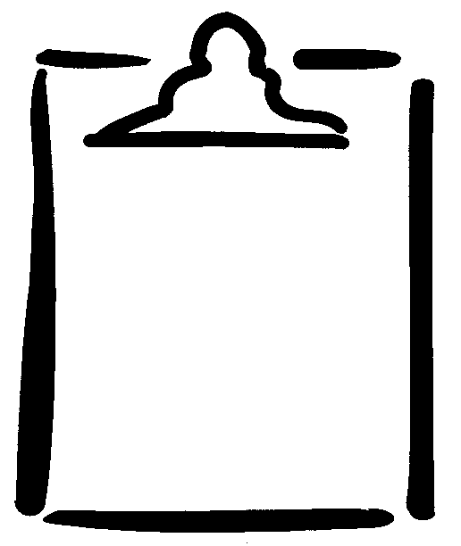  Page 1 of 2
Name |  |  | Class | Date

Background Information: Use the following FITT principle and general guidelines when setting goals and developing action plans on the next page.

FITT Principle | Guidelines
Frequency:  How many times a week should I work out? | - Perform cardiovascular endurance workouts at least four to seven days a week.  - Perform muscular strength and endurance exercises two to four days a week.  - Perform flexibility exercises four to seven days a week.
Intensity:  Intensity Levels:  Overall, train within intensity level 2 or 3, using these indicators:  1 - Body slightly warm, heart rate slightly elevated.  2 - Some perspiration, faster than normal breathing.  3 - Maximum effort, heavy perspiration, and heavy breathing.  How hard should I train? | - For developing cardiovascular endurance, stay within your target heart-rate zone for a minimum of 20 minutes.  Determine target heart-rate zone* using the following formula:  Lower limit: 220 – (your age) x . ____ (lower percentage) = _____divided by 6 =_________ beats per 10 seconds.  Upper limit: 220 – (your age) x . _____ (upper percentage) = _____divided by 6 =_________beats per 10 seconds.  - For developing muscular strength and endurance, perform exercises to moderate fatigue with proper technique.  - For developing flexibility, ensure stretches are controlled and sustained (no bouncing).  * To calculate a target heart-rate zone, select percentages that are appropriate to age and ability. A guideline for determining target heart-rate zone for vigorous activities is 70% (.70) to 85% (.85).
Time:  For how long will I need to work out? | - For developing cardiovascular endurance, participate for 20 to 60 minutes to develop aerobic fitness.  - For developing muscular endurance and strength, perform two or three sets of eight to 12 repetitions.  - For developing flexibility, hold each stretch for 10 to 20 seconds and repeat three times. The best time to stretch is after a muscle is warm.
Type:  What type of activities do I need to do to improve for each fitness component? | - Cardiovascular endurance activities are large muscle group activities that make you breathe deeper, make your heart beat faster, and make you feel warm.  - Muscular strength and endurance activities such as lifting free weights and resistance training (using bands, tubing) build your muscles. Choose specific exercises for specific muscle groups.  - Flexibility activities include bending, stretching, and reaching activities that keep your joints moving. Choose stretching exercises that are specific to muscle groups.

