K.2.7.A.1  BLM  7-5 | Health-Related Fitness Components Questionnaire |  | 
Name |  | Class | Date

Health-Related Fitness Components
Muscular  strength | Cardiovascular endurance | Muscular  endurance | Flexibility

Complete each of the following definitions by inserting the applicable health-related fitness components in the spaces provided.

1.  _______________________________  is the amount of force exerted by the muscles in a single effort. | 
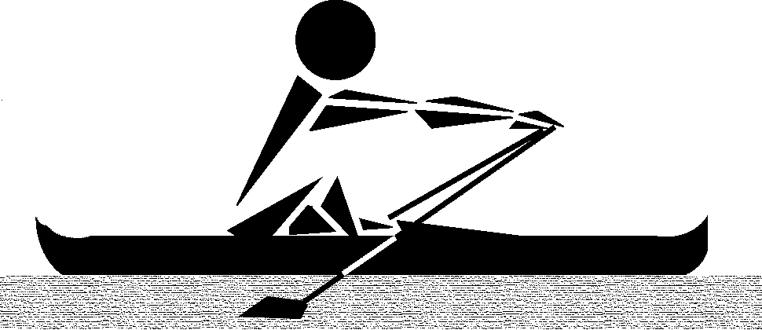 | 2.  _______________________________  is the ability of the muscles to exert a force over a period of time without incurring fatigue.
3.  _______________________________  is the ability of the heart, blood vessels, and lungs to provide working muscles with oxygen over a prolonged activity. | 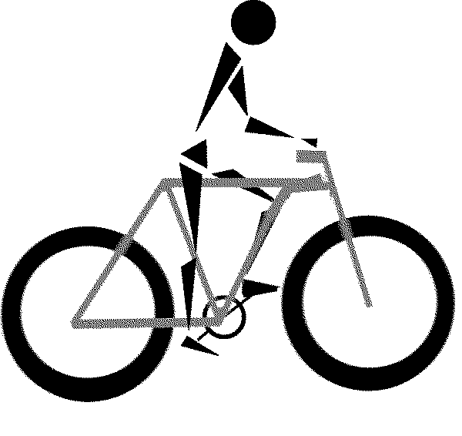
 | 4.  ______________________________  is the range and ease of movement of a joint.

