S.1.7.C.1  BLM  7-2 | Orienteering Relay Symbols | 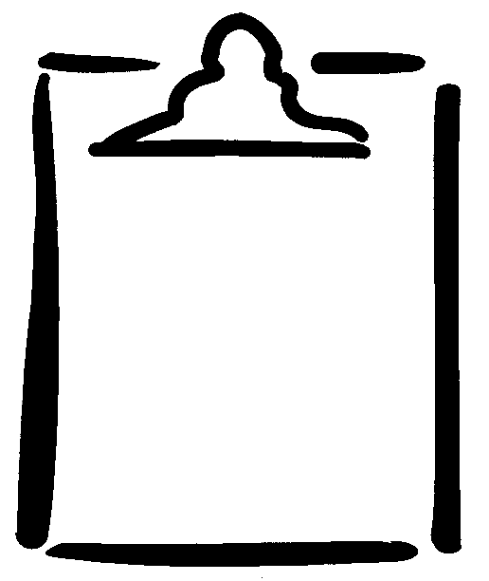
Page 1 of 2
