S.1.7.C.1  BLM  7-2 | Orienteering Relay Symbols  (Answer Key) | 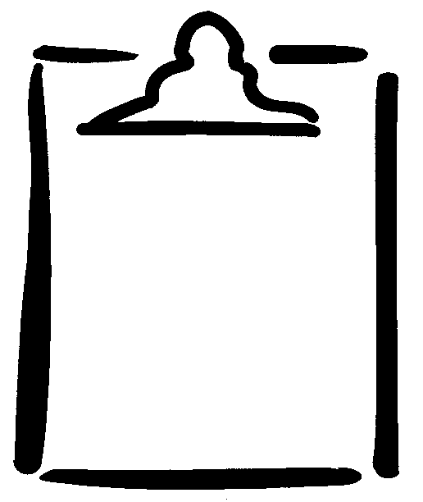
Page 2 of 2
