K.2.6.C.1a K.2.6.C.1b  BLM  6-4 | Skeleton Diagram  (Parts of Skeleton) |  |  |  |  | 
 |  |  |  |  | Page 5 of 5
Name ____________________ |  |  | Class ____________________ |  | Date ___________
Name: ____________________ |  |  | Class: ____________________ |  | Date: ___________
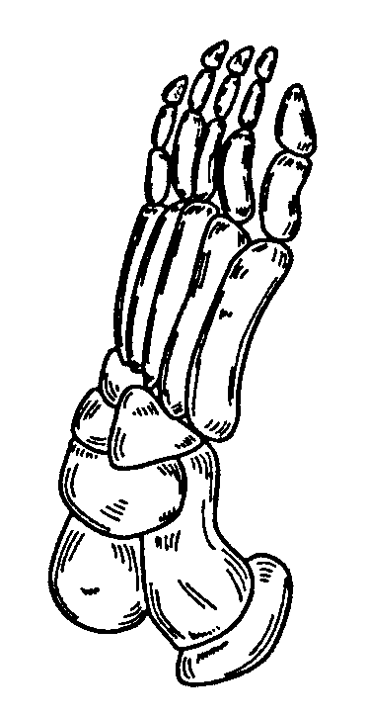 |  | 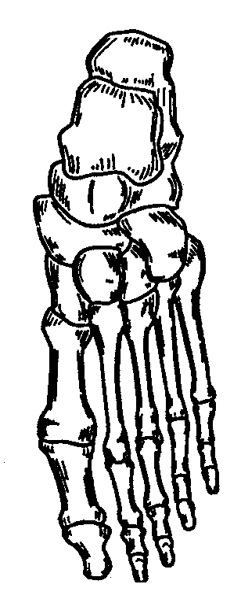 |  | 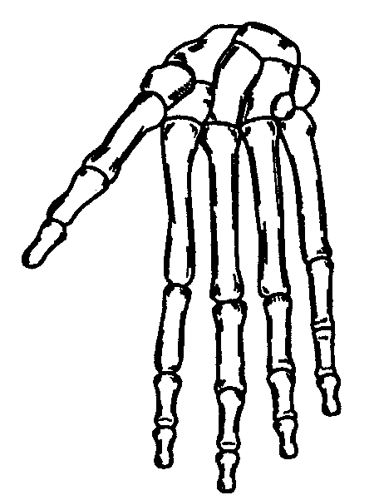
 |  | 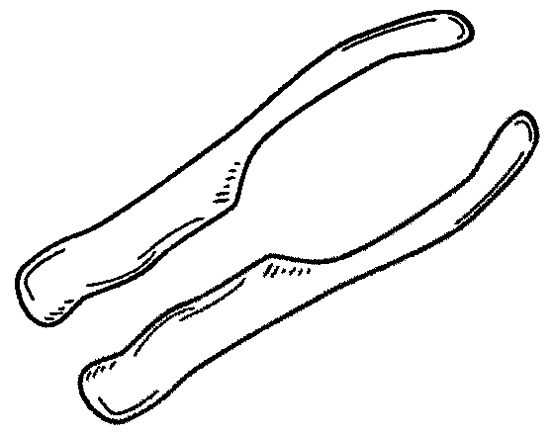
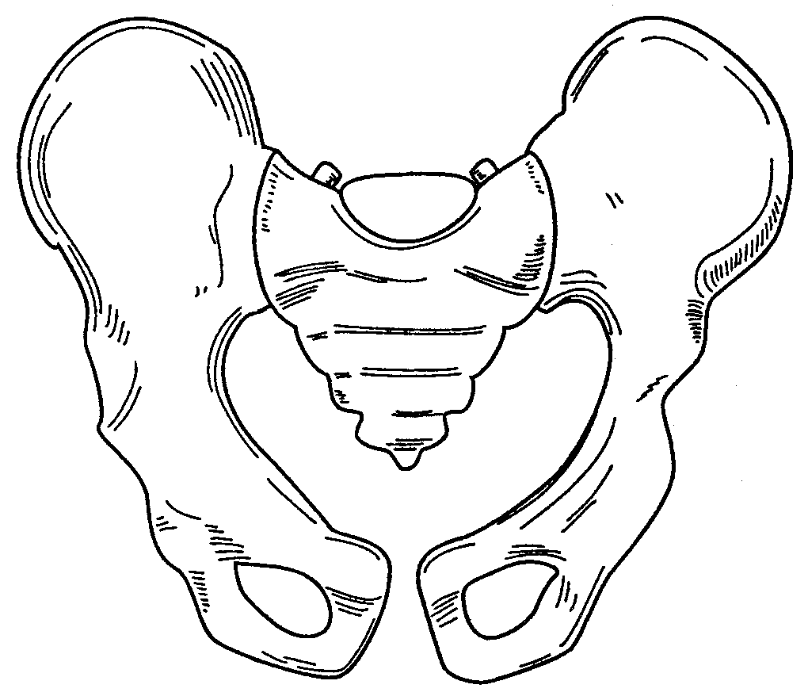 |  |  |  | 