K.1.6.B.3  BLM  6-2  S.1.6.D.2 | Gymnastic Routine |  |  | 
 |  | Class _____________________ | Date ____________
Student Names _____________ |  | __________________________ | ________________
__________________________ |  | __________________________ | ________________

In your group, create a gymnastic routine that has the following characteristics. Write/ draw them in the spaces provided below.
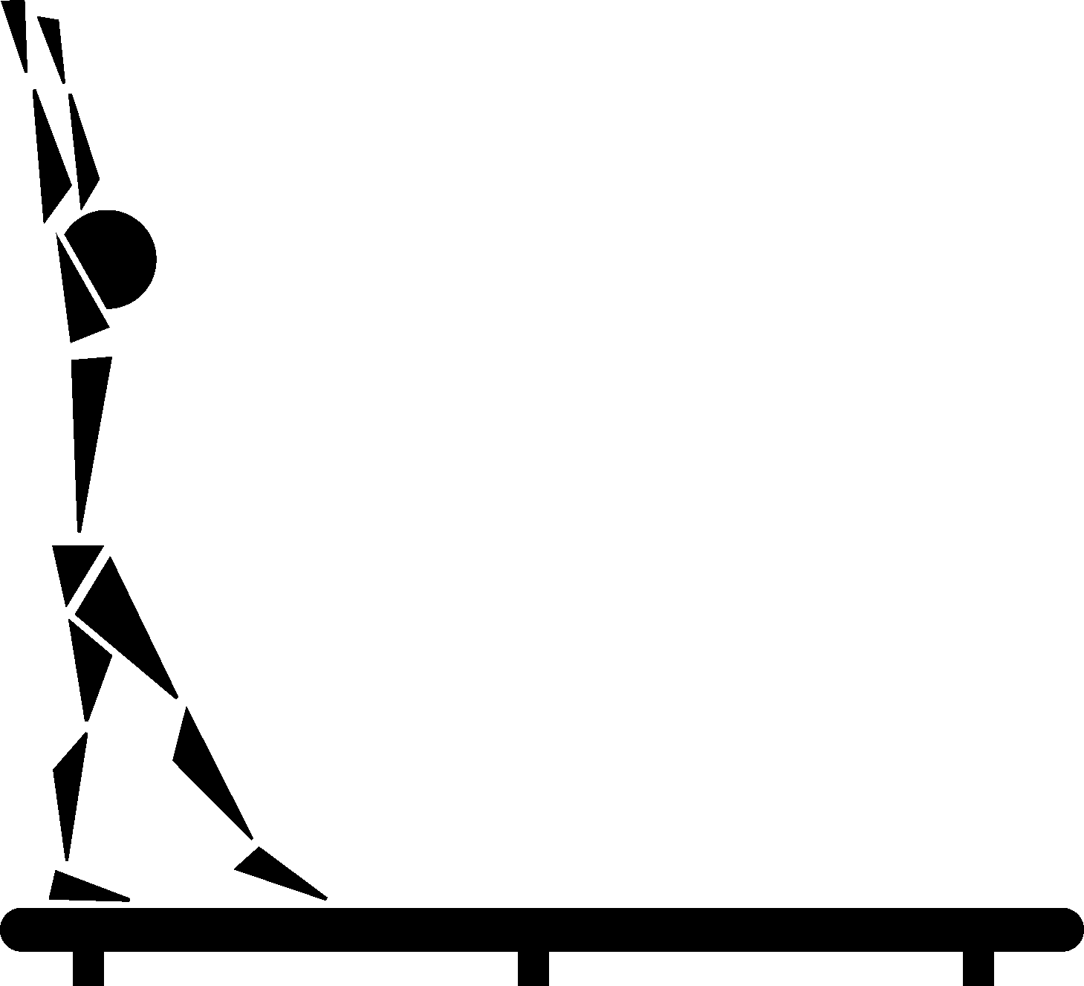
Beginning pose (hold for count of three)
Three different combinations of skills

Two changes of levels (e.g., high to low, low to high, medium to high)

Two changes in directions (e.g., forwards to backwards, sideways to backwards)

Two changes of pathways (e.g., straight, zigzag, curved)

Two changes of formations (e.g., circle to straight line, straight line to backwards)


Ending pose (hold for count of three)

Routine is polished (evidence of practice)

