K.1.6.B.2  BLM  6-1 | Overhand Throwing for Distance | 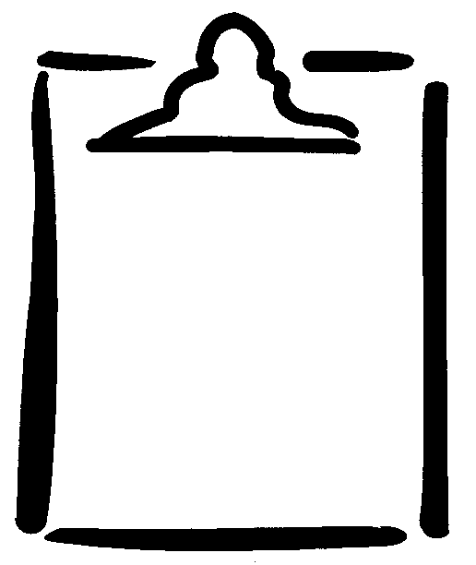
Class ___________________________________ Date __________________________
Instructions: Place group members' names in the first column of the chart below. Have each member throw a beanbag from a designated starting point, and then measure and record the results under Throw 1. Repeat the same steps for Throw 2 and Throw 3.

Name | Throw 1 | Throw 2 | Throw 3
Name | Stand facing forward, feet together, and throw. | Stand sideways, feet shoulder-width apart, rotate the hips and trunk (no step), and throw. | Stand sideways, weight on the back foot, step forward, rotate the hips and trunk, and throw.

Measure each throw. Circle the farthest throw.
As a group, explain the results using biomechanical concepts:
________________________________________________________________________
________________________________________________________________________
________________________________________________________________________
________________________________________________________________________
________________________________________________________________________
________________________________________________________________________
________________________________________________________________________

