K.2.5.A.1  BLM  5-5  S.2.5.A.3a  S.2.5.A.3b | Personal Record Sheet |  | 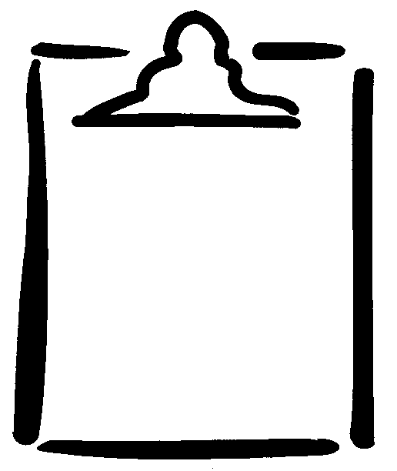
Name |  | Class | Date
Part 1: Complete the following chart.
Fitness Task/Test | Health-Related Fitness Component | Term 1 | Goal | Term 2 | Goal | Term 3

Part 2: For a set period of time, keep a record of how many minutes you are physically active each day, participating in moderate and vigorous physical activity. Based on this information, indicate on the following chart whether you met (M) or have not yet (NY) met the recommended time. This time can be accumulated throughout the day or all at once.
Term/Date | At Least 60 Minutes of  Moderate Physical Activity* | At Least 30 Minutes of  Vigorous Physical Activity*
* Based on Canada's Physical Activity Guide for Youth (Health Canada).

Part 3: Identify the health-related fitness components, your goal(s), and an example of a physical activity/exercise you will do to help you improve in each area.
Health-Related Fitness Component | Goal | Exercise to Improve

