K.1.5.B.3b  BLM  5-3 | Body Sculpture Cards | 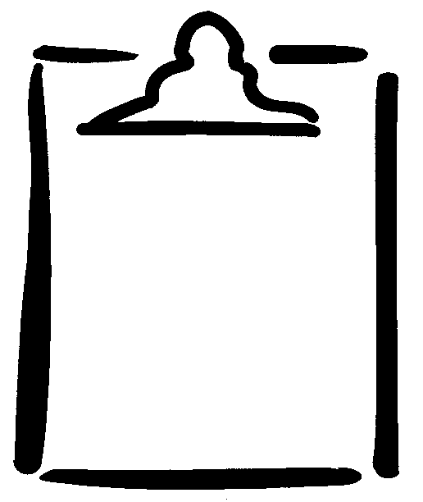

Flex Right Elbow | Flex Right Knee | Flex Left Elbow | Flex Left Knee | Flex Right Elbow and Left Knee
Flex Left Elbow and Right Knee | Flex Right Knee and Right Elbow | Flex Left Knee and Left Elbow | Flex Right Hip | Flex Left Hip
Rotate Left Hip | Rotate Trunk | Flex Trunk | Flex Right Elbow, Left Hip, and Left Knee | Flex Left Elbow, Right Hip, and Right Knee
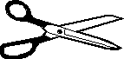  Flex Right Hip and Right Knee | Flex Left Hip and Left Knee | Rotate Right Shoulder | Rotate Left Shoulder | Rotate Right Hip

