K.1.5.B.3a  BLM  5-2  S.1.5.D.1 | Design a Routine  Checklist | 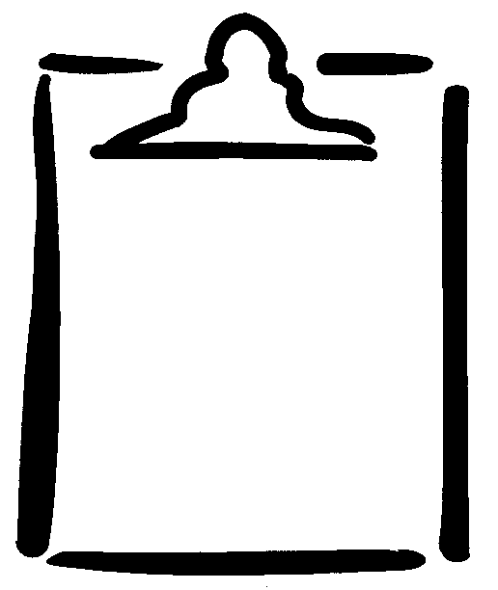

Name(s) ______________________________ Style of Routine ______________

_____________________________________ Date _______________________
Create a routine by yourself or with others. Include the following components in your routine.
Components | Student Checklist | Teacher Checklist
A beginning pose (hold for three seconds) | ❑ | ❑
Two changes of level (low, medium, high) | ❑ | ❑
Two changes in direction (forwards, backwards, sideways) | ❑ | ❑
Two changes of pathways (straight, zigzag, curved) | ❑ | ❑
An ending pose (hold for three seconds) | ❑ | ❑
