K.5.5.E.1b  BLM  5-12  K.5.5.E.2 | Puberty Changes |  | 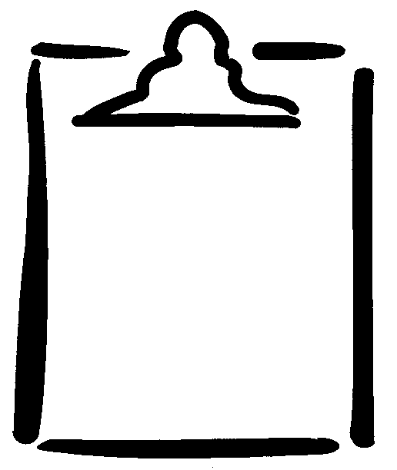
Name |  | Class | Date

Changes That Occur in Puberty | Identify changes that occur for…
Changes That Occur in Puberty | Males Only (M) | Females Only (F) | Both Males and Females (B) | Answer Key
- Breasts begin to grow. |  |  |  | F
- Breasts swell or feel uncomfortable. |  |  |  | B
- Height increases. |  |  |  | B
- Weight increases. |  |  |  | B
- Feelings of clumsiness occur. |  |  |  | B
- Voice deepens. |  |  |  | M
- Mood changes. |  |  |  | B
- Need to be independent increases. |  |  |  | B
- Skin gets oilier. |  |  |  | B
- Perspiration increases. |  |  |  | B
- Scrotum gets larger. |  |  |  | M
- Hair grows in pubic area. |  |  |  | B
- Menstruation begins. |  |  |  | F
- Hair grows under arms and on legs. |  |  |  | B
- First ejaculation of semen occurs. |  |  |  | M
- Wet dreams occur. |  |  |  | M
- Hair grows on chest. |  |  |  | M
- Penis increases in length and width. |  |  |  | M
- Vaginal discharge may be noticeable. |  |  |  | F
- Acne develops. |  |  |  | B
- Shoulders grow wider/broader. |  |  |  | B
- Hips grow wider. |  |  |  | F
- Feelings of insecurity may develop. |  |  |  | B
- Need to conform or fit in with others increases. |  |  |  | B

