S.4.5.A.1  BLM  5-11  K.4.6.A.2a  S.5.6.A.3b  K.4.8.A.2a | Goal Setting |  | 
Name |  | Class | Date
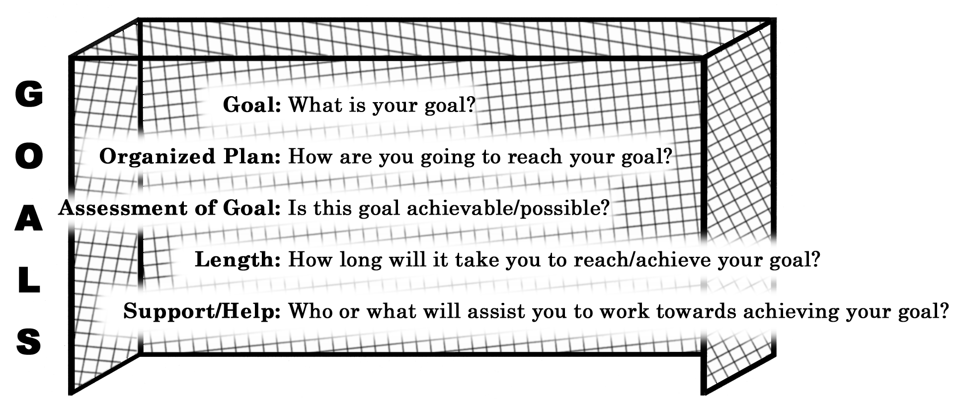

Letter* | Response  to Above Questions | Self-Assessment
Letter* | Response  to Above Questions | Description | Above Expectations | Meets Expectations | Below Expectations
G |  | Clearly stated the goal.
O |  | Outlined steps to achieve the goal.
A |  | Set a realistic goal.
L |  | Revised the goal/plan as needed.
S |  | Obtained support and used self-monitoring strategies.
* Colour in the letter upon completion of what you set out to do for each letter.

