BLM  4-6  S.3.4.A.2 | Practices to Assist an  Injured Person |  |  | 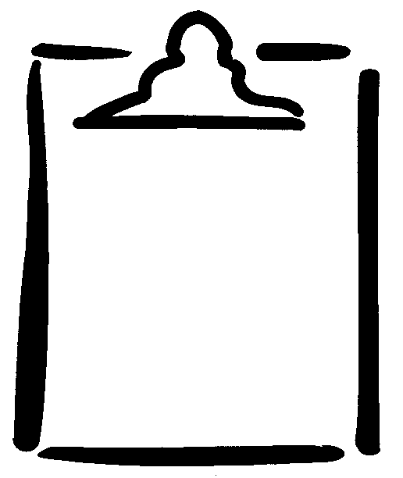
Name |  |  | Class | Date
  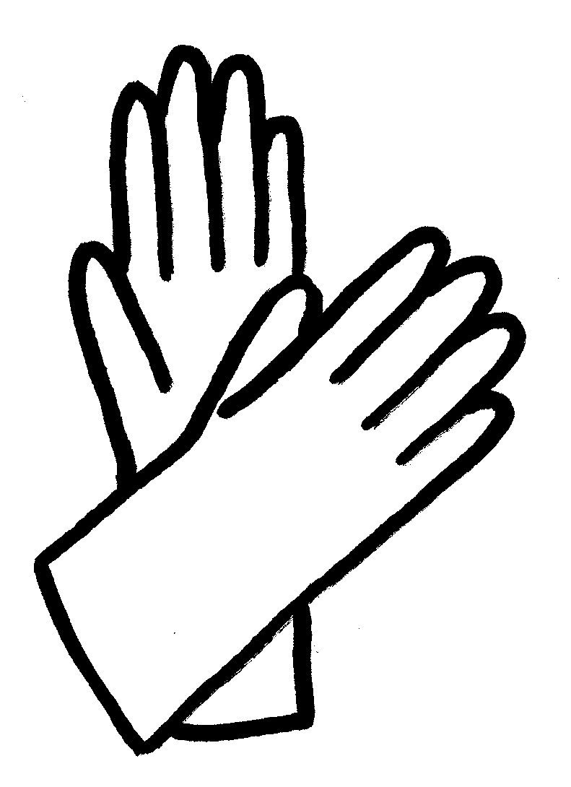  Name ______________ Date ________   got help quickly   explained clearly and  accurately what happened   avoided contact with body fluids   did not try to move the injured person  Observations: |  | Name ______________ Date ________   got help quickly   explained clearly and  accurately what happened   avoided contact with body fluids   did not try to move the injured person  Observations:
Name ______________ Date ________   got help quickly   explained clearly and  accurately what happened   avoided contact with body fluids   did not try to move the injured person  Observations: |  | Name ______________ Date ________   got help quickly   explained clearly and  accurately what happened   avoided contact with body fluids   did not try to move the injured person  Observations:

