BLM  4-5  K.3.4.B.1 | Road and Traffic Symbols | 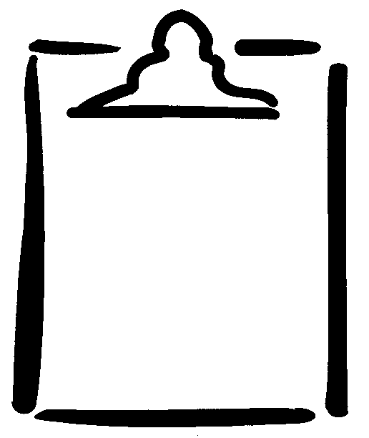

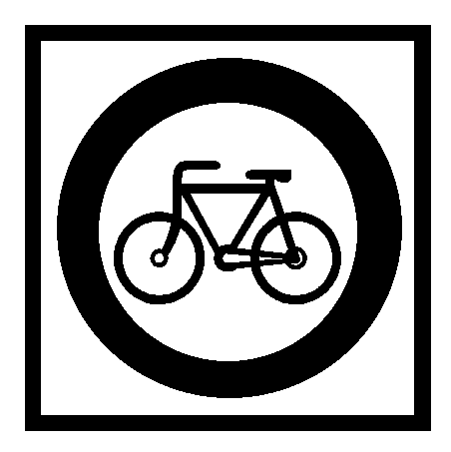 | 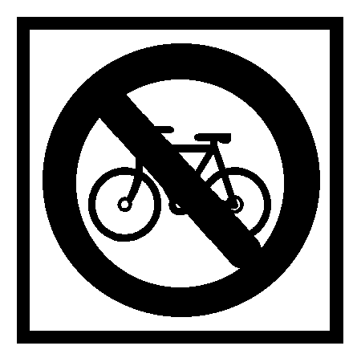 | 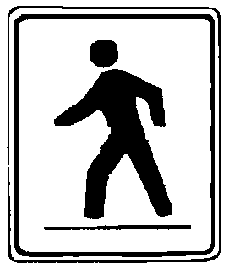 | 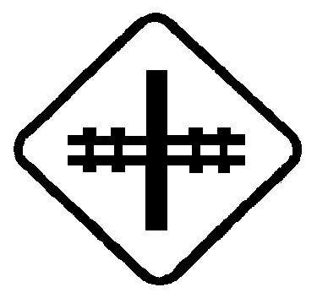
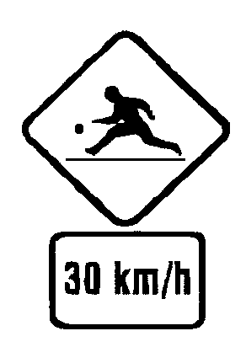 | 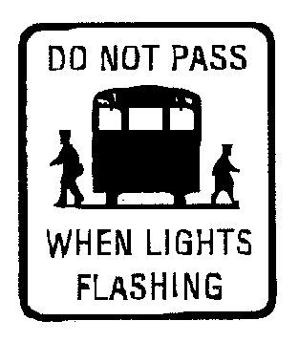 | 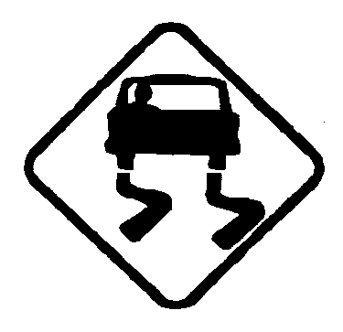 | 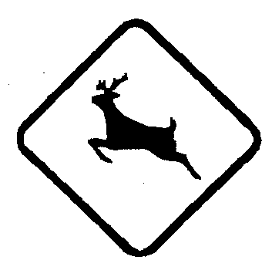
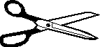
 | 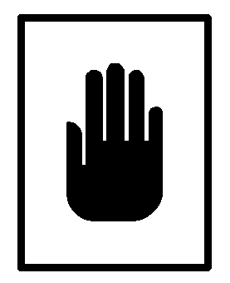 | STOP  Come to a full stop. Check for traffic all ways. Go when it’s safe. | RAILWAY CROSSING  Slow down. Look both ways. Listen for a train. Go if it is safe.
WILDLIFE IN AREA  Go carefully. Wildlife may cross in front of you. | SLIPPERY ROAD  Go carefully. The road  may be slippery. | DON’T WALK | PLAYGROUND AHEAD  Go carefully. Children  at play.
SCHOOL ZONE | TRAFFIC LIGHTS AHEAD | DO NOT ENTER | NO BICYCLES ALLOWED
BICYCLES  ALLOWED | CROSSWALK  Slow down. Be ready to stop for pedestrians. | ONE WAY  Go only the way the  arrow is pointing. | YIELD  Slow down or stop for traffic.

