BLM  4-2  4.2.4.C.1a | My Heart |  | 
Name |  | Class | Date
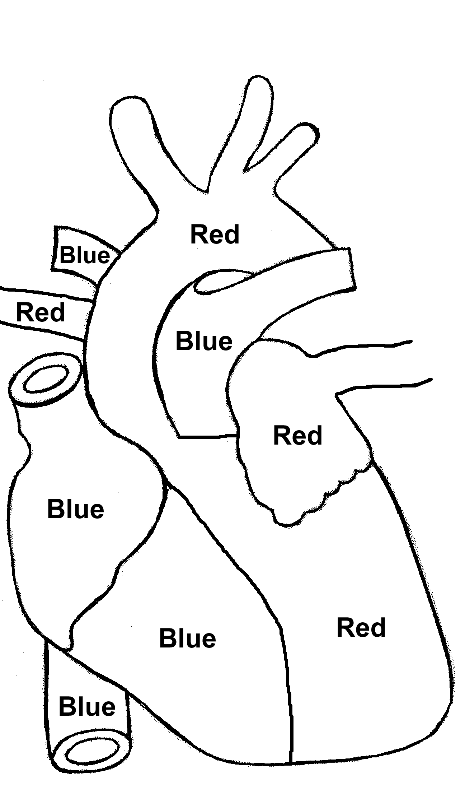

Colour the arteries red (they carry oxygen) and the veins blue (they carry carbon dioxide).

