BLM  3-3  K.3.3.B.4 | What’s Your Job? |  | 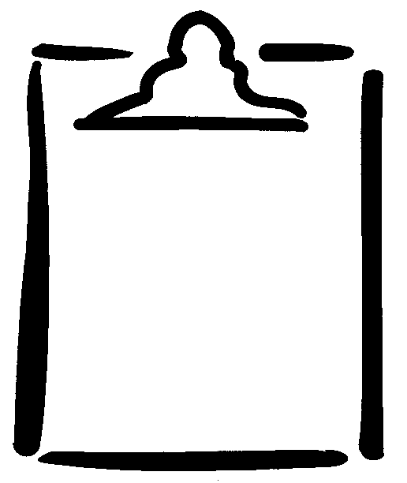
Name |  | Class | Date
Draw a line matching the safety helper (○) to the safety situation (◻).
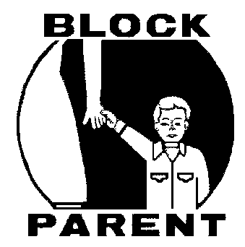
If you have an injury at school.
If you cross the street near the school.
If you have a stomach ache at home.
If you see a person driving over the speed limit.
If you meet a person who scares you on the way home from school.
If you see smoke and fire.
If you break a leg.

