BLM  3-1  K.1.3.C.1 | Game Write-Up |  |  | 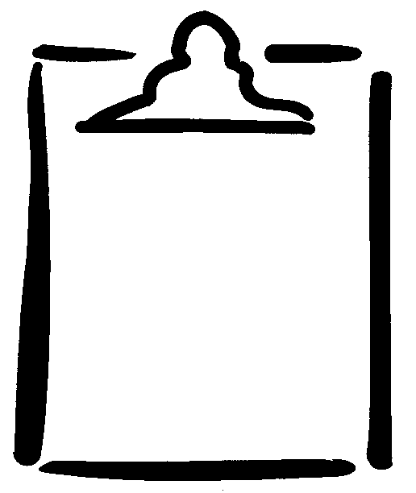
Student Names  Class |  |  |  | Activity  Date
Name of Game
Number of Players
Area Used

Equipment Needed

Object of Game

Game Rules and Skills
Diagram of Game

